VL 1: Introduction to biochemistry
Macromolecules and their building blocks
- Lipids: Fatty acids – Triglycerides
for membranes and energy storage
- Carbohydrates: Monosaccharides- Polysaccharides
for energy production and energy storage
- DNA/RNA: nucleotides
For storage, transfer and replication of information
- Proteins: Amino acids- Polypeptides (+prosthetic groups, metals)
For cell and organism structure, cell movement and catalyzation of reactions
Electronegativity
- Electronegativity= The ability of an atom (or functional group) to attract electrons in a covalent bond -> partially charges molecules
- Hydrogen Bond: Bond between partially charged molecules or partially charged molecules with charged particles, reason for high boiling point of water
- Hydrogen bonds are found in hydration shells, structure in DNA and protein
- Common hydrogen bonds: Water-water, water-amino group, water-carboxyl group
Amphiphilic molecules
- Both hydrophobic (tail) and hydrophilic (head)
- Mainly phospholipids
- can form micelles, liposomes, bilayers, cellular membranes
Acids and bases
- pH=-log[H+], describes ratio of H+ and OH-
- Acidic solution: [H+] > [OH-], pH < 7
- Basic solution [OH-] > [H+], pH > 7
- Depending on pH-level some groups can be charged: COO-, NH3+, S- (Lecture 2)
Buffers
- Buffers resist changes in pH at their pKa
- Acid: Proton donor (AH ↔ A- + H+)
- Base: Proton acceptor (B- + H+ ↔ BH)
- Henderson- Hasselbalch equation: $pH={pK}_{a}+log\frac{[A^{-}]}{[HA]}$
- Ex. for physiological buffer: Carbonic acid with two pKa: ${pK}_{A1}=6,4 ,{pK}_{A2}=10,3$
$${pK}_{A1}=6,4: H_{2}{CO}_{3}↔{\left({HCO}_{3}\right)}^{-}+ H^{+}$$
$${pK}_{A2}=10,3: {\left({HCO}_{3}\right)}^{-}↔{\left({CO}_{3}\right)}^{2-}+ H^{+}$$
Gibbs Energy
- $∆G= ∆H-T ∆S$
H= Enthalpy (Heat)
T= Temperature
S= Entropy (randomness)
- Reactions are favorable if the product has lower free/gibbs energy
- ATP hydrolysis is very favorable and therefore often coupled with less favorable reactions
- Nernst equation: $ΔG=ΔG_{0}+RTlnK$
- $K=\frac{\left[C\right][D]}{\left[A\right][B]}$ at equilibrium of$A+B ↔C+D$

VL 2 Amino acids and proteins

Protein structure
1. Primary Structure
Primary Structure describes the unique order in which amino acids are linked together to form a protein. Proteins are constructed from a set of 20 amino acids. Generally, amino acids have the following structural properties:
A carbon (the alpha carbon) bonded to the four groups below:
A hydrogen atom (H)
A Carboxyl group (-COOH)
An Amino group (-NH2)
A "variable" group or "R" group
All amino acids have the alpha carbon bonded to a hydrogen atom, carboxyl group, and an amino group. The "R" group varies among amino acids and determines the differences between these protein monomers. The amino acid sequence of a protein is determined by the information found in the cellular genetic code. The order of amino acids in a polypeptide chain is unique and specific to a particular protein. Altering a single amino acid causes a gene mutation, which most often results in a non-functioning protein.
2. Secondary Structure
Secondary Structure refers to the coiling or folding of a polypeptide chain that gives the protein its 3-D shape. There are two types of secondary structures observed in proteins. One type is the alpha (α) helix structure. This structure resembles a coiled spring and is secured by hydrogen bonding in the polypeptide chain. The second type of secondary structure in proteins is the beta (β) pleated sheet. This structure appears to be folded or pleated and is held together by hydrogen bonding between polypeptide units of the folded chain that lie adjacent to one another.
3. Tertiary Structure
Tertiary Structure refers to the comprehensive 3-D structure of the polypeptide chain of a protein. There are several types of bonds and forces that hold a protein in its tertiary structure.
Hydrophobic interactions greatly contribute to the folding and shaping of a protein. The "R" group of the amino acid is either hydrophobic or hydrophilic. The amino acids with hydrophilic "R" groups will seek contact with their aqueous environment, while amino acids with hydrophobic "R" groups will seek to avoid water and position themselves towards the center of the protein. ​
Hydrogen bonding in the polypeptide chain and between amino acid "R" groups helps to stabilize protein structure by holding the protein in the shape established by the hydrophobic interactions.
Due to protein folding, ionic bonding can occur between the positively and negatively charged "R" groups that come in close contact with one another.
Folding can also result in covalent bonding between the "R" groups of cysteine amino acids. This type of bonding forms what is called a disulfide bridge. Interactions called van der Waals forces also assist in the stabilization of protein structure. These interactions pertain to the attractive and repulsive forces that occur between molecules that become polarized. These forces contribute to the bonding that occurs between molecules.
4. Quaternary Structure
Quaternary Structure refers to the structure of a protein macromolecule formed by interactions between multiple polypeptide chains. Each polypeptide chain is referred to as a subunit. Proteins with quaternary structure may consist of more than one of the same type of protein subunit. They may also be composed of different subunits. Hemoglobin is an example of a protein with quaternary structure. Hemoglobin, found in the blood, is an iron-containing protein that binds oxygen molecules. It contains four subunits: two alpha subunits and two beta subunits.

Amino Acids

- Building blocks for proteins
- Precursors (Vorläufer) for signaling molecules
- Stereoisomerism / Chirality: L and D amino acids - specificity of synthesis and recognition
L-amino acid refers to a stereoisomer of a particular amino acid whose amino group is on the left side in its Fisher projection while D-amino acid refers to the other stereoisomer of the amino acid whose amino group is on the right side in its Fisher projection
L-amino acids are the form of stereoisomers used by the cells to produce proteins

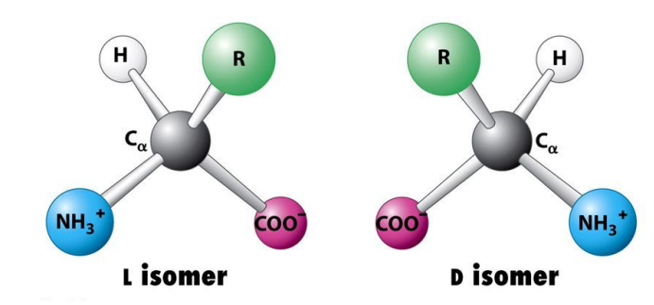

Amino Acids den Gruppen zuordnen können
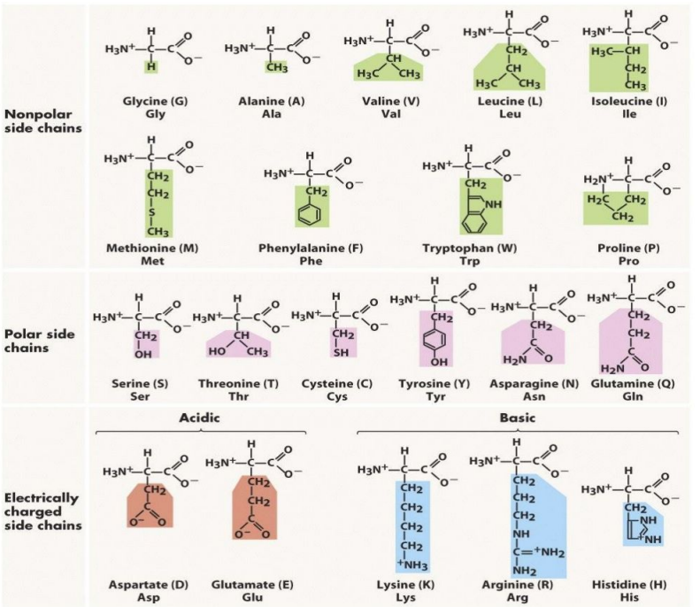

Strukturformeln

Nonpolar
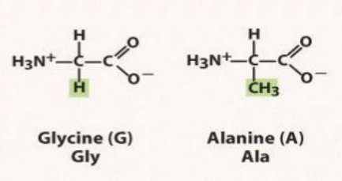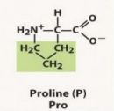

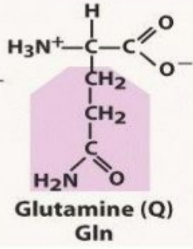
Polar
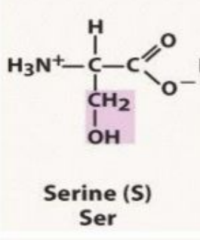

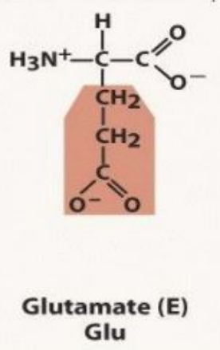
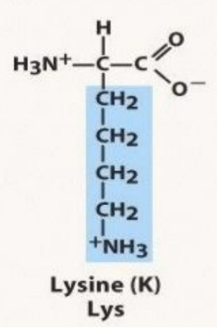
Charged Acidic Charged Basic

Amino Acid functions
- Building blocks for proteins
- Precursors for nucleotides, prosthetic groups and signaling molecules: neurotransmitters, hormones
- pH balance: ammonia metabolism
- Transport of amino groups
- Source of energy

Amino Acid ionization
- AA is a Zwitterion at physiological pH
A zwitterion is a molecule with functional groups, of which at least one has a positive and one has a negative electrical charge. The net charge of the entire molecule is zero.
Amino acids are the best-known examples of zwitterions. They contain an amine group (basic) and a carboxylic group (acidic). The -NH₂ group is the stronger base, and so it picks up H⁺ from the -COOH group to leave a zwitterion (i.e. the amine group de-protonates the carboxylic acid)
- Isoelectric point - pI = pH at which amino acid charge is 0
- The charge of side chains is important for protein folding, reaction catalysis and protein-protein interactions

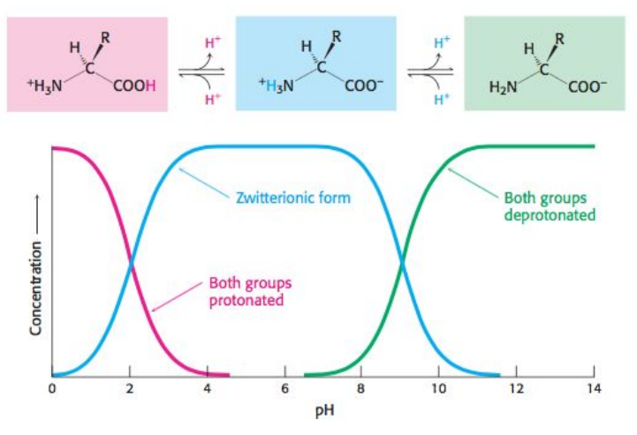
- Each ionizable group has its own pKa
- Glycine - two pKa values
- Glutamate - three pKa values
- pI = average of two pKa values
pK_{a} is the negative base-10 logarithm of the acid dissociation constant (K_{a}) of a solution.
pKa = -log₁₀K_{a}
The lower the pK_{a} value, the stronger the acid.
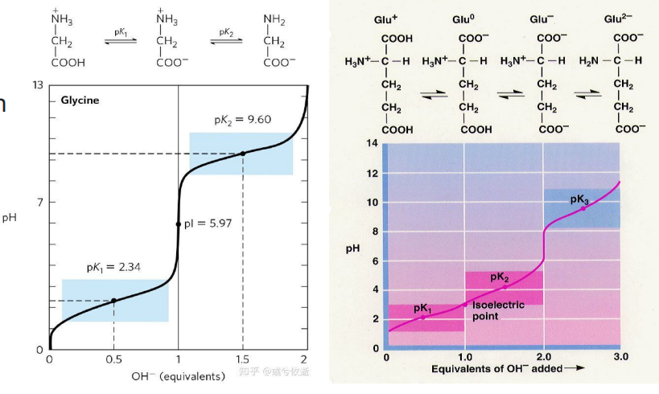

Proteinogenic amino acids
Proteinogenic amino acids are amino acids that are incorporated biosynthetically into proteins during translation
- 20 encoded amino acids

Amino acid classification
- Proteinogenic / non-proteinogenic
- Essential / nonessential
- Ketogenic / Glucogenic

Non-proteinogenic amino acids
- γ-Aminobutyric acid (GABA)
  - Neurotransmitter
  - Synthesized by synaptic neurons to limit excitability

Amino acids as precursors of signaling molecules
- Histamine produced from histidine
- Neurons: neurotransmitter in the brain, spinal cord and uterus
- Adrenaline (epinephrine)
  - Produced by the adrenal glands and neurons from phenylalanine or tyrosine
  - Binds adrenergic receptors
  - Fight-or-flight response:
    - Increased blood flow to muscles
    - Pupil dilation, respiratory control
    - Blood sugar level

Linked amino acids: peptides
- Glutathione: isopeptide bond (gamma-carboxyl + alpha-amino)
- Antioxidant: protects cells by reducing reactive oxygen species:
  - 2GSH + R2O2 → GSSG + 2ROH
- Thiol protection and redox regulation of cellular thiol proteins under oxidative stress by protein S-glutathionylation

Peptide bond
- alpha-carboxyl + alpha-amino = peptide bond
- Amide bond - partial double bond character, planar
- Protein synthesis: peptidyl transferase activity of the ribosome
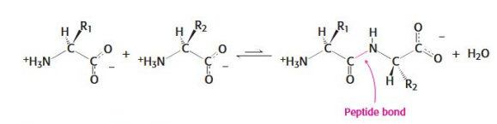

Cis and trans configurations
Cis-trans isomers are compounds that have different configurations (groups permanently in different places in space) because of the presence of a rigid structure in their molecule. Alkenes and cyclic compounds can exhibit cis-trans isomerism.
- Peptide bonds/groups preferentially in the trans configuration
- X-Pro bonds are less selective for cis: trans, around 1:30
- X-Pro bonds can be isomerized: peptidyl-prolyl cis-transisomerase

Torsional angles around neighboring peptide bonds

- Steric hindrance (Sterische Hindernisse) of R groups (aa side chains)
- Torsion angles
  - N-C: Phi
  - C-CO: Psi
- Possible angle combinations define the spatial configuration of the polypeptide chain
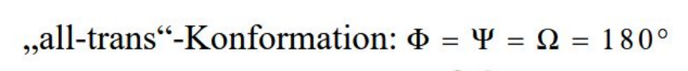
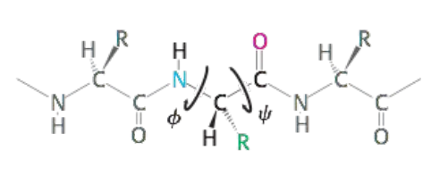
Secondary Structures:

Alpha helix
- Sequence (the order of AA) is essential
- Right-handed helix Hydrogen bonds between the CO and NH groups of the backbone
- Can be disrupted (unterbrochen) by Pro, Val, Ile, Ser, Asp, Asn

Beta strand
- Stabilized by hydrogen bonds
- R groups face alternating sides
- Parallel and anti-parallel
- Assemble into beta-sheets and beta-barrels
- Beta strands assemble into beta-sheets and beta-barrels
- Certain residues (Reste) (e.g., Proline) disrupt secondary structure and are often found in turns and loops

Protein motifs and domains
The identification of motifs and domains in proteins is an important aspect of the classification of protein sequences and functional annotation.
- Folded functional units within a single polypeptide bond
- Tertiary structure is stabilized by hydrogen bonds between amino acid side chains
- Examples:
  - Ligand / DNA binding
  - Kinase / Protease catalytic domains

Protein folding
Chaperons / Chaperonins
Chaperone sind Proteine, die in Zellen für die korrekte Faltung anderer komplexer Proteine sorgen. Sie kommen bei Prokaryoten und Eukaryoten vor.
- ATPase activity
- Assist folding of nascent and denatured proteins
- Prevent aggregation of unfolded proteins
- Heat shock protein family Hsp70/80
Hsp70 (Hsp steht für Hitzeschockprotein) sind eine Gruppe von Proteinen und Enzymen, die manchen anderen Proteinen bei der Proteinfaltung oder bei der Entfaltung eines Proteins vor einem Membrantransport helfen. Dabei stellen Hsp70 mit einer Masse von 70 kDa eine wichtige Komponente des Chaperonsystems dar, das in eukaryontischen Zellen, in Eubakterien und in vielen Archaeen vorkommt.

Disulphide bonds
Eine Disulfidbrücke, Disulfidgruppe, Disulfidbindung oder Disulfidbrückenbindung bezeichnet in der Biochemie eine kovalente Bindung (Atombindung) zwischen den Schwefel-Atomen zweier Cysteine, die in der Aminosäureseitenkette eines Proteins vorkommen.
L-Cystein ist eine schwefelhaltige Aminosäure, die als einer der Basisstoffe für die Glutathion-Synthese benötigt wird

- Cysteine - Cysteine S-S bonds: oxidized state
- Oxidation-reduction reaction Ero1 (ER oxidoreductin) and PDI (Protein disulphide isomerase)
- Essential for protein folding and activity
- Reducing agents: (beta-mercaptoethanol / DTT) help unfold proteins

Protein folding
- RNAse as a research model: a very stable protein
- After denaturation regains activity
- Correct S-S bonds are required for enzymatic activity

Sequence of amino acids defines protein structure
- All the information for protein structure and function is contained within the primary sequence

Isoelectric point of a peptide
isoelektrischer Punkt, Kurzzeichen pI oder IEP, der pH-Wert, bei dem die Gesamtladung (elektrische Ladung) eines zwitterionisch (Zwitterionen) aufgebauten Moleküls (z.B. einer Aminosäure, eines Peptids, Proteins oder Nucleotids) neutral ist, d.h. gleichviel positive wie negative Ladungen vorliegen.

Fibrous proteins: keratin
- A class of alpha-helical proteins
- Form robust, elastic and insoluble fibrils
- Stabilized by disulfide bonds, hydrogen bonds

Collagen
- Most abundant (reichlich vorhanden) protein in human body
- Triple helix (not alpha helix)
- Helix stabilized by steric repulsion of proline side chains
- Triple helix stabilized by hydrogen bonds between individual chains
- Hydroxylation of proline - more hydrogen bonds
- Hydroxylation/oxidation of lysine residues - covalent aldol crosslinks

Oxygen-binding proteins
- Myoglobin:
  - muscle cells
  - Monomeric protein
  - Very high affinity for O2 Oxygen storage

- Heme:
  - porphyrin prosthetic group

- Hemoglobin:
  - red blood cells
  - Tetramer (4 subunits)
  - Oxygen carrier protein

- Hemoglobin O2 binding
  - Oxygen binding to one subunit induces a conformational change that enhances O2 binding to other subunits = cooperative binding
  - Deoxyhemoglobin (tight = T state)
  - Oxyhemoglobin (relaxed = R state)

- Hemoglobin regulation
  - Hemoglobin affinity for oxygen is regulated by 2,3-bisphosphoglycerate (2,3 BPG) - a byproduct of glycolysis
  - Allosteric regulation
In biochemistry, allosteric regulation (or allosteric control) is the regulation of an enzyme by binding an effector molecule at a site other than the enzyme's active site
  - Fetal hemoglobin (2 alpha + 2 gamma subunits) does not bind 2,3BPG and has a higher affinity for O2
  - CO2 effects: hemoglobin affinity for oxygen is regulated by pH
  - Lower pH in tissues stabilizes the T state - lower affinity for oxygen
  - Direct binding of CO2 to Hg stabilizes the T state
  - Transport of CO2 from tissues to the lung

Protein analysis
- Analysis of individual/specific proteins
- Batch protein analysis = sample characterization

Antibodies
- Recognize specific antigens/epitopes
- Produced in mouse or rabbit
- Research / therapeutic tools
- A specific reagent for the protein of interest
- Different functional groups can be attached to the antibody
- Generating antibodies in vitro
  - Antibody phage display
  - Yeast display
  - Ribosome display

Immunofluorescence / immunohistochemistry
- Antibodies are coupled to functional reagents / groups that allow antibody detection
- Fluorescent / chromogenic substrates
- Protein levels or localization in cell or tissue
- Compare expression of protein of interest in many individual samples
- Diagnostic / Prognostic implications
- Antibodies allow validation of the MS proteome data in broad panels of samples

VL 3: Enzymes
Important terms
- Enzymes: conformationally flexible catalysts, consist mostly of protein
- Substrate: molecule that the enzyme works on
- Cofactor: non-protein small molecule that assists catalysis (metals or coenzymes)
- Apoenzyme: Enzyme without its cofactor
- Holoenzyme: Enzyme with cofactor, catalytically active
- Prosthetic groups: tightly bound coenzymes
- Cosubstrates: Loosely bound coenzymes – are released after reaction
- Catalyst: lower activation energy and accelerate the attainment of equilibrium but don’t change the free energy of the reactions or reaction equilibrium [senkt die Aktivierungsenergie und beschleunigt das Erreichen des Gleichgewichts, ändert aber nicht die freie Energie der Reaktionen oder das Reaktionsgleichgewicht]
Enzyme specificity
- Precise interaction of substrate and enzyme because of unique 3D shape
- Old model: lock and key (substrate fits perfectly in enzyme)
- New model: induced fit (enzyme changes form around substrate, adapts to it)
Not like usual catalyst
Kinetics
- Enzymes bring substrates together at the right angle and speed
- Would be unlikely without enzyme
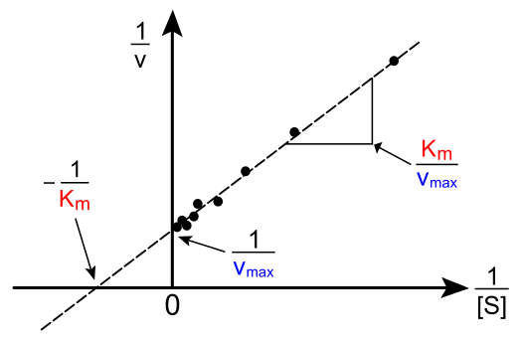
- Michaelis- Menten equation: $V_{0}=V_{max}\frac{[S]}{\left[S\right]+K_{M}}$
- $K_{M}=\frac{k_{-1}+k_{2}}{k_{1}}$ is measure of enzyme affinity for the substrate
- First order: $\left[S\right]≪K_{M}$ -> $V_{0}= \frac{V_{max}[S]}{K_{M}}$
- Zero order: $\left[S\right]≫K_{M}$ -> $V_{0}= V_{max}$
- $V_{max}$ and $K_{M}$ can be found via Lineweaver-Burk Plot:
- Turnover number: $K_{cat}=k_{2}=\frac{V_{max}}{\left[E\right]T}$ is used to compare enzymes, molecules converted per second
- Catalytic efficiency= $\frac{K_{cat}}{K_{M}}$. When higher 10^8: perfect enzymes, velocity [Geschwindigkeit] is only restricted by diffusion
- Allosteric Enzymes do not obey Michaelis Menten kinetics. Several binding position effect each other. Sigmoidal plot instead of hyperbolic (V0 over [S])
Different Enzyme Reactions
- Sequential reactions: all substrates bind before any product is released.
Substrates bind either in defined order (ordered) or random
- Ping pong reactions: one or more products are released before al substrates bind.
Substituted enzyme intermediate: enzyme is temporarily modified (ex.: stores reactive groups)

Enzyme inhibitors
- Competitive: Enzyme can bind either substrate or inhibitor.
Binds at catalytic site
$V_{max}$ is the same but is reached only with higher substrate concentration. $K_{M}$is increased
- Noncompetitive: Substrate and inhibitor can bind simultaneously.
Different binding sites
$V_{max}$ is reduced, inhibition can’t be overcome by higher substrate concentration. $K_{M}$is unaffected.
- Irreversible: Inhibitor binds covalently with enzyme. Reactive site is changed.
Group specific: inhibitor is similar to substrate but binds covalently
Suicide inhibitor: modified substrate can’t be released after catalytic mechanism
Ex.: Penicillin inhibits transpeptidase as group specific irreversible inhibitor. Binds to serin residue at active site.
Ex.: Aspirin inhibits COX as irreversible inhibitor. Reacts to serin close to reactive site and blocks access.
Enzyme classification
- Oxidoreductase: Oxidation-reduction (Dehydrogenase); Takes away H+
- Transferase: intermolecular group transfer
- Hydrolase: Hydrolysis reaction; Transfer of functional group to water
- Lyase: addition or removal of groups to form double bonds
- Isomerase: Isomerization / intramolecular group transfer
- Ligase: Ligation/Join of two substrates at expense of ATP hydrolysis
Chymotrypsin
- Splits up Proteins/ Peptide bonds on carboxyl side
- Steps 1-4: Acylation; Steps 5-7: Deacylation
1. Alkoxide ion: Substrate binds
2. Tetrahedral intermediate is formed (unstable)
3. Acyl-Enzyme: Protein is splitted, H+ is transferred from Enzyme to Amino group
4. Acyl-Enzyme: Side with amino group is released
5. Acyl-Enzyme: Water binds to carboxyl group
6.Tetrahedral intermediate: H+ is transferred to Enzyme
7.Carboxylic acid product: Side with carboxyl group is released

Biochemistry Summary – Lecture 4: Nucleic Acids/ DNA Replication

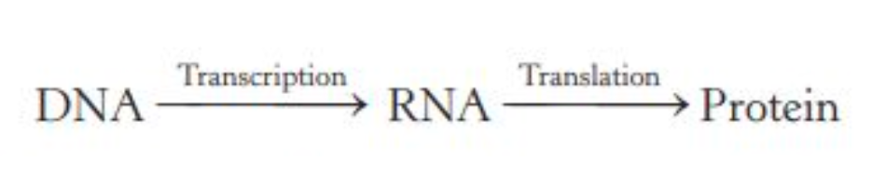
Structure of Nucleic Acids
- DNA and RNA consist of linear polymers of nucleotides
- Sequence of bases in the polymer characterizes a nucleic acid and constitutes a form of linear information
- Chain of sugars linked by phosphodiester bridges is referred to as the backbone
- Schematic structure of a nucleic acid’s backbone and bases
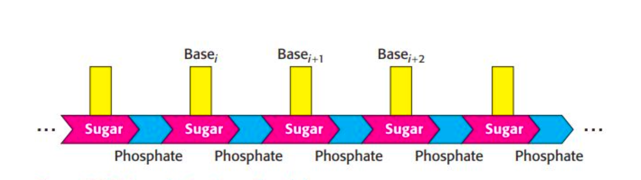
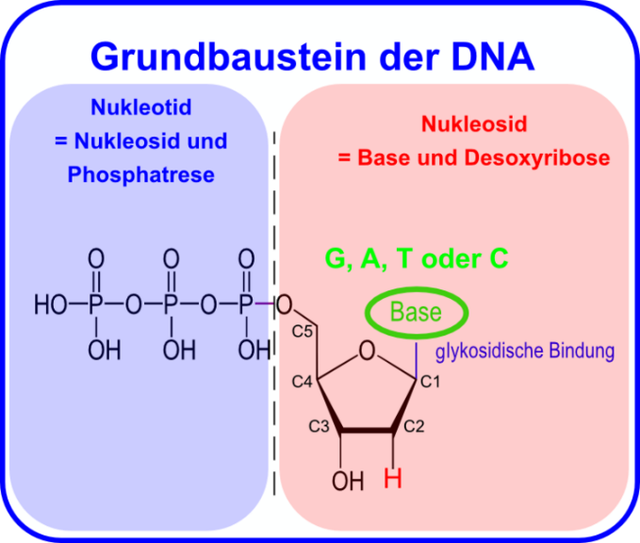

- Sugars:
  - RNA: ribose
  - DNA: deoxyribose
- Bases:
  - Purines: DNA adenine (A) and guanine (G)
  - Pyrimidines: cytosine (C), thymine (T), uracil (U)
- Nucleosides (= base + sugar):
  - RNA nucleosides: adenosine, guanosine, cytidine, uridine
  - DNA nucleosides: deoxyadenosine, deoxyguanosine, deoxycytidine, thymidine
N-9 of a purine or N-1 of a pyrimidine is attached to C-1 of the sugar by an N-glycosidic linkage
- Nucleotide (nucleoside + phosphoryl group)
  - Nucleoside and one or more phosphoryl groups are joined by an ester linkage forming a nucleotide (Nucleotide triphosphates = nucleosides joined to three phosphoryl groups)
  - A compound formed by the attachment of a phosphoryl group to C-5 of a nucleoside sugar is called a nucleoside 5’-phosphate or a 5’-nucleotide.
  - The number of phosphoryl groups and the attachment site are designated (Adenosine 5’-triphosphate Deoxyguanosine 3’-monophosphate (3’-dGMP))
- DNA/RNA (nucleotide linked by phosphodiester bonds)
  - DNA backbone has a negative charge - repels nucleophilic species such as hydroxide ions - phosphodiester linkages are less susceptible to hydrolytic attack than are other esters (e.g, carboxylic acid esters).
  - Maintains the integrity of genetic information stored in nucleic acids.
- DNA is a sequence nucleotide
  - DNA chain has directionality = polarity. One end of the chain has a free 5’-OH group (or a 5’-OH group attached to a phosphoryl group) and the other end has a free 3’-OH group, neither of which is linked to another nucleotide.
  - The base sequence is written in the 5’-to-3’ direction
- DNA double helix
  - The human genome comprises ~ 6 billion nucleotides divided among 24 distinct molecules of DNA called chromosomes (22 autosomal plus the X and Y sex chromosomes)
  - Two helical polynucleotide chains are coiled around a common axis with a right-handed screw sense. The chains are antiparallel = opposite polarity
  - The sugar-phosphate backbones are on the outside and the purine and pyrimidine bases lie on the inside of the helix.
- DNA base stacking
  - The stacking of base pairs: hydrophobic effect - bases cluster in the interior of the helix away from the surrounding water, more polar surfaces are exposed to water
  - The hydrophobic effect stacks the bases on top of one another. The stacked base pairs attract one another through stacking forces (van der Waals forces)
  - Base stacking in DNA is favored by the conformations of the rigid five- membered rings of the backbone sugars
- DNA Base Pairing (complementary)
  - Adenine pairs with Thymine (2 hydrogen bonds)
  - Guanine pairs with Cytosine (3 hydrogen bonds)
  - Complementarity provides mechanisms for:
    - Structural organization
    - Replication
    - Transcription
- DNA helix forms different structures
  - Most of DNA is in the B-form (bases oriented perpendicular to the axis)
  - A-form helix: base pairs are tilted to the helix axis; wider and shorter than the B-form
  - Z-form: left-handed with zigzagged phosphates in the backbone
  - forces: hydrophobic interactions, hydrogen bonds
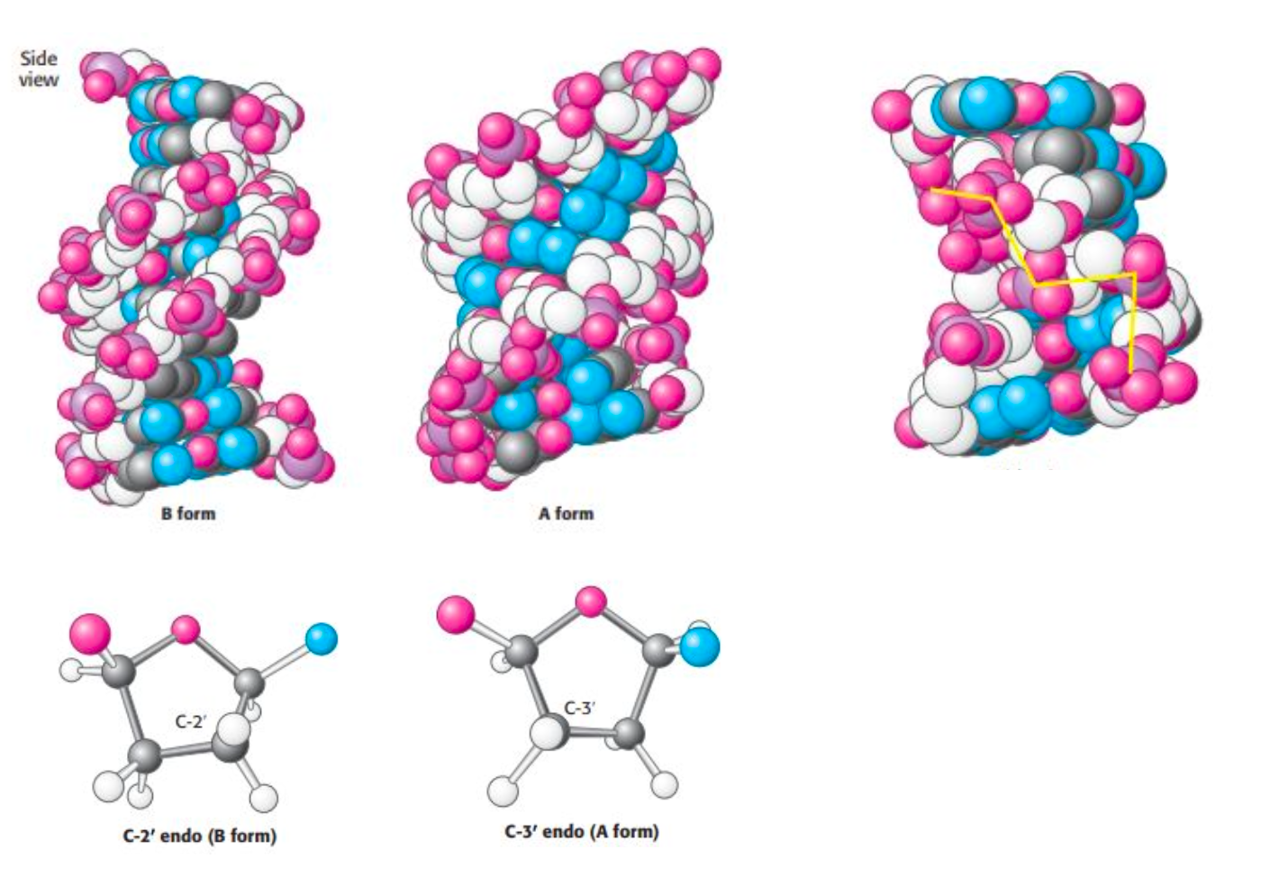

- Types of RNA:
  - 1. Messenger RNA (mRNA): template for protein synthesis
  - 2. Transfer RNA (tRNA): carries amino acids in an activated form to the ribosome for peptide-bond formation, in a sequence dictated by the mRNA template
  - 3. Ribosomal RNA (rRNA): In prokaryotes: three kinds of rRNA, one molecule of each per ribosome, structural and catalytic role in protein synthesis
  - 4. Small nuclear RNA (snRNA): splicing of RNA exons (only in eukaryotic cells)
  - 6. Micro RNA (miRNA) is a class of small noncoding RNAs that bind to complementary mRNA molecules and inhibit their translation (only in eukaryotic cells)
  - 7. Small interfering RNA (siRNA) is a class of small RNA molecules that bind to mRNA and facilitate its degradation (only in eukaryotic cells)
- RNA as genetic material:
  - Genes in all cellular organisms are made of DNA; some viruses out of RNA
  - The DNA version of the viral genome can become incorporated into the chromosomal DNA of the host and is replicated along with the normal cellular DNA. At a later time, the integrated viral genome is expressed to form viral RNA and viral proteins, which assemble into new virus particle
- Genetic code
  - 1. Three nucleotides (codon) encode an amino acid. A minimum of three bases is required to encode 20 amino acids.
  - 2. The code is non overlapping.
  - 3. The code is conserved across all domains of life with minimal deviations: in human mitochondria ribosomes read UGA as a codon for tryptophan rather than as a stop signal; AGA and AGG are read as stop signals rather than as codons for arginine, and AUA is read as a codon for methionine instead of isoleucine.
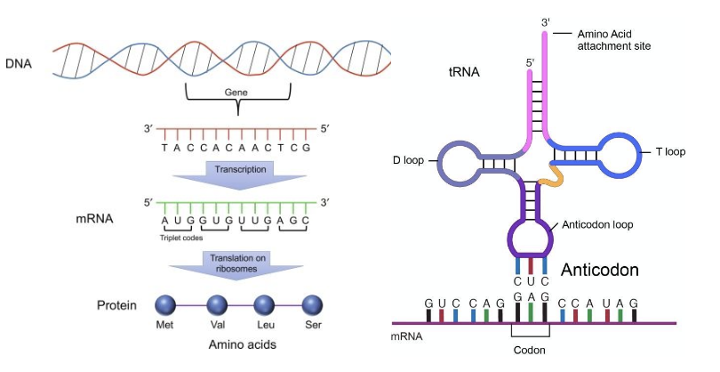

Semiconservative DNA Replication
- The sequence of bases of one strand of the double helix precisely determines the sequence of the other strand.
- requirements for DNA replication: template, primer, dNTPs, Mg2, energy; direction of synthesis 5’-3’
- Steps of DNA replication
  - 1. The reaction requires four deoxynucleoside 5’-triphosphates dATP, dGTP, dCTP, and TTP and Mg2+ ions.
  - 2.DNA polymerases catalyze the formation of a phosphodiester linkage only if the base on the incoming nucleoside triphosphate is complementary to the base on the template strand. Thus, DNA polymerase is a template-directed enzyme.
  - 3. DNA polymerases require a primer with a free 3’-OH group bound to the template strand. The chain-elongation reaction catalyzed by DNA polymerases is a nucleophilic attack by the 3’-OH terminus of the growing chain on the innermost phosphorus atom of the incoming deoxynucleoside triphosphate. A phosphodiester bond is formed and pyrophosphate is released. The subsequent hydrolysis of pyrophosphate to yield two ions of orthophosphate (Pi) by pyrophosphatase helps drive the polymerization forward. Elongation of the DNA chain proceeds in the 5’-to-3’ direction.
  - 4. Many DNA polymerases are able to correct mistakes in DNA by removing mismatched nucleotides. These polymerases have a distinct nuclease activity that allows them to excise incorrect bases by a separate reaction = proofreading. This nuclease activity contributes to the fidelity of DNA replication.
- Proofreading by the replicative polymerase
  - The epsilon subunit of E. coli DNA polymerase III functions as a 3’-to-5’ exonuclease to remove mismatched nucleotides from the 3’ end of DNA by hydrolysis. As a new strand of DNA is synthesized, it is proofread.
- DNA replication requires RNA primer
  - The primase RNA polymerase synthesizes a short stretch of RNA that is complementary to one of the template DNA strands. Later the RNA primer is removed by hydrolysis and replaced by DNA
  - The site of DNA synthesis is called the replication fork
  - Replication fork: helicase (bact - dnaB), DNA polymerase III, sliding clamp, primase, SSB protein
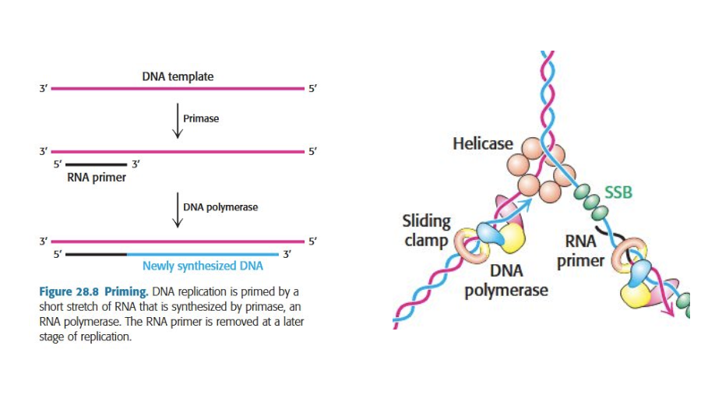

- Replication requires DNA ligase activity
  - Leading strand is synthesized continuously. The lagging strand is copied as ~ 1000bp long Okazaki fragments. As replication proceeds, these fragments become covalently joined through the action of DNA ligase.
  - DNA Polymerase I: removes primers and fills gaps on the lagging strand; DNA ligase joins pieces
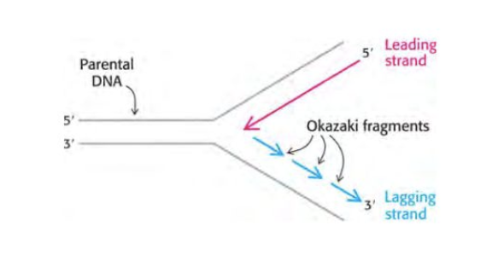

- Unwinding generates topological torsional stress (supercoils)
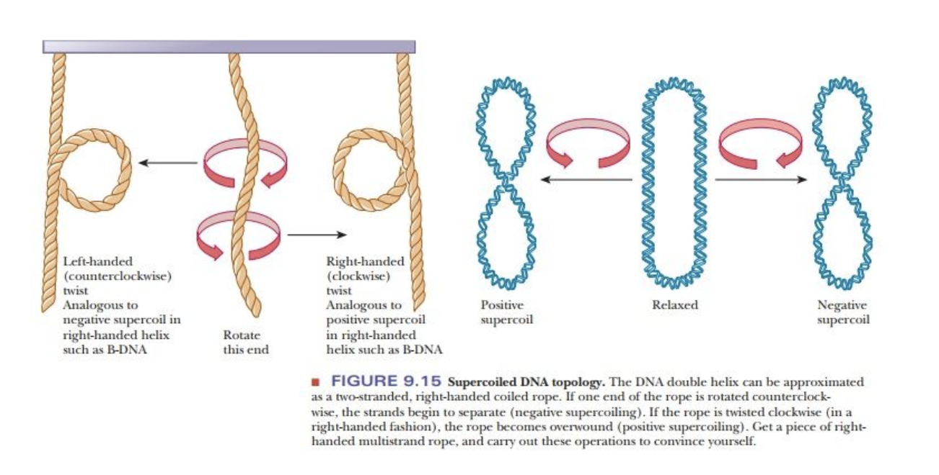

- Toposisomerase relieve helical stress
  - topoisomerases I relax/unwind supercoils
  - topoisomerases II cuts both strands and uses ATP
- Inititation of DNA replication
  - In E. coli DNA replication starts at a single unique site - origin of replication oriC - with binding sites for DnaA and tandem array of AT-rich sequences
  - 1. Binding of DnaA - related to the hexameric helicases. Each DnaA monomer contains ATPase and DNA-binding binding domains
  - 2. Single DNA strands are exposed in the prepriming complex. The helicase DnaB is loaded with SSB protein and helicase loader protein DnaC forming the prepriming complex. The primase, DnaG, is now able to make the RNA primer.
  - 3. The DNA polymerase III holoenzyme assembles on the prepriming complex, initiated by interactions between DnaB and the sliding-clamp subunit of DNA PolIII. These interactions also trigger ATP hydrolysis within the DnaA subunits, signaling the initiation of DNA replication. The breakup of the DnaA assembly prevents additional rounds of reolication
DnaA ist ein Protein, das eine wichtige Rolle bei der Initiation der DNA-Replikation in Prokaryoten spielt. Es bewirkt die initiale Entspiralisierung der bakteriellen DNA im Bereich des Replikationsursprungs OriC.
DnaB helicase is an enzyme in bacteria which opens the replication fork during DNA replication.

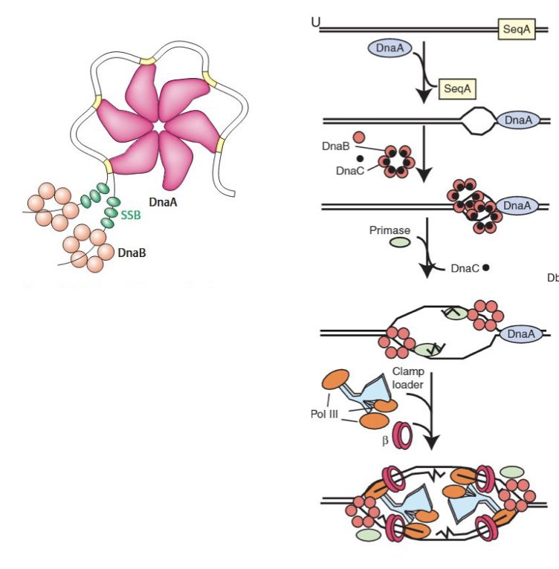
- End of Replication of circular DNA (bact) vs. linear (human):
  - Linear DNA:
    - Telomeres are replicated by telomerase that carries its own RNA template
    - Telomerase is related to reverse transcriptases, enzymes that copy RNA into DNA
    - Thus, telomerase is a specialized reverse transcriptase that carries its own template
  - Circular DNA:
    - Telomerase uses its template and telomere chromosome end as the primer to extend the chromosome
    - Following translocation, the reaction is repeated elongating the chromosome ends
    - Telomerase is generally expressed at high levels only in rapidly growing cells. Telomerase can play important roles in cancer cell biology and may be exploited as a drug target
- Types of DNA damage and repair (genauer auf Folien erklärt, wäre hier zu viel)
  - Damages: UV / cisplatin crosslinks, damaged bases (due to ROS, mutagens and mutations)
  - Repair mechanisms: nucleotide excision repair, base excision repair, mismatch repair, Repair of DNA double strand breaks

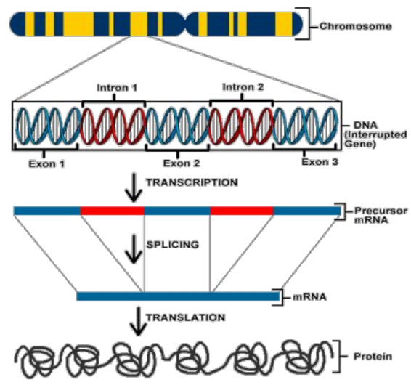
VL 5: Transcription / gene expression
- RNA synthesis: Transcription is a key mechanism to control gene expression
Gene expression underlies cell diversity and specialization within an organism
initiation, elongation, and termination
- Gene expression: transcription – splicing – translation – protein product – phenotypic change
- E. coli: single RNAP with 5 types of subunits
- Eukaryotes: 3 RNAP (polymerases) enzymes for different classes of RNAs:
8-14 subunits
- Base pairing in DNA and RNA: Adenine – Thymine and Guanine – Cytosine
- Transcription reaction: starts with 3’-OH of the last nucleotide; initiation phase of RNA synthesis: recognizing promoter, assembling RNAP holoenzyme and formation of first phosphodiester bond
- Transcription elongation: ribonucleoside triphosphate binds in the active site of the RNA polymerase
RNA-DNA hybrid can move in opposite directions of elongation backtracking is energetically less favorable since bond between base pair breaks
- Non-Watson-Crick: incorporation [Einbau] of an incorrect nucleotide
- Sigma factor finds promoters and binds to them
- Transcription termination: stop signal is palindromic GD-rich region (RNA folds into hairpin)
- Factor rho ρ (10S, 13S, 17S): hydrolyzes ATP in the presence of single-stranded RNA,
hexametric rho is an RNA helicase, The helicase activity of rho pulls nascent [entstehende] RNA, catches RNA polymerase at the transcription bubble and breaks the RNA–DNA hybrid
- Riboswitches: mRNAs that secondary structures bind directly to small molecules
- Antibiotics inhibit transcription: Rifampicin and actinomycin (antibiotics) inhibit bacterial
transcription
Rifampicin inhibits the initiation of RNA synthesis
Actinomycin D prevents double-helical DNA from being an effective template for RNA synthesis
- tRNA and rRNA molecules are generated by cleavage and other modifications of nascent RNA chains
- mRNA molecules undergo little modifications in procaryotes
- TATA box: resembles the prokaryotic -10 sequence, but further from start side
- initiator element lnr: sequence at the transcriptional start side between -3 and -5
- basal transcription complex initiates transcription at low frequency
site-specific transcription factors are required to achieve high rate of mRNA synthesis
selective regulation of gene expression
- almost all eukaryotic transcriptions are processed
- pre-RNA is assembled with ribosomal proteins
- eukaryotic tRNAs are heavily modified on base and ribose moieties [Anteile]
modifications are important for function
- eukaryotic mRNAs contain a pola(A) tail at the 3’ end, DNA does not encode it
- immediate product of RNA polymerase II is pre-mRNA, most of them are spliced
- mRNA splicing:
- spliceosome: are associated with specific proteins to form complexes (snRNPs), large dynamic assemblies
- splicing defects in disease: normally defective mRNA is rather degraded than translated, sometimes mutations in the 5’ splice site may not be recognized by the splicing machinery can lead to genetic diseases
- CTD: consists of a unique repeated 7 aa sequence, contributes to efficient transcription by recruiting proteins to the pre-mRNA,
function: capping enzymes, splicing, adenylation
- histones: group of small basic proteins, constitute half the mass of a eukaryotic chromosome, protein complex = histone octamer

Prokaryotes vs. eukaryotes:
distance to promoters, coordinated regulation of the pathway, polycistronic mRNA, direct interaction with RNAP
- Agonists: molecules that bind to a receptor and trigger signaling pathways, stimulate the expression of genes that enhance the development of muscle mass
- Antagonists: bind to nuclear hormone receptors but don’t trigger signaling pathways (can be drugs)
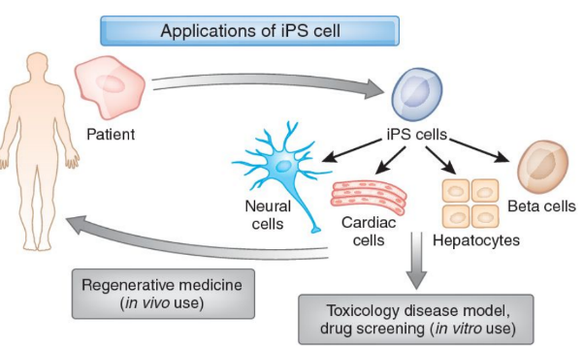
- histone acetylation [Acetylierung]: only takes place at lysin residues [Lysinreste] and neutralizes the positively charged ammonium, enhances [verbessert] transcription through transcription factors
- histone deacetylases: plays a central role in the removal of acetyl residues from lysine side chains of histone complexes
- pluripotent stem cells: ability to differentiate into many different cell types
- miRNA = microRNA: important role for splicing
- wichtig: Codieren anschauen falls Bsp. drankommt,

Vorlesung 6 – Protein synthesis
mRNA is decoded in the 5’ to 3’ direction.
The Protein synthesis goes from N to C.

Genetic code
The genetic code is build on the recognition of three base codons on the mRNA. Three base pairs encode for one amino acid.
- 64 possible codes encoding for 21 amino acids
- UGA even though it is a stop codon can be encoded to Selenocystein (number 21)
- Stop codons: UAA, UGA and UAG
- Start codon: AUG (methionine)
- Universal code e.g. mitochondria
- Reading frames?
- Code degeneracy: multiple base triplets encode for the same amino acid

tRNA
- Single chain between 73 and 93 RNA nucleotides
- 5’ terminus is phosphorylated
- 3’ terminus has a free -OH group
- Between 7 and 15 bases are methylated derivatives of A, U, C and G
- Prevents base pairing and creates the known secondary and tertiary structure
- L-shaped
- Half the nucleotides are base-paired to form A-Form double helices
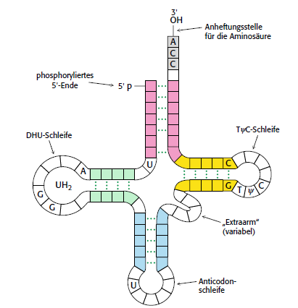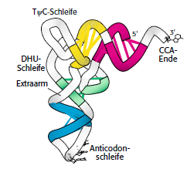
- Five groups of bases are not base paired:
  - 3’ CCA terminal part of the acceptor stem
  - TC loop
  - DHU loopSS
  - Anticodon loop

tRNA synthetase
- Amino acid binding to tRNA:
  - Amino acid needs to be activated
  - Activated amino acid binds to the either the 2’- or the 3’-hydroxyl group of the ribose unit at the 3’ end of tRNA.
  - Both steps are catalyzed by the aminoacyl-tRNA synthetase
- Control of correct tRNA and amino acid:
  - Activation side (acylation side): acylates aa which are smaller than the correct one and rejects bigger aa. Afterwards the bonded tRNA is added.
  - Editing side (hydrolytic side): cleaves the activated aa of the aminoacyl-tRNA that are smaller than the correct one
- tRNA recognition is possible on different surfaces of the enzyme
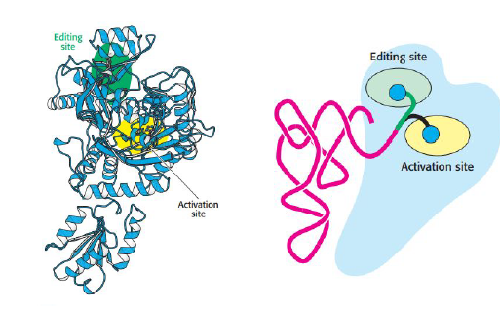

Codon and anticodon
- The first two bases of a codon pair precisely
- Wobble hypothesis: first base of an anticodon decides the allowed pairing at the third base of the codon. (important! Reading direction 5’-to-3’ but the orientation of anticodon and codon is in opposite directions)
- There are more than one triplets to encode for one amino acid. Inosine allows to minimize the amount of different tRNAs needed to encode all amino acids.
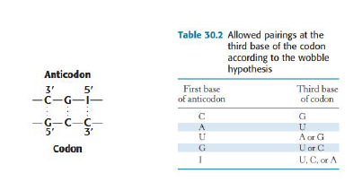

Ribosome
- Structure: large subunit + small subunit consisting of proteins + RNAs
- Prokaryote: 70s (with two subunits 50s and 30s)
- Eukaryote: 80s (with two subunits 60s and 40s)
- tRNA is in contact with both subunits
- binding site: A, P, E (tRNA not connected to mRNA
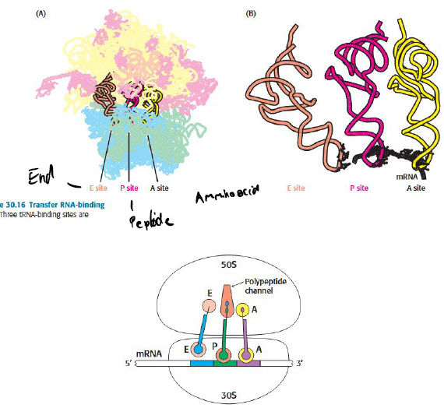

Translation initiation (https://www.youtube.com/watch?v=ncT6TLP8WsY)
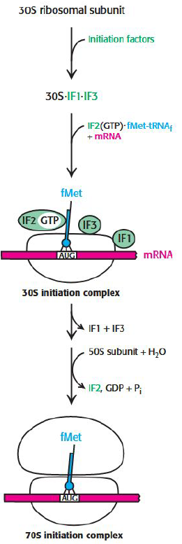
30S ribosomal subunit
↓
30s-IF1-IF3 subunit -> IF1 and IF3 prevent an early binding of 50S subunit
↓ mRNA with shine Delgado sequence occurs
mRNA binds at the 3’ end of the 16S rRNA of the 30s-IF1-IF3 subunit
↓
IF2 binds fMet-tRNAf after conformational change
↓
IF2-GTP initiator-tRNA complex binds mRNA and the 30s-IF1-IF3 subunit
↓
30S initiation complex is formed
↓
binding site E and A are blocked by IF2 and IF3
↓
fMet-tRNA binds initiation codon on mRNA at P binding site
↓
Structual changes lead to the ejection of IF1 and IF3
↓
GTP bound to IF2 is hydrolyzed
↓
IF2 is released
↓
70s initiation complex is formed
↓
Elongation can start

Elongation
Elongation Faktor TU (EF-TU) sorgt dafür, dass eine Aminoacyl-tRNA zur A-Stelle gebracht wird. Das funktioniert nur, wenn EF-TU ein GTP gebunden hat.
↓
EF-TU kommuniziert mit der 16S-RNA der Ribosom Obereinheit ob die tRNAs an den Stellen A und P korrekt sind.
↓ ja!
In der Ribosom Untereinheit kommt es zu einer Strukturveränderung, welche die GTPase-Aktivität von EF-Tu aktiviert.
↓ EF-Tu + GDP verlässt das Ribosom und wird durch EF-Ts
↓ wieder in die GTP-Form geführt
Die Aminoacyl-tRNA wird in die A-Seite gedreht, wodurch die Aminosäure in die Nähe der Aminoacyl-tRNa der P-Stelle gelangt.
↓
Es kommt zu einer Peptidbindung an der A-Stelle
↓
Durch EF-G werden mRNA und tRNAs weiter geschoben.
Dadurch wird die A-Stelle wieder frei. P-Stelle ist mit dem Polypetid-tRNA besetzt. Die E-Stelle ist mit der tRNA besetzt, welche dissoziieren kann. Der Zyklus geht weiter bis das Stopp-Codon erreicht wird
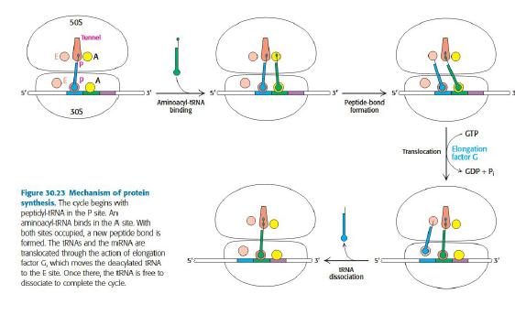
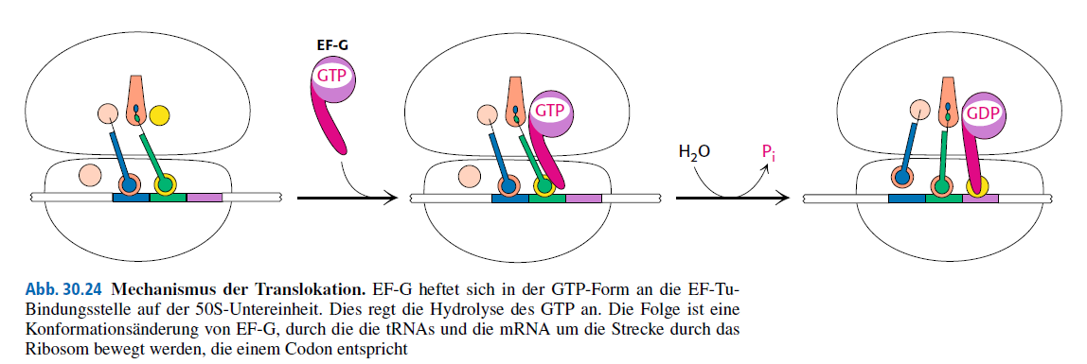

Termination factors
Stop codons are recognized either by RF1 (UAA or UAG) or RF2 (UAA or UGA).

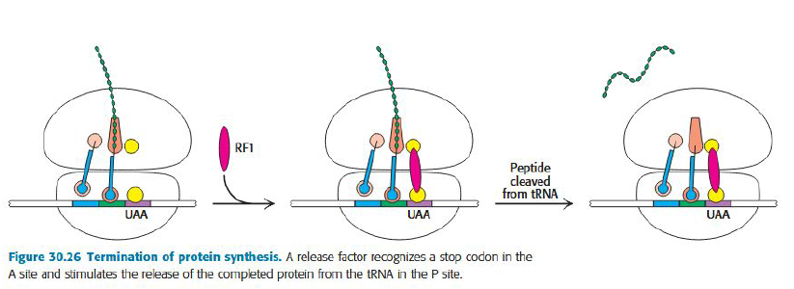
The release factor (RF) promotes the attack of the water molecule on the ester linkage between the tRNA and the polypeptide chain.

Prokaryotic vs eukaryotic translation

 | Eukaryotic | Prokaryotic
Ribosomes | 60s+40s=80s | 50s+30s=70s
Initiation amino acid | Methionine | Met-tRNAf
Initiation | The AUG nearest 5’ end of mRNA is selected as start site.  - Only one start site | mRNA can have multiple Shine-Dalgarno sequences.  - Multiple start sites  - mRNA is a template for several Proteins
Structure of mRNA | Circular | Planar
Elongation and Termination | see p.36 script  Termination is carried out by one release factor | see p.36 script  Termination is carried out by two release factors
Organization | Organized into large complexes associated with the cytoskeleton

Translation inhibitors

We just need to know Streptomycin and puromycin.
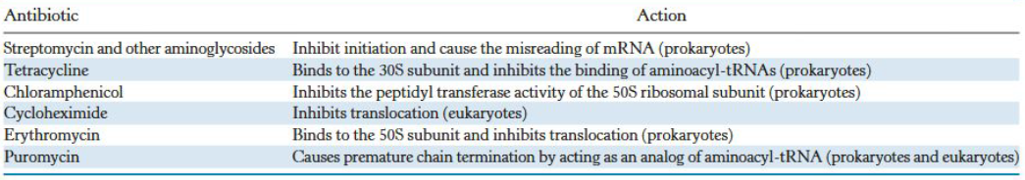

Protein synthesis in ER

If the protein is not needed in the cell but elsewhere, Signal recognition particle escorts ribosome to the ER membrane.
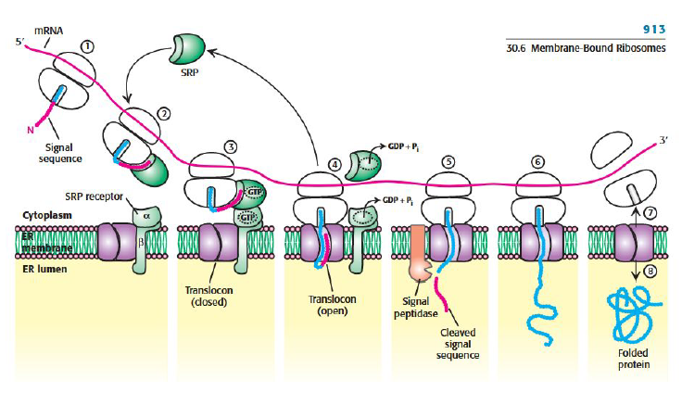

Protein folding
- can occur right at the ribosome and later

Modifications
Lipidation: Lipids can be attached to residues of Cysteine, Glycine, Lysine, and Serine.
Phosphorylation: Transfer a phosphate group from ATP on the residues of Serine, Threonine and Tyrosine, catalyzed by kinases.
Acetylation: of Lysine catalyzed by acetyl transferase.

Protein degradation
If a protein needs to be degraded the COOH-Group of a Ubiquitin Protein is covalently linked to a lysine residue to mark the Protein. This is recognized by the proteasome which can unfold and cleave the substrate protein into peptide. Ubiquitin is recycled.
Enzyme 1 and Enzyme 2 (both not relevant) prepare the Ubiquitin to be transferred by Enzyme 3 (Ubiquitin Ligase) on to the target protein. Deubiquitinase (DUB) can remove the Ubiquitin of the target protein.
The proteasome recycles the Ubiquitin and converts the target protein into short peptides. There are three types of proteasome: trypsin-like, chymotrypsin-like and caspase-like proteases.

Vorlesung 7 – Lipids and Membranes

Fatty acids

General Facts:
- Fatty acids are long hydrocarbon chains with carboxylic acid groups.
- Usually even number of carbons (14-24)
- Saturated – no double bonds
- Unsaturated – double bonds
Rules for nomenclature:
- C18:1 -> 18 = number of C-atoms in the carbon chain, 1 = number of double chains
- Fatty acid carbon atoms are numbered starting at the carboxyl terminus.
- Carbon atom 2 = alpha
- Carbon atom 3 = beta
- Methyl carbon at the distal end = omega
- A double bond is represented by Δ followed by the number of the carbon atom. You can also start counting from the omega-carbon atom as number 1, changing Δ to Omega.
- Cis and trans specifies the double bond configuration
Examples:
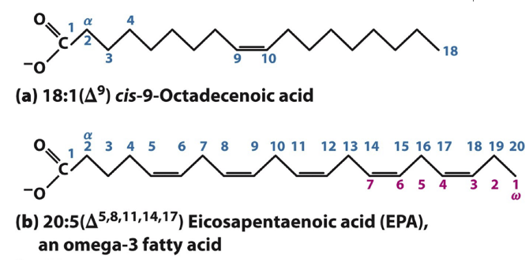
Know the structures of:
Palmitate | 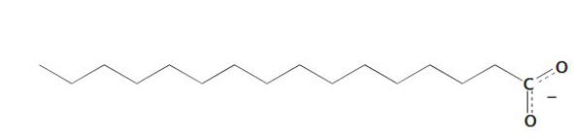
Stearate | 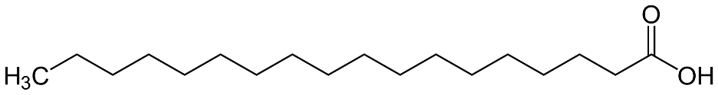
Arachidonate | 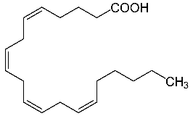
Palmitoleate | 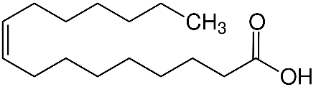

Lipid classes
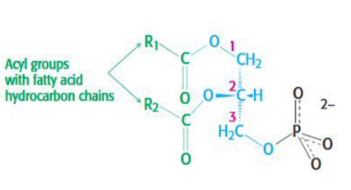
- Phospholipids
Structure: Glycerol + fatty acids + phosphate = phosphatidate + alcohol
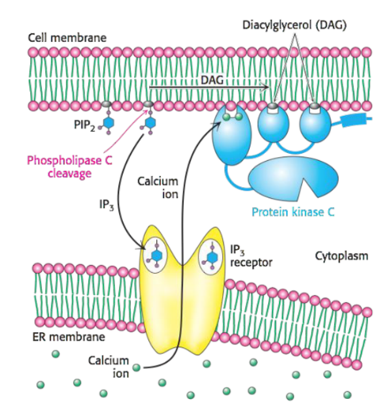
Alcohol examples: serine, inositol, choline, ethanolamine
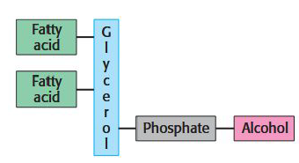
Phospholipase C can cleave PIP₂ (a Phospholipid) into two second messengers DAG and and IP3 to start a cascade.
- Sphingolipids
Key content of myelin shells of neuron.
Sphingosine = amino alcohol with a long carbohydrate chain
Structure = Sphingosine + fatty acid
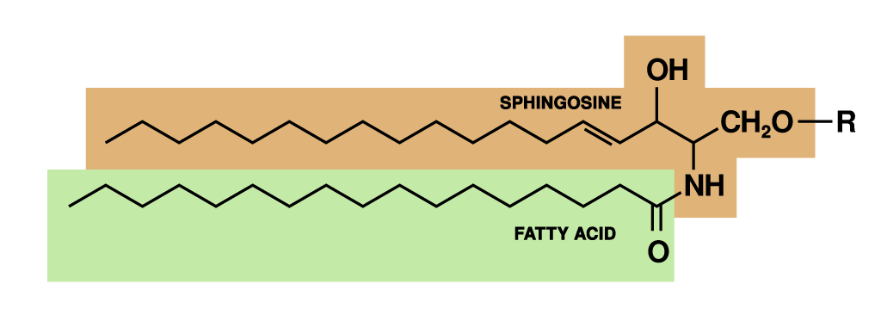
- Glycolipids = Sphingosine + fatty acid + sugar(s)
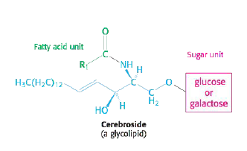
- Steroids (we just talked about Cholesterol)
Cholesterol
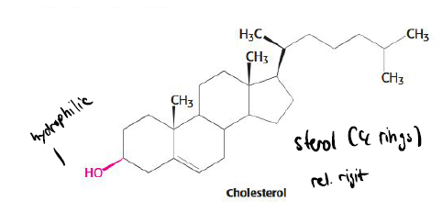
Structure:

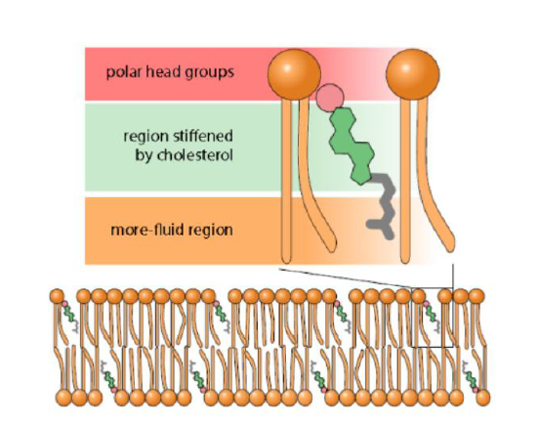
Role in membrane structure:
At high temperatures, cholesterol’s flat, rigid structure limits phospholipid movement
- decrease in fluidity.
At low temperatures disrupts lipid packing –
- increase in fluidity.

Membrane

Two fatty acid chains of a phospholipid are too bulky for the interior of a micelle. Therefore, they form into a lipid bilayer with the tails interacting with one another forming a hydrophobic interior that acts as a permeability barrier. The hydrophilic head interacts with the aqueous medium on each side of the layer. The growth of these bilayers is spontaneous and rapid, driven by hydrophobic interactions.
The Membrane does not only consist of lipids but also of integral and peripheral Proteins such as bacteriorhodopsin, porin and prostaglandin-H2-synthase.
Fluid mosaic model:
Membranes are two-dimensional solutions of oriented lipids and globular proteins. The lipid bilayer is therefore a solvent for integral Proteins and a permeability barrier. This enables Proteins and Lipids to diffuse lateral and transverse.
Soluble proteins can associate with membranes via hydrophobic groups in three possible ways:
(1) a palmitoyl group attached to a specific cysteine residue by a thioester bond (palmitoylation)
(2) a farnesyl group attached to a cysteine residue at the carboxyl terminus (prenylation)
(3) a glycolipid structure termed a glycosyl-phosphatidylinositol (GPI) anchor attached to the carboxyl terminus. (GPI-Iation)
Properties of membranes are fluidity, dynamic and the proteins and lipids it consists of. Unsaturated fatty acids increase the fluidity in the membrane.
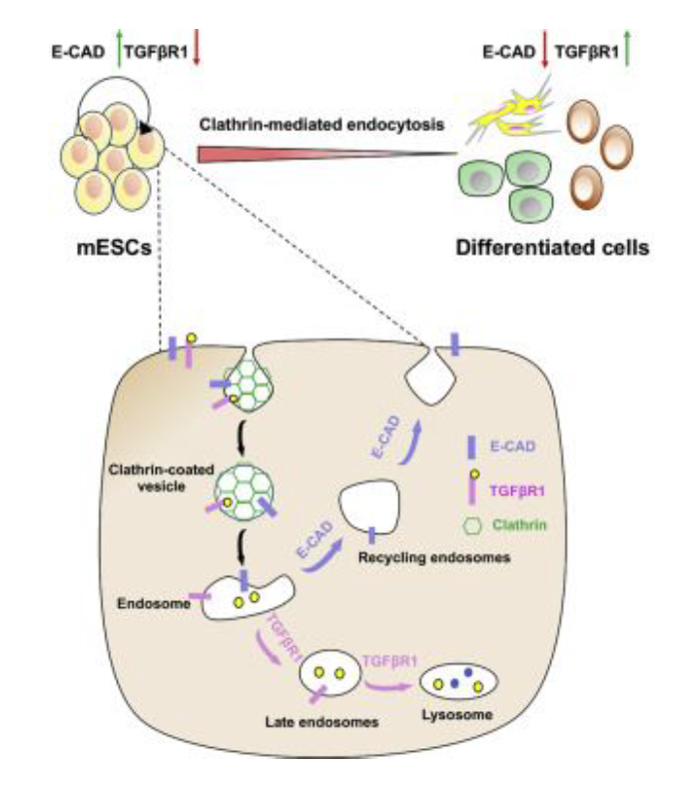
The permeability is dependent on the size and charge of a molecule. The membrane has a high permeability for small and neutral molecules, while it is low for ions and most polar molecules with a bigger size.

Endocytosis
A protein binds to a receptor on the cell surface. Specialized proteins act to cause the membrane to invaginate. One of these special proteins is called clathrin. Clathrin polymerizes into a lattice network around the growing hole, often called clathrin-coated pit. Eventually the invaginated membrane breaks off and fuses to form a vesicle. The vesicles fuse with the Endosome where it either will be recycled or send to a Lysosome.

Types of transport proteins

- Na-K ATPase pump
This pump maintains the resting potential and regulates transport and cellular volume.
- Carriers (e.g Na-Glucose symporter or Lactose permease)
Carriers mediate transport of ions and small molecules across the membrane without the consumption of ATP.
Lactose permease uses the H+ gradient across the membrane to drive the uptake of lactose against a concentration gradient. It is a secondary active transport.
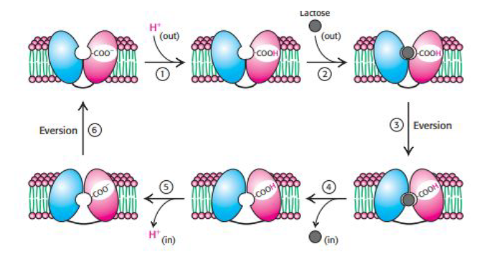
- Channels
Channels provide a membrane pore through which ions can pass without energy input.
Gap junction channels allow the flow of metabolites and ions between cells.
The selectivity of a Potassium channel is provided by a five-amino-acid stretch within the region of the pore. The conserved sequence is orientated in a way that it is in good position to interact with potassium ions. The energy needed to dehydrate potassium in the channel is compensated by the favorable interaction in the filter. The filter does not interact that well with sodium which is why it cannot be dehydrated and therefore not go through the channel.

Lecture 8: Signaling – Summary
- Cellular Signaling
  - The ability of a cell to receive, process, and transmit signals with its environment and with itself. Signals that originate from outside a cell (or extracellular signals) can be physical agents like mechanical pressure, temperature, light, or chemical signals (e.g., small molecules, gases).
  - Cell signaling can occur over short or long distances. Signaling molecules can be released via specialized transport or during cell damage
  - The downstream effects of signaling pathways include proteolytic cleavage, phosphorylation, and ubiquitylation
- Signaling molecules
  - Signaling molecules can belong to several chemical classes: lipids, phospholipids, amino acids, proteins, gases.
  - Signaling molecules binding surface receptors are generally hydrophilic (eg, epinephrine), while those entering the cell are generally hydrophobic (e.g. estrogen, thyroid hormones, retinoic acid).
  - In animal cells, specialized cells release these hormones and send them through the circulatory system to other parts of the body. They then reach target cells, which can recognize and respond to the hormones and produce a result. This is also known as endocrine signaling.
  - Release by exocytosis or reverse transport through membrane transport proteins
- Signal receptors
  - Receptors detect chemical signals or physical stimuli.
  - Cell surface receptors usually bind extracellular signals (ligands), which causes a conformational change in the receptor that alters enzymatic / ion channel activity. Some receptors do not contain enzymatic or channel-like domains but are instead linked to enzymes or transporters.
  - Other receptors (eg, nuclear hormone receptors) have a different mechanism such as changing their DNA binding properties and cellular localization to the nucleus.
  - Signal transduction - transformation of primary signal into different (chemical) species
  - Receptors may bind ligands or may sense physical agents like light and temperature. Reception occurs when the target cell (any cell with a receptor protein specific to the signal molecule) detects a signal, usually in the form of a small, water-soluble molecule, via binding to a receptor protein on the cell surface, or once inside the cell, the signaling molecule can bind to intracellular receptors, other elements, or stimulate enzyme activity (e.g. gasses), as in intracrine signaling.
  - Signaling molecules interact with a target cell as a ligand to cell surface receptors, and/or by entering into the cell through its membrane or endocytosis for intracrine signaling.
  - This results in generation of second messengers.

- Receptors
  - Major types: Ion channel linked receptors, G protein–coupled receptors (GPCR), and enzyme-linked receptors.
  - Ion channel linked receptors: ion-channels which allow ions to pass through the membrane in response to the binding of a ligand, such as a neurotransmitter.
  - GPCR: ligands can bind either to extracellular N-terminus and loops (e.g. glutamate receptors) or to the binding site within transmembrane helices (Rhodopsin-like family). cAMP signal pathway and phosphatidylinositol signal pathway.
  - Enzyme-linked receptors (or catalytic receptors) are transmembrane receptors that, upon activation by an extracellular ligand, causes enzymatic activity on the intracellular side.
- Intracellular receptors
  - Steroid hormone receptors are found in the nucleus, cytosol, and on the plasma membrane of target cells.
  - Cytoplasmic or nuclear and initiate signal transduction for steroid hormones which lead to changes in gene expression over a time period of hours to days.
  - In addition to nuclear receptors, several G protein-coupled receptors and ion channels act as cell surface receptors for certain steroid hormones.
- Steps in signal transduction
  - 1. Release of the Primary Messenger: A stimulus such as a wound or digested meal triggers the release of the signal molecule, also called the primary messenger.
  - 2. Reception of the Primary Messenger: Most signal molecules do not enter cells. Instead, proteins in the cell membrane act as receptors that bind the signal molecules and transfer the information that the molecule has bound from the environment to the cell's interior. Receptors span the cell membrane and thus have both extracellular and intracellular components. A binding site on the extracellular side specifically the ligand. Such binding sites are analogous to enzyme active sites except that no catalysis takes place within them. The interaction of the ligand and the receptor alters receptor structure so as to induce a structural change on the intracellular side.
  - 3. Delivery of the Message Inside the Cell by the Second Messenger: Other small molecules, called second messengers, are used to relay information from receptor-ligand complexes. Second messengers are intracellular molecules that change in concentration in response to environmental signals and mediate the next step in the molecular information circuit. Some particularly important second messengers are cyclic AMP (cAMP) and GMP (cGMP), calcium, inositol 1,4,5-trisphosphate (IP3), and diacylglycerol (DAG). The use of second messengers has several consequences:
    - Signal amplification
    - Second messengers can diffuse throughout the cell
    - Common second messengers in multiple signaling pathways - opportunities and problems.
  - 4. Activation of Effectors That Directly Alter the Physiological Response: The ultimate effect of the signal pathway is to activate or inhibit pumps, channels, enzymes, and transcription factors that directly control metabolic pathways, gene expression, and the permeability of membranes to specific ions.
  - 5. Termination of the Signal: After a cell has completed its response to a signal, the signaling process must be terminated or the cell loses its responsiveness to new signals. Moreover, signaling processes that fail to terminate properly can have highly undesirable consequences. As we will see, many cancers are associated with signal-transduction processes that are not properly terminated, especially processes that control cell growth.
- Epinephrine receptor
  - Epinephrine = A hormone secreted by the adrenal glands of mammals in response to internal and external stressors. “Fight or flight” response - rapid muscular activity (eg, acceleration of heart rate), dilation of the airways, the breakdown of glycogen and fatty acids
  - The conformational change in the β-AR receptor activates a G protein. The activated G protein stimulates the activity of adenylate cyclase, an enzyme that catalyzes the conversion of ATP into cAMP. The G protein and adenylate cyclase remain attached to the membrane, whereas cAMP can travel throughout the cell.
  - In its inactive state, the G protein bound to GDP is a heterotrimer consisting of α, β, and ɣ subunits; the α subunit (Gα) binds the nucleotide. The a and g subunits are usually anchored to the membrane by covalently attached fatty acids.
- PKA activation by cAMP
  - adenylate cyclase, the enzyme that converts ATP into cAMP
  - the net result is that the binding of epinephrine to the receptor on the cell surface increases the rate of cAMP production inside the cell.
  - Activation mechanism:
    - Many effects of cAMP in eukaryotic cells are mediated by the activation of the protein kinase A (PKA).
    - PKA two regulatory (R) chains and two catalytic (C) chains. In the absence of cAMP, the R2C2 complex is catalytically inactive. The binding of cAMP to the regulatory chains releases the catalytic chains, which are active on their own.
    - Activated PKA then phosphorylates specific serine and threonine residues in many targets to alter their activity. For instance, PKA phosphorylates enzymes that lead to the breakdown of glycogen, the polymeric store of glucose, and the inhibition of further glycogen synthesis
- Signal termination: GTPase activity of G proteins and beta-arrestin
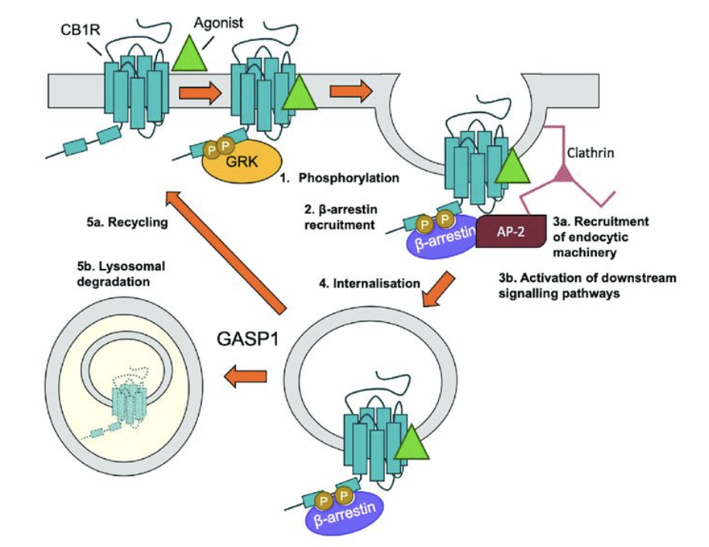

- Phosphodiesterase
  - The cyclic nucleotide phosphodiesterases comprise a group of enzymes that degrade the phosphodiester bond in the second messenger molecules cAMP and cGMP.
  - PDEs regulate the localization, duration, and amplitude of cyclic nucleotide signaling within subcellular domains.
  - PDEs are important regulators of signal transduction mediated by these second messenger molecules.
- Phosphoinositide cascade
  - The intracellular messengers arise from the cleavage of phosphatidylinositol 4,5-bisphosphate (PIP2).
  - Primary messenger - hormone angiotensin II, a peptide hormone that controls blood pressure.
  - Angiotensin II receptor activates a G protein called Gaq. In its GTP-form, Gaq binds to and activates the phospholipase C.
  - This enzyme catalyzes the cleavage of PIP2 into the two second messengers inositol 1,4,5-trisphosphate (IP3) and diacylglycerol (DAG).
  - IP3 causes the rapid release of Ca2+ from the intracellular stores in the endoplasmic reticulum (ER), which accumulates Ca2+ through the action of Ca2+ ATPase.
  - IP3-gated Ca-channel proteins in the ER membrane open to allow calcium ions to flow from the ER into the cytoplasm. Ca2+ is itself a signaling molecule: it can bind calmodulin and protein kinase C to trigger smooth-muscle contraction, glycogen breakdown, and vesicle release.
  - DAG activates protein kinase PKC. The DAG-binding domains of this kinase requires calcium. Diacylglycerol and IP3 work in tandem: IP3 increases the Ca2+ concentration, and Ca2+ facilitates the DAG-mediated activation of protein kinase C. Both IP3 and DAG act transiently because they are converted into other species by phosphorylation or other processes.
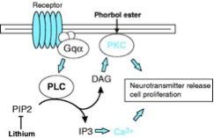

- Ca2+ as a second messenger
  - Calcium levels are kept low by transport systems that extrude Ca2+ from the cytoplasm
  - Ca2+ can bind to proteins and induce structural rearrangements
- Calmodulin is a calcium sensor
  - Calmodulin (CaM): four Ca2+-binding sites, serves as a calcium sensor in nearly all eukaryotic cells. At concentrations above about 500 nM, Ca2 binds to and activates calmodulin. A protein of EF hand family
  - The EF hand is Ca2+-binding helix-loop-helix motif. Seven oxygen atoms are coordinated to each Ca2+, six from the protein and one from a bound water molecule. Calmodulin is made up of four EF-hand motifs, each of which can bind a single Ca2+ ion.
  - The binding of Ca2+ to calmodulin exposes hydrophobic surfaces that can bind other proteins. EF hands of calmodulin clamp around alpha helices with hydrophobic and charged groups. The Ca2-calmodulin complex stimulates a wide variety of enzymes, pumps, and other target proteins by inducing structural rearrangements in these binding partners.
  - Calmodulin-dependent protein kinases (CaM kinases) phosphorylate many different proteins and regulate fuel metabolism, ionic permeability, neurotransmitter synthesis and neurotransmitter release
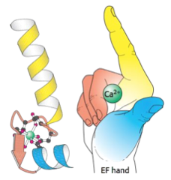

- Insulin receptor signaling
  - Insulin is a peptide hormone - two chains, linked by three disulfide bonds. Insulin receptor is a dimer of two identical units. Each unit consists of one ɑ chain and one β chain linked by a disulfide bond. Each alpha subunit lies completely outside the cell, whereas each beta subunit lies primarily inside the cell, spanning the membrane with a single transmembrane segment. The two a subunits form a binding site for a single insulin molecule.
  - Each β subunit includes a tyrosine kinase domain. (so insulin receptor is a receptor tyrosine kinase). The insulin receptor kinase is in an inactive conformation when the domain is not covalently modified. The kinase is rendered inactive by the position of an unstructured loop (called the activation loop) that lies in the center of the structure.
  - When the two alpha subunits move together to surround an insulin molecule, the activation loop of one kinase subunit fits into the active site of the other kinase subunit within the dimer.
  - With the two beta subunits forced together, the kinase domains catalyze the addition of phosphoryl groups from ATP to tyrosine residues in the activation loops. When these tyrosine residues are phosphorylated, a conformational change takes place.
  - The rearrangement of the activation loop converts the kinase into an active conformation.
  - Insulin binding on the outside of the cell results in the activation of a membrane-associated kinase within the cell.
  - On phosphorylation, the IR tyrosine kinase is activated and autophosphorylated - these pTyr sites act as docking sites for insulin-receptor substrates (IRS). The amino-terminal part of IRS includes a pleckstrin homology domain, which binds phosphoinositide, and a pTyr-binding domain.
  - These domains anchor the IRS protein to the insulin receptor and the associated membrane. Each IRS protein contains four Tyr-X-X-Met sequences - substrates for the activated insulin-receptor kinase.
  - When the tyrosine residues within these sequences are phosphorylated to become pTyr, IRS molecules act as adaptor proteins to tether the downstream components of this signaling pathway to the membrane.
  - Phosphotyrosine residues in the IRS proteins, are recognized by Src homology 2 (SH2) domains.
  - Phosphoinositide 3-kinase (PI3Ks), that adds a phosphoryl group to the 3-position of inositol in phosphatidylinositol 4,5-bisphosphate (PIP2).
  - Through SH2 domains PI3K binds to IRS at the membrane where it phosphorylates PIP2 to form phosphatidylinositol 3,4,5-trisphosphate (PIP3). PIP3, in turn, activates a protein kinase, PDK1, pleckstrin homology domain present in this kinase that is specific for PIP3. The activated PDK1 phosphorylates and activates Akt, another protein kinase. Akt is not membrane anchored and moves through the cell to phosphorylate targets that include components that control the trafficking of the glucose receptor GLUT4 to the cell surface as well as enzymes that stimulate glycogen synthesis.
  - Insulin signaling termination
    - Three classes of enzymes shut off the pathway:
    - 1) Tyrosine phosphatases that remove phosphoryl groups from tyrosine residues on the insulin receptor and the IRS adaptor proteins
    - 2) Lipid phosphatases that hydrolyze PIP3 to PIP2
    - 3) Serine phosphatases that remove phosphoryl groups from activated protein kinases such as Akt.
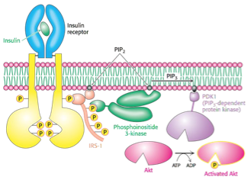

- EGF receptor signaling
  - This pathway is activated by epidermal growth factor (EGF) - a 6-kd polypeptide that stimulates the growth of epidermal and epithelial cells.
  - The EGF receptor (EGFR) is a dimer of two subunits. Each subunit contains an intracellular protein tyrosine kinase domain that participates in cross-phosphorylation reactions.
  - The EGFR subunits are monomers until they bind EGF. Each EGFR monomer binds a single molecule of EGF by its extracellular domain.
  - EGF molecule lies far away from the dimer interface. This interface includes the dimerization arm from each monomer that reaches out and inserts into a binding pocket on the other monomer.
  - Why doesn’t the receptor dimerize and signal in the absence of EGF?
    - Each EGFR monomer is in a conformation that is quite different from that observed in the ligand- bound dimer. In particular, the dimerization arm binds to a domain within the same monomer that holds the receptor in a closed configuration. In essence, the contact between the interaction loop and another part of the structure, ready to bind ligand and change into a conformation active for dimerization and signaling.
- Targeting EGFR signaling in cancer
  - Therapeutic targeting of EGFR - monoclonal antibodies to the extracellular domain of the receptor.
  - Cetuximab competes with EGF for binding to EGFR. Because the antibody sterically blocks the change in conformation that exposes the dimerization arm, the antibody itself cannot induce dimerization. The result is that the EGFR-controlled pathway is not initiated.
  - Trastuzumab (Herceptin) inhibits another EGFR family member - Her2 - that is overexpressed in ca. 30% of breast cancers.
- Apoptotic signaling
  - Two pathways: intrinsic pathway - cell senses cell stress; extrinsic pathway - signals from other cells.
  - The intrinsic pathway depends on the release of proteins from the intermembrane space of mitochondria.
  - The extrinsic pathway is activated by extracellular ligands binding to cell-surface death receptors, which leads to the formation of the death-inducing signaling complex (DISC).
  - Heat, radiation, nutrient deprivation, viral infection, hypoxia, can trigger the release of intracellular apoptotic signals by a damaged cell.
  - Intrinsic pathway
    - Apoptotic proteins cause mitochondrial swelling through the formation of membrane pores. They may also increase the permeability of the mitochondrial membrane and cause apoptotic effectors to leak out.
    - Cytochrome c is released from mitochondria through Bax/Bak heterodimers inserted into the outer membrane. Cytochrome c binds apoptotic protease activating factor (Apaf-1), ATP and pro-caspase-9 to create a protein complex known as an apoptosome. The apoptosome cleaves the pro-caspase to its active form of caspase-9, which in turn cleaves and activates pro-caspase into the effector caspase-3.
    - Mitochondria also release SMAC proteins that inactivate IAP proteins that suppress the activity of caspases.
  - Extrinsic pathway
    - TNF receptor (TNFR) coupled to extrinsic signals. TNF-alpha is a cytokine produced by activated macrophages. The binding of TNF-alpha to TNFR initiates caspase activation via the intermediate membrane proteins TNF receptor-associated death domain (TRADD) and Fas-associated death domain protein (FADD).
    - The Fas receptor is a transmembrane protein of the TNF family which binds the Fas ligand (FasL). The interaction between Fas and FasL results in the formation of the death-inducing signaling complex (DISC), which contains FADD, caspase-8 and caspase-10. Processed caspase-8 directly activates other members of the caspase family, and triggers the execution of apoptosis of the cell.
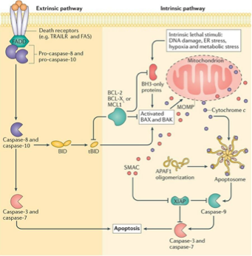
- Caspase activation
  - Initiator Caspases (Caspase 2, Caspase 8, Caspase 9, Caspase 10); Executioner Caspases (Caspase 3, Caspase 6 and Caspase 7).. Executioner caspases degrade over 600 cellular components.
  - Intrinsic pathway: During times of cellular stress, mitochondrial cytochrome c is released into the cytosol. This molecule binds an adaptor protein (APAF-1), which recruits initiator Caspase-9 - formation of a caspase activating complex Apoptosome. Activated initiator caspases cleave and activate executioner caspases.
  - Extrinsic pathway: The caspase cascade is activated by extracellular ligands via cell surface Death Receptors: formation of a multiprotein Death Inducing Signalling Complex (DISC) that recruits and activates a pro-caspase.

VL9 Carbohydrates
C_{n}H_{2n}0_{n}. Bei einer Hexose mit 6 C-Atomen wäre die Summenformel entsprechend C₆(H₂0)₆.
- Carbohydrates are carbon-based molecules rich in hydroxyl groups. The formula for many carbohydrates is (CH2O)n - a carbon hydrate.
- Simple carbohydrates - monosaccharides - fuel molecules and building blocks for macromolecules - DNA, RNA.
- Monosaccharides are aldehydes or ketones that have two or more hydroxyl groups. The smallest monosaccharides, composed of three carbon atoms, are dihydroxyacetone and Dand L-glyceraldehyde.
- Dihydroxyacetone - ketose - contains a keto group
- glyceraldehyde - aldose - contains an aldehyde group
- monosaccharides with 3, 4, 5, 6 carbon atoms are called treose, tetrose, pentose, hexoses

Monosaccharide isomers
Monosaccharide sind die kleinsten Zuckereinheiten und damit die Grundbausteine der Kohlenhydrate. Wenn sich Monosaccharide über glykosidische Bindungen miteinander verknüpfen, dann können sie Disaccharide und Polysaccharide bilden. Die allgemeine Summenformel für Monosaccharide lautet Cn(H2O)n, wobei sie aus einer Kohlenstoffkette, einer Carbonylgruppe und mindestens einer Hydroxygruppe bestehen.
Sind an einem Kohlenstoff-Atom vier unterschiedliche SubstituentenLex (gemeint ist immer der ganze Rest!) gebunden, so nennt man dieses Kohlenstoff-Atom auch "asymmetrisches Kohlenstoff-Atom", welches mit einem Sternchen gekennzeichnet wird. In so einem Fall gibt es verschiedene Isomere, die sich wie Bild und Spiegelbild verhalten. Daher spricht man auch von Stereoisomeren. Sie lassen sich durch keine Drehung zur Deckung bringen. Solche "Spiegelbild-Moleküle" nennt man auch Enantiomere.
Diastereomere sind Stereoisomere (chemische Verbindungen gleicher Konstitution aber unterschiedlicher Konfiguration), welche sich – im Gegensatz zu Enantiomeren – nicht wie Bild und Spiegelbild verhalten. Diastereomere können sowohl chiral als auch achiral sein. Sie unterscheiden sich in allen physikalischen (Schmelzpunkt, Löslichkeit usw.) und chemischen Eigenschaften voneinander.
Anomere sind bei den Strukturen von Kohlenhydraten eine besondere Art von Isomeren, die sich nur in der Konfiguration am anomeren Zentrum unterscheiden. Anomere treten bei Kohlenhydraten und analogen Verbindungen in der zyklischen Form auf.

- Dihydroxyacetone and glyceraldehyde are constitutional isomers - identical molecular formulas but differ in how the atoms are ordered. Stereoisomers are isomers that differ in spatial arrangement. stereoisomers are designated as having either D or L configuration.
- Glyceraldehyde has a single asymmetric carbon atom and, thus, there are two stereoisomers of this sugar: D-glyceraldehyde and L-glyceraldehyde - enantiomers -mirror images of each other. Most vertebrate monosaccharides have the D configuration. D and L isomers are determined by the configuration of the asymmetric carbon atom from the aldehyde or keto group.
- Dihydroxyacetone is the only monosaccharide without at least one asymmetric carbon atom.
- Monosaccharides made up of more than three carbon atoms have multiple asymmetric carbons and can exist also as diastereoisomers, isomers that are not mirror images of each other. The number of possible stereoisomers equals 2^n, where n is the number of asymmetric carbon atoms. Thus, a six-carbon aldose with 4 asymmetric carbon atoms can exist in 16 possible diastereoisomers, of which glucose is one such isomer.
- Sugars that are diastereoisomers differing in configuration at only a single asymmetric center are called epimers. D-glucose and D-mannose are epimeric at C-2; D-glucose and D-galactose are epimeric at C-4. Note that ketoses have one less asymmetric center than aldoses with the same number of carbon atoms.

Common monosaccharides
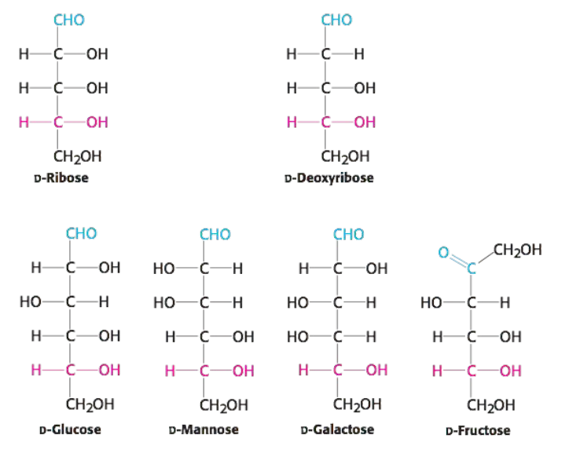

Ring form of monosaccharides
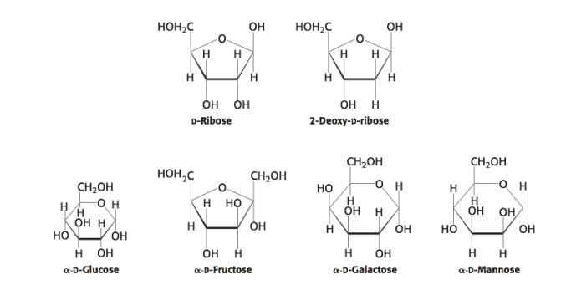

Hemiketal, hemiacetal

The open-chain forms of these sugars cyclize into rings.
The chemical basis for ring formation is that an aldehyde can react with an alcohol to form a hemiacetal.
In glucose, a single molecule provides both the aldehyde and the alcohol: the C-1 aldehyde in the open-chain form of glucose reacts with the C-5 hydroxyl group to form an intramolecular hemiacetal.
The resulting cyclic hemiacetal six-membered ring is called pyranose because of its similarity to pyran.
A ketone can react with an alcohol to form a hemiketal.
The C-2 keto group in the open-chain form of a ketohexose, such as fructose, can form an intramolecular hemiketal by reacting with either the C-6 hydroxyl group to form a six-membered cyclic hemiketal or the C-5 hydroxyl group to form a five-membered cyclic hemiketal.
The five-membered ring is called a furanose because of its similarity to furan.
In Haworth projections, the carbon atoms in the ring are not written out. The approximate plane of the ring is perpendicular to the plane of the paper, with the heavy line on the ring projecting toward the reader.

Glycosidic bond

Eine glykosidische Bindung verknüpft das anomere Kohlenstoffatom eines Kohlenhydrats mit einer weiteren chemischen Gruppe. Neben O-glykosidischen Bindungen (z. B. Di- und Polysaccharide) gibt es auch N-glykosidische Bindungen (z. B. im ATP-Molekül).
Als Stereodeskriptoren der Anomere werden die griechischen Buchstaben α (alpha) und β (beta) verwendet. Unter Anwendung der R,S-Nomenklatur (CIP-Nomenklatur) gilt:
* α-Form: S-Konfiguration am anomeren C-Atom.
* β-Form: R-Konfiguration am anomeren C-Atom.
In der Haworth-Projektion des entsprechenden Zuckers weist die OH-Gruppe am anomeren Kohlenstoff beim α-Anomer nach unten und beim β-Anomer nach oben
The biochemical properties of monosaccharides can be modified by reaction with other molecules. Three common reactants are alcohols, amines, and phosphates.
A bond formed between the anomeric carbon atom of glucose and the oxygen atom of an alcohol is O-glycosidic bond. O-Glycosidic bonds are prominent when carbohydrates are linked together to form long polymers and when they are attached to proteins.
The anomeric carbon atom of a sugar can be linked to the nitrogen atom of an amine - N-glycosidic bond, such as when nitrogenous bases are attached to ribose units to form nucleosides

Glucose is a reducing sugar

- Because the a and b isomers of glucose are in an equilibrium that passes through the open-chain form, glucose has some of the chemical properties of free aldehydes, such as the ability to react with oxidizing agents. For example, glucose can react with cupric ion (Cu2+), reducing it to cuprous ion (Cu+), while being oxidized to gluconic acid.
- Solutions of cupric ion (Fehling’s solution) provide a simplest for the presence of sugars such as glucose. Sugars that react are called reducing sugars vs. nonreducing sugars. Reducing sugars can often nonspecifically react with other molecules. For instance, as a reducing sugar, glucose can react with hemoglobin to form glycosylated hemoglobin.

Disaccharides

- A disaccharide consists of two sugars joined by an O-glycosidic bond. Three abundant disaccharides that we encounter frequently are sucrose, lactose, and maltose.
- The anomeric carbon atoms of a glucose unit and a fructose unit are joined in sucrose; the configuration of this glycosidic linkage is a for glucose and b for fructose. Sucrose can be cleaved into its component monosaccharides by the enzyme sucrase. Lactose consists of galactose joined to glucose by a b-1,4-glycosidic linkage.
- Lactose is hydrolyzed to these monosaccharides by lactase in humans and by -galactosidase in bacteria. In maltose, two glucose units are joined by an a-1,4-glycosidic linkage - comes from starch and glycogen and is in turn hydrolyzed to glucose by maltase

Glucose Polymers

Glucose is an important energy source in virtually all life forms. However, free glucose molecules cannot be stored because in high concentrations, glucose disturbs the osmotic balance of the cell. The solution is to store glucose as units in a large polymer, which is not osmotically active.
Large polymeric oligosaccharides, formed by the linkage of multiple monosaccharides, are called polysaccharides and play vital roles in energy storage and in maintaining the structural integrity of an organism.
Homopolymer - all of the monosaccharide units in a polysaccharide are the same. The most common homopolymer in animal cells is glycogen, the storage form of glucose.

Das Glykogen (auch Glycogen, tierische Stärke oder Leberstärke) ist ein verzweigtes Polysaccharid (Vielfachzucker), das aus Glucose-Einheiten aufgebaut ist. Glykogen dient der kurz- bis mittelfristigen Speicherung und Bereitstellung des Energieträgers Glucose im menschlichen und tierischen Organismus

Aminozucker sind Einfachzucker (Monosaccharide), bei denen eine oder mehrere Hydroxylgruppen (–OH) durch eine Aminogruppe (–NH₂) ersetzt wurden. Freie Aminozucker sind stark basisch und kommen in der Natur nicht vor; die Monosaccharide sind immer Bestandteile von Glykosiden und polymeren Stoffen. Als Bausteine verschiedenster, häufig essentieller Biomoleküle sind sie für viele zentrale chemische Vorgänge und molekulare Strukturen in der Natur grundlegend.

Starch: amylose and amylopectin

- Most of the glucose units in glycogen are linked by a-1,4-glycosidic bonds. The branches are formed by a-1,6-glycosidic bonds, present about once in 10 units.
- The nutritional reservoir in plants is the homopolymer starch, of which there are two forms. Amylose, the unbranched type of starch, consists of glucose residues in a-1,4 linkage. Amylopectin, the branched form, has about 1 a-1,6 linkage per 30 a-1,4 linkages, in similar fashion to glycogen except for its lower degree of branching.
- More than half the carbohydrate ingested by human beings is starch found in wheat, potatoes and rice. Amylopectin, amylose, and glycogen are rapidly hydrolyzed by a-amylase, an enzyme secreted by the salivary glands and the pancreas.

Cellulose

Cellulose, the other major polysaccharide of glucose found in plants, serves a structural rather than a nutritional role as an important component of the plant cell wall.
Cellulose is an unbranched polymer of glucose residues joined by b-1,4 linkages, in contrast with the a-1,4 linkage seen in starch and glycogen. The b configuration allows cellulose to form very long, straight chains. Fibrils are formed by parallel chains that interact with one another through hydrogen bonds, generating a rigid, supportive structure.
The a-1,4 linkages in glycogen and starch produce a very different molecular architecture: a hollow helix is formed instead of a straight chain. The hollow helix formed by a linkages is well suited to the formation of a more-compact, accessible store of sugar.

Glycoproteins

1 Definition
Unter Glykoproteinen versteht man Proteine, die zusätzlich meist verzweigte Heteroglykanreste enthalten. Sie setzen sich häufig aus den Monosacchariden Glukose, Mannose, Fructose sowie acetylierten Aminozuckern zusammen.

2 Hintergrund
Glykoproteine sind außerordentlich häufig. Praktisch alle extrazellulären löslichen Proteine und Enzyme weisen Zuckerreste auf. Die Verknüpfung der Zucker und des Proteins erfolgt über glykosidische Bindungen an den Aminosäuren Serin (o-glykosidisch) oder Asparagin (n-glykosidisch).
All N-linked oligosaccharides have in common a pentasaccharide core consisting of three mannose and two N-acetylglucosamine residues.
Glykoproteinhormone haben pleiotrope Wirkungen auf eine Vielzahl an Organsystemen. Beispiele sind Thyreoidea-stimulierendes Hormon (TSH), Follikelstimulierendes Hormon (FSH), Luteinisierendes Hormon (LH) und Humanes Choriongonadotropin (HCG).
Einige Blutgruppensysteme basieren auf Polymorphismen von Glykoproteinen auf der Zellmembran. Die Thrombozytenglykoproteine - wie zum Beispiel Glykoprotein IIb/IIIa - sind Rezeptoren, die die Funktion der Thrombozyten steuern. Der Begriff Glykoprotein ist hier auch Bestandteil der Nomenklatur.

3 Funktion
Glykoproteine können zahlreiche Funktionen im Organismus übernehmen. Als Bestandteile der Zellmembran haben Glykoproteine vor allem Rezeptor-, Transport- oder stabilisierende Funktionen. Außerdem bilden sie zusammen mit Glykolipiden die Glykokalyx, die bei Zellen ohne Zellwand zusammen mit dem Zytoskelett für Stabilität sorgt

Glycoproteins: erythropoietin

- The glycoprotein hormone erythropoietin (EPO) is secreted by the kidneys and stimulates the production of red blood cells (erythrocytes).
- EPO is composed of 165 amino acids and is N -glycosylated at three asparagine residues and O-glycosylated on a serine residue. The mature EPO is 40% carbohydrate by weight, and glycosylation enhances the stability of the protein in the blood. Unglycosylated protein has only about 10% of the bioactivity of the glycosylated form because the protein is rapidly removed from the blood by the kidneys.
- Recombinant human EPO is used in the treatment of anemias. However, some athletes have used recombinant human EPO to increase the red-blood-cell count and hence their oxygen-carrying capacity.

Proteoglycans
Proteoglykane sind ein Hauptbestandteil der tierischen extrazellulären Matrix, die die Stabilisierung zwischen den Zellen eines Organismus bewerkstelligen. Hier bilden sie große Komplexe, sowohl zu anderen Proteoglykanen, als auch zu Hyaluronsäure, sowie zu Faserproteinen wie Kollagen. Sie sind außerdem an der Bindung von Kationen beteiligt und regulieren die Bewegung von Molekülen durch die Matrix. Es gibt Hinweise darauf dass sie die Aktivität und Stabilität von Proteinen und Signalmolekülen innerhalb der Matrix beeinflussen können. Die Funktion des Proteoglykans kann teilweise dem Proteinkern oder der befestigten GAG Kette zugeschrieben werden.
Hyaluronsäure (Hyaluronan) ist ein Polysaccharid, genauer gesagt ein Glykosaminoglykan, das bei fast allen Wirbeltieren ein wesentlicher Bestandteil der extrazellulären Matrix ist

Protein glycosylation in ER

- Glycosylation takes place inside the lumen of the endoplasmic reticulum (ER) and in the Golgi complex. The protein is synthesized by ribosomes attached to the cytoplasmic face of the ER membrane, and the peptide chain is inserted into the lumen of the ER.
- The N-linked glycosylation begins in the ER and continues in the Golgi complex, whereas the O-linked glycosylation takes place exclusively in the Golgi complex.
- A large oligosaccharide destined for attachment to the asparagine residue of a protein is assembled on dolichol phosphate, a specialized lipid molecule located in the ER membrane and containing about 20 isoprene (C5) units.

Glycosyltransferase
- Complex carbohydrates are synthesized by glycosyltransferases, which catalyze the formation of glycosidic bonds. Highly diverse family of enzymes - account for 1% to 2% of gene products in all organisms examined.
- These reactions are catalyzed by a glycosyltransferase. The sugar to be added comes in the form of an activated (energy-rich) sugar nucleotide, such as UDP-glucose.

Glycolysis

- Glycolysis is the sequence of reactions that metabolizes one molecule of glucose to two molecules of pyruvate with the concomitant net production of two molecules of ATP.
- Glycolysis is anaerobic (does not require O2) because it evolved before substantial amounts of oxygen accumulated in the atmosphere. Pyruvate can be further processed anaerobically to lactate (lactic acid fermentation) or ethanol (alcoholic fermentation). Under aerobic conditions, pyruvate can be completely oxidized to CO2.
- Because glucose is such a precious fuel, metabolic products, such as pyruvate and lactate, are salvaged to synthesize glucose in the process of gluconeogenesis. Although glycolysis and gluconeogenesis have some enzymes in common, the two pathways are not simply the reverse of each other.
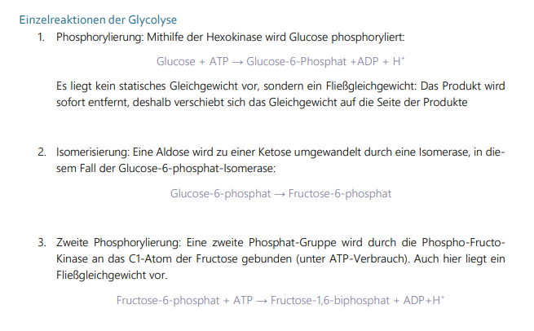
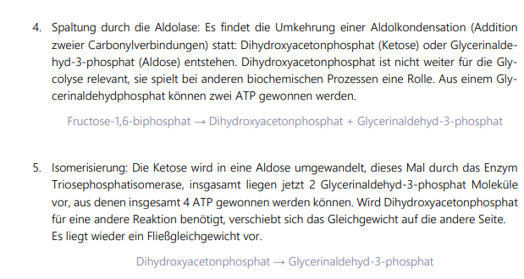
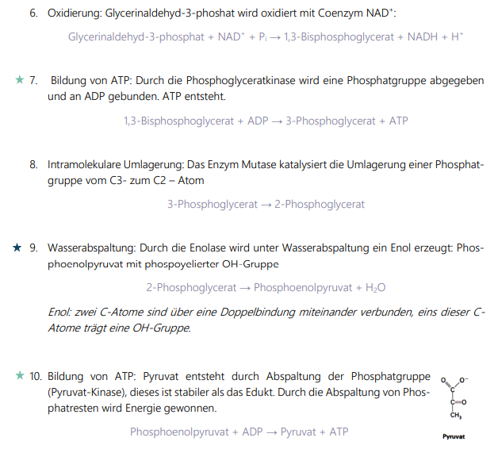
Die drei irreversiblen Reaktionen der Glykolyse sind:
• Hexokinase: Glucose zu Glucose-6-Phosphat
• Phosphofructokinase: Fructose-6-Phosphat zu Fructose-1,6-Bisphosphat
• Pyruvatkinase: Phosphoenolpyruvat zu Pyruvat.
Diese drei Reaktionen müssen in der Gluconeogenese umgangen werden.
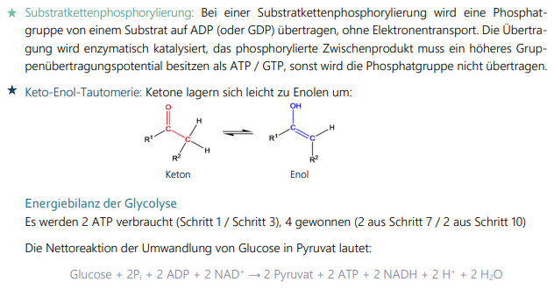
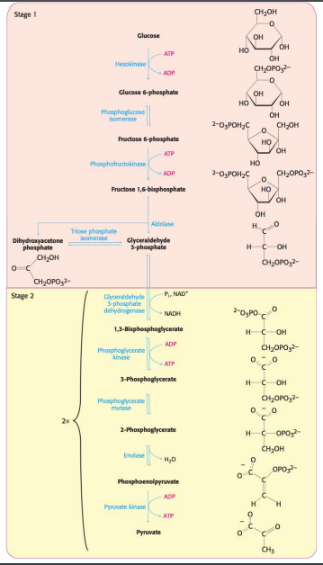
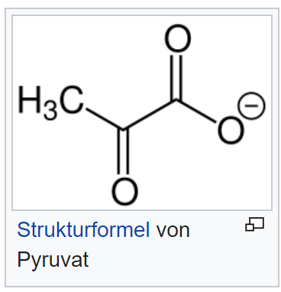
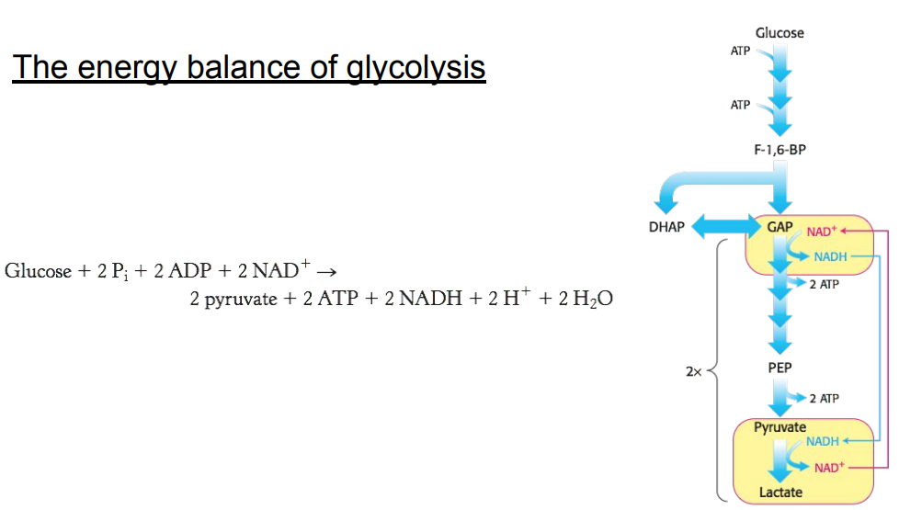

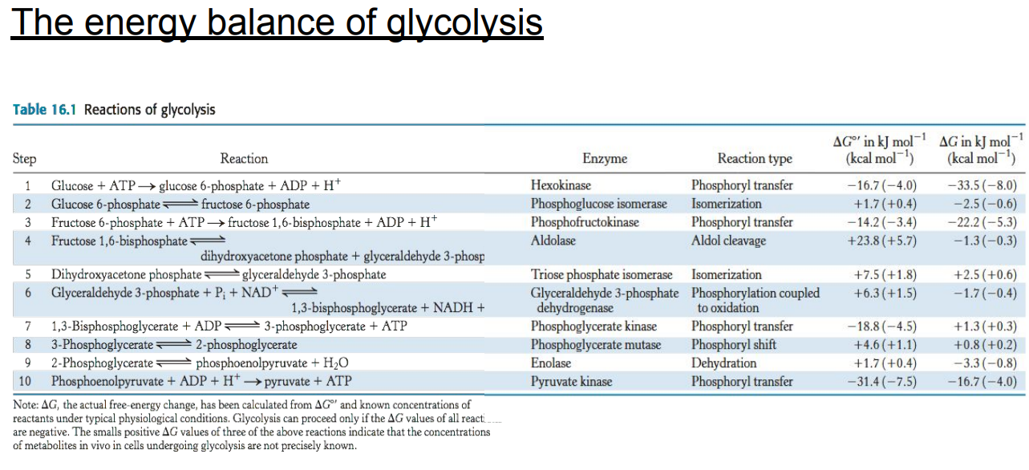

NADH regeneration

- The conversion of glucose into two molecules of pyruvate has resulted in the net synthesis of ATP. However, an energy-converting pathway that stops at pyruvate will not proceed for long, because redox balance has not been maintained.
- The activity of glyceraldehyde 3-phosphate dehydrogenase, in addition to generating a compound with high phosphoryl-transfer potential leads to the reduction of NAD+ to NADH.
- In the cell, there are limited amounts of NAD+, which is derived from the vitamin niacin. Consequently, NAD+ must be regenerated for glycolysis to proceed. The final process in the pathway is the regeneration of NAD+ through the metabolism of pyruvate.

Alcoholic fermentation

- Ethanol is formed from pyruvate in yeast. The first step is the decarboxylation of pyruvate. This reaction is catalyzed by pyruvate decarboxylase, which requires the coenzyme thiamine pyrophosphate, derived from the vitamin thiamine (B1). The second step is the reduction of acetaldehyde to ethanol by NADH, in a reaction catalyzed by alcohol dehydrogenase. This process regenerates NAD+.
- The active site of alcohol dehydrogenase contains a zinc ion that is coordinated to the sulfur atoms of two cysteine residues and a nitrogen atom of histidine. This zinc ion polarizes the carbonyl group of the substrate to favor the transfer of a hydride from NADH.
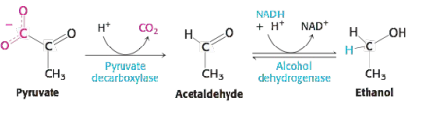

Lactate fermentation

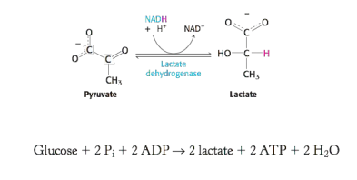

Regulation of glycolysis

Phosphofructokinase

- is the most important control site in the glycolysis. High levels of ATP allosterically inhibit the enzyme (a 340-kd tetramer). ATP binds to a specific regulatory site that is distinct from the catalytic site. The binding of ATP lowers the enzyme’s affinity for fructose 6-phosphate.
- A high concentration of ATP converts the hyperbolic binding curve of fructose 6-phosphate into sigmoidal. AMP reverses the inhibitory action of ATP, and so the activity of the enzyme increases when the ATP/AMP ratio is lowered. In other words, glycolysis is stimulated as the energy charge falls.
- AMP is a more sensitive activator than ADP

Hexokinase

- is inhibited by its product, glucose 6-phosphate. High concentrations of this molecule signal that the cell no longer requires glucose for energy or for the synthesis of glycogen, a storage form of glucose, and the glucose will be left in the blood. A rise in glucose 6-phosphate concentration is a means by which phosphofructokinase communicates with hexokinase. When phosphofructokinase is inactive, the concentration of fructose 6-phosphate rises. In turn, the level of glucose 6-phosphate rises because it is in equilibrium with fructose 6-phosphate. Hence, the inhibition of phosphofructokinase leads to the inhibition of hexokinase.
- The first irreversible reaction unique to the glycolytic pathway is the phosphorylation of fructose 6-phosphate to fructose 1,6-bisphosphate.

Pyruvate kinase

- the enzyme catalyzing the third irreversible step in glycolysis, controls the outflow from this pathway. This final step yields ATP and pyruvate, a central metabolic intermediate that can be oxidized further or used as a building block.

- ATP allosterically inhibits pyruvate kinase to slow glycolysis when the energy charge is high.

- Alanine (synthesized in one step from pyruvate) also allosterically inhibits pyruvate kinase - in this case, to signal that building blocks are abundant.

- When the pace of glycolysis increases, fructose 1,6-bisphosphate, the product of the preceding irreversible step in glycolysis, activates PK to enable it to keep pace with the oncoming high flux of intermediates.

VL 10: The citric acid cycle / ETC / Ox-phos
- Processing of glucose: starts with complete oxidation of glucose derivatives to CO2 (citric acid cycle)
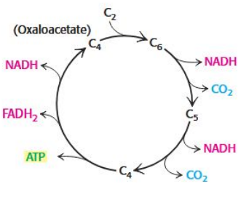
- Coenzyme A: derived [abgeleitet] from vitamin pantothenate, important constituents in catabolism [Oxidation der Fettsäuren] and anabolism [Aufbau von körpereigenen Stoffen, z.B. Synthese von Membranlipiden]

TCA - the citric acid cycle:
- „im Citratzyklus treffen die Abbauwege des
Kohlenhydrat-, Protein- und Fettstoffwechsels in Form der aktivierten Essigsäure zusammen“
- metabolic center
- includes a series of reactions that result in the oxidation of an acetyl group to two molecules of carbon dioxide generates high-energetic electrons
- function: harvest of high-energy electrons from carbon fuels
- removes electrons from acetyl CoA and uses them to form NADH and FADH2, 6 electrons are transferred to 3 NAD and one pair of hydrogen atoms is transferred to one molecule of FAD (flavin adenine dinucleotide)
- provides the vast preponderance of energy used by aerobic cells

- reaction 1: condensation of oxaloacetate (4C unit) and acetyl group of acetyl CoA (2C unit), oxaloacetate condenses with acetyl CoA to form citryl CoA
Oxalacetate + Acetyl-CoA + H2O → Citrate + H+ + HS-CoA
- reaction 2: isomerization of citrate by dehydration step followed by hydration step (enzyme: aconitase)
Citrate → cis-Aconitate → Isocitrate
- reaction 3: oxidative decarboxylation of isocitrate is catalyzed by isocitrate dehydrogenase
Isocitrate + NAD+ → NADH + H+ + Oxalsuccinate → 𝛼-ketoglutarate + CO2
- reaction 4: oxidative decarboxylation; NAD+ is catalyzed by a-ketoglutarate and forms Succinyl-CoA
𝛼-ketoglutarate + NAD+ + CoA → Succinyl-CoA + CO2 + NADH
- reaction 5: the enzyme succinyl CoA cleaves thioester bond to get GTP
Succinyl CoA + Pi + GDP → Succinate + GTP + CoA
- reaction 6: methylene group (CH2) is converted into carbonyl group (C=O) in three steps: oxidation, hydration and second oxidation
Succinate +FAD → FADH2 (energy) + fumarate
- reaction 7: hydration by fumarase to form L-malate
Fumarate + H2O → malate
- reaction 8: malate is oxidized to form oxaloacetate, reaction is driven by the use of the products
Malate + NAD+ → NADH + H+ + Oxalacetate
- the formation of acetyl CoA from pyruvate is an irreversible step (also unable to convert acetyl CoA back to glucose
- regulation: primary control points are isocitrate dehydrogenase and a-ketoglutarate dehydrogenase (allosteric enzymes)
ATP is inhibitory of citrate synthase
NADH inhibits isocitrate dehydrogenase by directly displacing NAD+
a-Ketoglutarate-DH is inhibited by succinyl CoA and NADH
- biosynthetic role: provides intermediates for biosynthesis
- replenishment: oxaloacetate is formed by the carboxylation of pyruvate, in a reaction catalyzed by pyruvate carboxylase
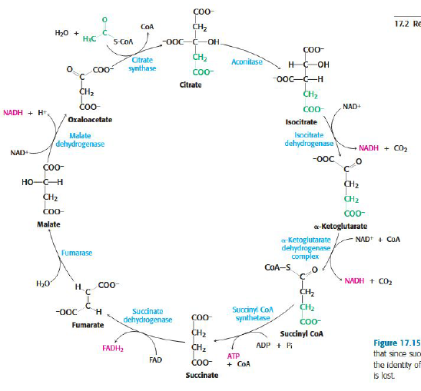

Pyruvate dehydrogenase:
- large, highly integrated complex of three distinct enzymes
- Glucose is processed by glycolysis into pyruvate (under anaerobic conditions lactate or ethanol, under aerobic conditions it’s transported into mitochondria)
- Reaction 1: decarboxylation
Reaction 2: oxidation
Reaction 3: formation of Acetyl CoA
Reaction 4: two electrons are transferred to an FAD prosthetic group of the enzyme
and then to NAD+
- Structure: core of the complex is formed by the transacetylase component E2 (consisting of eight catalytic trimers forming a hollow cube), each subunit has three major domains
- Regulation of pyruvate-DH: acetyl CoA inhibits the transacetylase component E2, NADH inhibits the dihydrolipoyl dehydrogenase E3
High concentrations of NADH and acetyl CoA inform the enzyme that the energy needs of the cell have been met or that fatty acids are being degraded to produce acetyl CoA and NADH
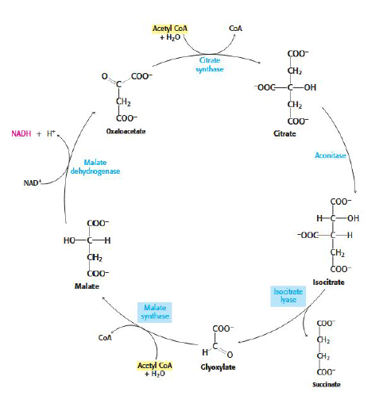
Glyoxylate cycle:
- Also begins with condensation of acetyl CoA to form citrate
- Then isomerization to isocitrate
Mitochondrial membrane:
- Two compartments in mitochondria:
intermembrane space between outer and inner membranes
and matrix which is bounded [begrenzt] by inner membrane
- Mitochondrial matrix is site of most of the reactions of the citric acid cycle and fatty acid oxidation
- Inner membrane is impermeable to nearly all ions and polar molecules

ETC - Electron transport chain:
- Electrons are transferred from NADH to O2 by NADH-Q oxidoreductase, Q-cytochrome c oxidoreductase and cytochrome c oxidase
- One function is to regenerate NAD+ for use in glycolysis
- Transport of protons across inner mitochondrial membrane
- All complexes except succinate-Q reductase pump protons
- Additions of one electron and one proton results in the semiquinone form (QH)
- Additions of a second electron and proton to the semiquinone generates ubiquinol (QH2 = fully reduced form of coenzyme Q which holds protons more tightly)
- Cytochrome c: small soluble protein, shuttles electrons
- ETC control: regulation of the rate of oxidative phosphorylation by the ADP level is called respiratory control or acceptor control
- Electron transport in complex I:
first step is binding of NADH and transfer of its two electrons to the flavin
electrons are transferred from FMNH to series of iron-sulfur clusters
- Electron transport in complex II:
FADH2 enters ETC at second protein complex of the chain
- Electron transport in complex III:
electrons from QH2 are passed on to cytochrome c by the second pump in the respiratory chain
function is to catalyze the transfer of electrons from QH2 to oxidized cytochrome
four protons are released on the cytoplasmic side, two protons are removed from mitochondrial matrix
- Electron transport in complex IV:
cytochrome c oxidase catalyzes the transfer of electrons from the reduced form of cytochrome c to O2
ATP synthesis:
- Electron transport and ATP synthesis are coupled by a proton gradient across the inner mitochondrial membrane
- electron transport generates a proton-motive force
- TP synthesis by ATP synthase can be powered by a proton-motive force
- Role of the proton gradient is not to form ATP but to release it from the synthase
- Requires proton flow: proton will enter a channel and bind the aspartate residue
rotation of the c ring, a unit remains stationary
- Inhibitors: rotenone, antimycin A, cyanide, azide and carbon monoxide
uncoupling electron transport from ATP synthesis
(oligomycin inhibits ATP synthase)
ATP synthase:
- catalyzes the formation of ATP from ADP and orthophosphate
- includes a moving part (c-ring and gamma-stalk) and a stationary part (remainder of the molecule)

