Questions of the bioimaging exam:
1: What is the unit of the effective dose in radiology
- Sv
- Bq
- eV
- Gy
2: What is the definition of activity
- Number of disintegrations per second
- Number of particles or photons send out per second
- Number of particles in a specific time frame
- …
3. Name 3 Methods to detect photons
4. Where are the most important declarations of human studies signed
5: what is the correct order of the sequence of MRI
- Slice – phase – frequency
- Phase – frequency – slice
- Frequency – slice -phase
- Slice – frequency - phase
- Phase – slice – frequency
6: Which one is correct about the MRI magnet?
- It is usually vertically positioned
- The magnetic field strength is about 150 times the earth magnetic field
- Superconducting magnets are usually not switched off during weekends and nights
- The static field B0 doesn’t affect spin echo sequences
- Clinics usually used permanent magnets
7: which isotope is mostly used in MRI
- 1H
- 2H
- 18F
- 12C
- 13C
9. Which statement about k-space is wrong
- Only one point is recorded between two RF pulses
- Each point in k-space is the sum of the vector of magnetisation… (this was right just don’t remember the sentence)
- …
- …
10: define the Lamor frequency
11: A new contrast agent is on the market. You are asked if you can use it on a 3 T scanner. Which parameters (inkl. Unit) do you need to know to answer that question.
12: How does the fat shift influence the MRI contrast and which methods can be used to reduce the chemical shift from fat.
15: RCC radiochemical conversion / RCP radiochemical purity/ SA specific activity definition
16: Which indication of breast MRI is wrong
- Differentiate cancer
- Stage cancer
- …
- …
- Instead of mammography
17: Diffusion weighted imaging is…
- Tool to get good anatomical images
- Way for PXXX/Pet
- Great for AI functional research
- …
- …
18: What is an advantage of MR over CT guided interventions (multiple choice?)
- Cheaper
- Better soft tissue contrast
- Less radiation
- …
- …
- …
19: What is wrong: Compared to PET / CT, PET / MRI
- Less radiation for staff
- Less radiation for patient
- More artifacts
- Better soft tissue contrast
- …
20: What is correct about covid 19 research:
- There are PBSM which are cells working with immune system which can be found in the body but not in the blood
- Metabolics is not a good tool for metabolic covid research
- The cytocine storm is a desired response of the immune system
21: Two images were given. They were similar to those:
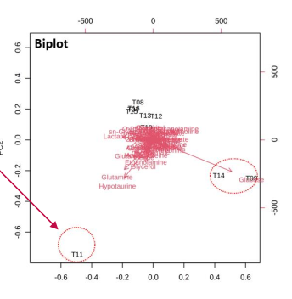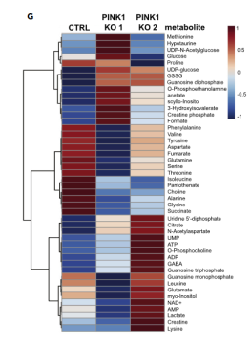
Which statement is not correct?
- T11 and T14 are outliers.. (this was correct)
- Patients who received XY treatment had increased values of a, b, c and d (this was also correct)
- Something super simple that was obviously wrong like “Metabolomics can’t be used to learn more about different pathologies and diseases.” (The first two options were a bit tricky to figure out first because it was a big image and lots of data.)
22: Which answers are correct about autoradiography (multiple choice)
- You can’t do more than one experiment in the same animal
- You can use many different isotopes
- …
- …
23: name the three main elements of the PET detector and its functions
25: how to get an input function (state 2 and bonus if extra (2 bonus points possible))
26: define pharmacodynamic / pharmacokinetics
27: which phenomenom is OCT based
- Light interference
- …
- …
- …
28: why is there a fast decay for hyper polarized tracers
- Decay with longitudinal relaxation
- Something about temperature
- Something about magnetic field
- …
29: Name two advantages of Hyperpolarization in translational medicine (2 bonus points for two extra).

