Nanoanalytics exam WS21/22

20 single choice questions with 4 possible answers.

Important formulas and values are given on the front page, some task-specific values are additionally in the tasks. Some “easy” formulas you have to know by yourself (e.g. elastocapillarity, time for diffusion t=0.5 L^2/D, F=mg, m=Vp, Volume sphere: 4/3 pi r^3, …)

1. If you decrease a mechanical system (spring constant or AFM-cantilever) by the factor of 2, how is the resonance frequency changed?

- increased by factor 2
- decreased by factor 2
- decreased by factor √2
- not changed

Solution: a

2. Particle with diameter of 100 nm - 10 µm, and density 1 g/cm^3. Mass range?

- 1 pg - 1ng
- 1 pg - 1µg
- 1 fg - 1ng
- 1 fg - 1pg

Solution: c, use of m = ρ*V with V = 4π/3 * r^3

3. Calculate the Reynolds number for honey with density similar to water, η = 10 Pa*s, l = 10 cm, v = 1 cm/s.

- 10^-4
- 10^-2
- 1
- 10^2

Solution: b

4. Joule effect: Extension of a fixed … (comparable to polymer) an increase of temperature as discussed in the lecture for rubber leads to

- increase in end-to-end distance.
- decrease in end-to-end distance.
- change of spring constant.
- …

Solution: b

5. Which statement about the persistence length of a polymer for the WLC model is wrong?

- The persistence length is dependent on the bending rigidity.
- The persistence length is dependent on the temperature.
- The persistence length is always bigger than the molecule length.
- The persistence length is dependent on the mechanical properites.

Solution: c

6. Which statement about the Debye length is wrong?

- Debye length is not dependent on Zeta potential.
- Debye length is dependent on the concentration and charge of ions.
- Debye length is dependent on
- Debye length is maximum distance of counter ions from surface.

Solution: a/d?

7. Micropillar substrate with E = 2 MPa, L = 8 m, r = 1 µm given.
Calculate k with given formula. What is the resulting force if micropillar is deflected by ∆x = 1 µm?
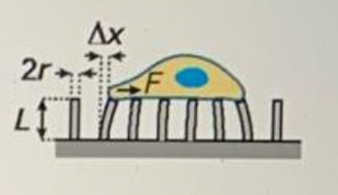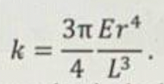
- 0.1 nN
- 1 nN
- 10 nN
- 100 nN

Solution: c

8. Consider a system in thermal equilibrium that can occupy one of two states 1 and 2, with a probability p1 and p2. Which of the following values for p1 and p2 is correct? ∆U = 2kBT between state 1 and 2.
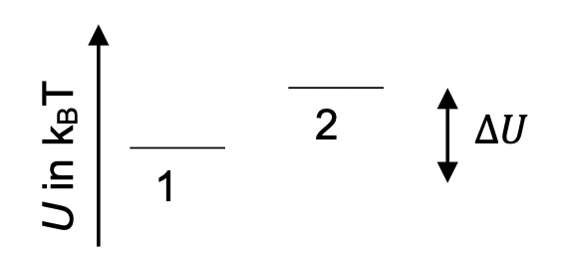
- p1 = ⅔ and p2 = ⅓
- p1 = 0.88 and p2 = 0.12
- p1 = 1 and p2 = 0.12
- p1 = 0.73 and p2 = 0.27

Solution: b

9. To observe dielectrophoresis you need

- a charged particle in an electric field.
- an homogeneous electric field.
- an inhomogeneous electric field.
- an inhomogeneous magnetic field.

Solution: c

10. For a semi flexible worm like chain (WLC) polymer with contour length L and persistence length P, the relation between an external force F (applied between the ends) and the end-to end-extension z of the molecule is given by:
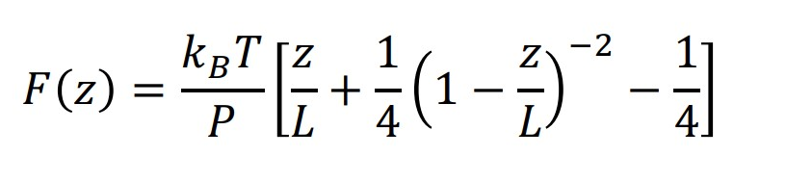
In a particular experiment, the persistence length is given by 50 nm and the polymer is extended to a 90 % of its contour length (z = 0.9L). What force is required to stretch the polymer to this length?

11. How long does it take for ink to diffuse? l = 10 cm, D = 10^-10 m^2/s

- 2 hours
- 2 days
- 2 years
- 2 months

Solution: c

12. How does the concentration distribution change over time? Different images of c(t) for t1 and t2 were given.

Solution:
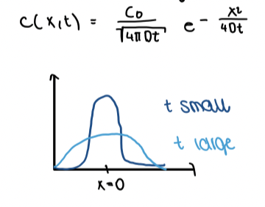

13. Calculation of Etvös Number for a paper clip swimming on water surface. Formula was given as
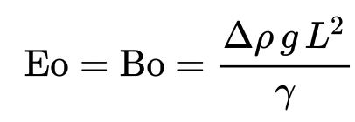
Only value for g was given in the text. Tip he gave: ∆ρ was only ρ of water, because air is neglectable.

- 10^-1
- 10^-3
- different values for Eo

Solution: a, assume the diameter L of the wire

14. Elastocapillarity: Water drop on material with E = 1 kPa. Calculate elastocapillary length Lc.
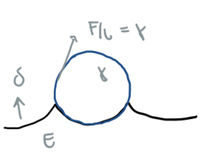
- 1 mm
- 1 µm
- 1 nm
- 0.1 mm

Solution: d

15. Anomalous diffusion: Plot of MSD <x^2> against t was given. We had to decide which was fitting to free diffusion, constrained diffusion, and diffusion in a porous environment (curves were numered 1-2-3).
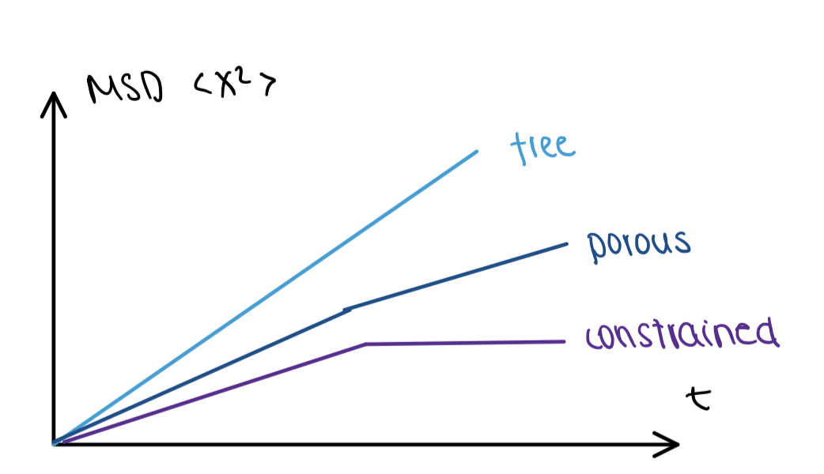
- free - porous - constrained
- free - constrained - porous
- porous - free - constrained
- constrained - porous - free

16. Calculation of zeta potential out of electroosmotic velocity. Formula was given and you just had to fill in values. Values given in the text were ∆V/L.

17. Calculate the pressure needed for water in a micro channel with squared diameter. Given values: Q = 1 fL/s, h = 100 nm, l = 10 µm (?)

18. Consider two motor proteins according to the one-state-model (as discussed in the lecture) with different step length l but same energy consumption per step (e.g. 1 ATP). Which statement is correct?

- The stall force is bigger for the protein with smaller step length.
- The stall force is smaller for the protein smaller step length.
- The stall force is the same for both but they differ in zero-force velocity.
- The stall force and zero-force velocity are the same.

Solution: a

19. Calculation of Fmax that a motor protein can have. Given were kon, koff, c0 = 100 ccrit, ccrit, δ = 0.6 nm

- 2 pN
- 6 pN
- 15 pN
- 30 pN

Solution: d -> Fmax can be calculated for dn/dt=0
Formula was not given:
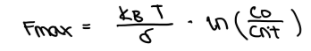

20. Electroosmotic velocity calculation... All given and also formula. Just pay attention to units.

- 70mm/s
- …
- ….
- ….

