Exam questions BMT I WS21/22

Sonography

- What is no interaction between ultrasound waves and tissue?
  - Attenuation
  - Reflection
  - Refraction
  - Scattering
  - Amplification

Solution: e

- Higher frequency results in
  - higher resolution, lower penetration
  - lower resolution, higher penetration
  - lower resolution, lower penetration
  - higher resolution, higher penetration
  - no impact

Solution: a

- What is true for a doppler angle of 90°
- no signal
- signal dependent on blood velocity
- signal dependent on blood direction
- signal dependent on …
- …

Solution: a

Laparoscopy

4. What is the central part of the Veress needle?
- spring
- variable diameter
- larger length
- sharp needle
- …

Solution: a

5. How high should the intraabdominal pressure be?
- 10-13 mmHg
- 10-13 psi
- 10-13 bar
- 10-13 Pa
- 10-13 atm

Solution: a

6. The best position of the laparoscopic camera?
- between the trocars
- opposite of the trocars
- far away from the trocars
- always at the umbilicus

Solution: a

Respirators in anesthesia and IC medicine

7. The most appropriate lung volume per min for a person weighing 60 kg?
- less than 2 l/min
- 3.5-4.8 l/min
- nothing of all given values
- 8-9 L/min
- more than 10 L/min

Solution: b

8. What is true about ventilation?
- Ventilation pressure needs to be limited because high pressure can lead to lung damage
- no possibility to insufflated change O2 level
- only intubation as respirators

Solution: a

9. Which statement is correct?
- artificial ventilation should not be applied in patients with lung failure due to chest trauma
- DuoPAP enables to support patients own respiration activity

Solution: b

Cardiac pacemakers and Defibrillators and IC medicine

10. Lead in the right ventricle and atrium. What can the device not have?
- Wireless Connection
- Battery
- coils that can deliver shocks
- Housing

Solution: c

11. Left ventricle pacing which vessel can be used

- Coronary sinus
- vena cava superior
- vena cava inferior
- pulmonary vein
- pulmonary artery

Solution: a

12. Order of the waves for correct sinus rhythm

- P wave - QRS complex - T wave - U wave
- QRS complex - T wave - P wave
- other combinations of ECG

Solution: a

13. Which is denoted as the primary pacemaker?
- HIS-bundle
- Purkinje fibers
- Sinus node
- AV node
- …

Solution: C

14. Which statement is wrong?
- the battery of an ICD lasts longer than for a pacemaker

15. Which statement is wrong?
- integrated light source in the center of the endoscope
- light source coupled with infrared filter in glass fiber

Solution: a

Endoscopy

16. Something about chip on a tip technology. Which statement is correct?
- Higher diameter compared to normal endoscopes
- Other possible modifications

Solution: ?

17. Which statement is correct for laparoscopy?
- valves of trocars are to prevent air to enter the peritoneum
- valves of trocars are to allow air to leave the peritoneum
- first trocar is placed in umbilicus

Solution: c

18. Something about rigid endoscopes. Which statement is wrong?
- the light source of a rigid endoscope is placed in the middle of the rigid device
- a cold light source is applicated … over fiber optic cables
- something with IR spectrum is filtered out by concave mirror
- Angle of vision can be variable
- something about the plane tip

19. and 20. about the location and size of an image for different positions of an object in front of a concave mirror
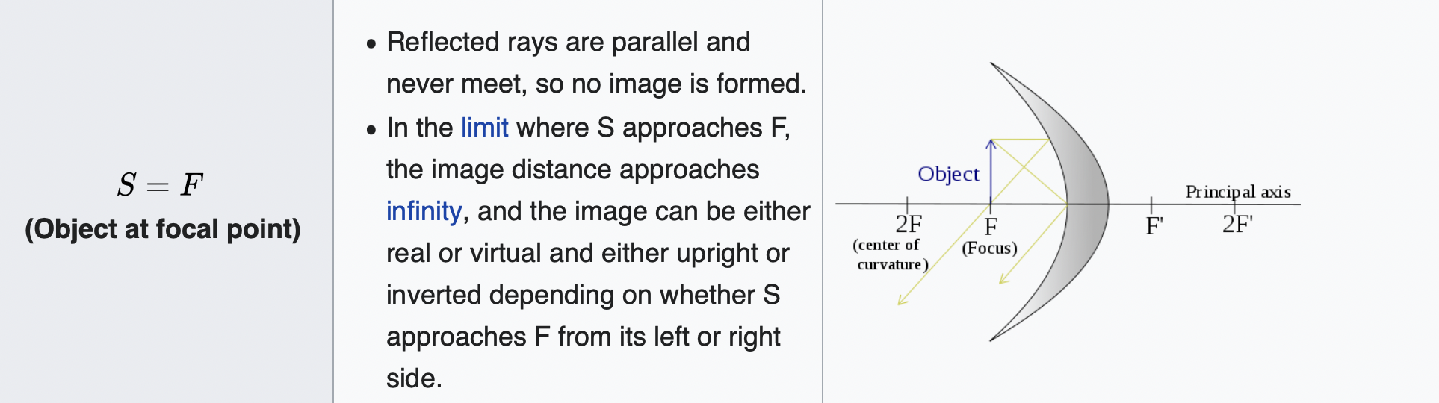
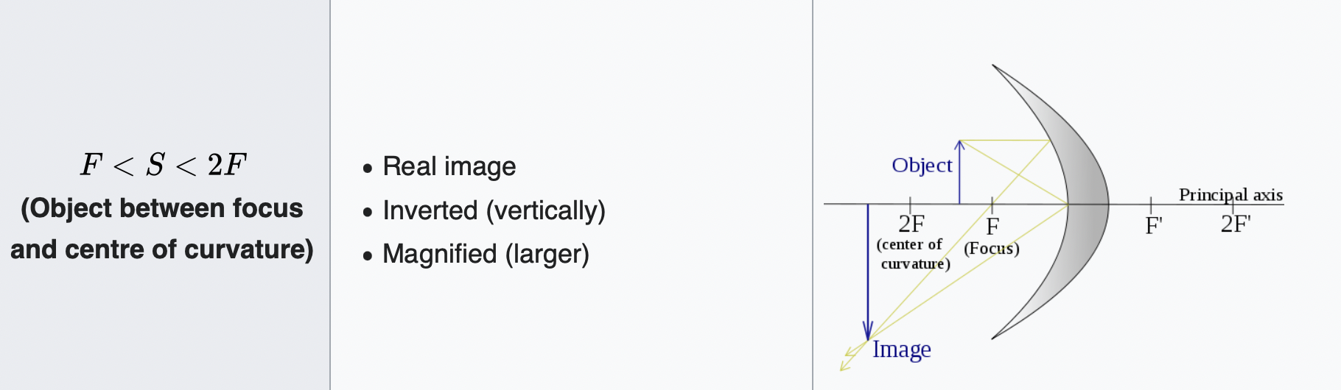

21. Which statement regarding total reflection is correct?
- refraction index of the core of an optic fiber must be higher than the one of the cladding

Solution: a

Pulmonary function testing

22. Determination of FEV1
- not dependent on the patients cooperation

23.

24. Which statement is correct?
- lung volume is dependent on sex and age

25. Something about EEG evoked responses, coherence, ….
- Each component of the evoked response…..

26. Something about pletysmography. Which statement is correct
- Must be performed in a hermetically sealed chamber
- Patients body temperature has influence on measurement
- Patients ..
- Enables to directly measure air flow through electric field

Solution: a

Data integration
What clinical standard does not exist?
- FHIR
- LOINC
- HL7
- CPR-2
- UCUM

Solution: d

Neurophysiology

27. Which is the right statement?
- MEG is based on Faradays law
- EEG is based on Biot-Savarts law
- EEG is based on Ohms law and voltage drop along axons
- EEG is based on Ohms law and voltage drop along volumes of current in the brain
- Amperes law

Solution: c

28. Which statement is correct? about infrared spectroscopic measurement of blood oxygenation and deoxygenation in the brain.
- wavelengths of 700 - 900 nm for measurements
- BOLD signals from fMRI can detect the blood deoxygenation and oxygenation.

29. wrong question, was crossed out

30. Something about innovations in MEG/EEG
- description of principle of atomic magnetometers

Solution: a

POCT

31: What is not a POCT device?
- Blood gas analysis
- ROTEM
- Multiplate platelet analyzer
- …
- blood pressure monitoring

Solution: e

32: Which of the following values for arterial blood gas analysis is correct?
- pH 6.35 - 6.45
- pCO2 75-100 mmHg
- pO2 40-50 mmHg
- BE -2 to +2
- Oxygen saturation less than 90%

Solution: d

33: Which platelet activation pathway is activated by the multiplate analyzer
- intrinsic pathway
- extrinsic pathway
- TRAP pathway
- fibrinogen
- FIIX activation

Solution: c

Clinical Laboratory Medicine

34. What is the intention behind the colored caps on the sample tubes?

- defines to which specific laboratory department it should go
- defines how fast the should be analysed
- tells the transporting personal how to carry them
- in the tubes are different anticoagulants and coagulant which are needed to proceed in the analysis later on

Solution: d

35. Test results in the clinical environment can be influenced. Thick the right statement.
- anthropologicals like age and sex have an influence on the results and should be therefore considered

36. How is the chance called, that a pathological result indeed identifies a sick person?
- diagnostic efficiency
- positive predictive value
- diagnostic sensitivity
- negative predictive value
- diagnostic specificity

Solution: b

Data integration

37. Which is not a standard used in data processing?
- LOINC
- UCUM
- SNOMED
- CPR-2
- FHIR

Solution: d

38. Types of integration
- semantic and structural
- harmonic and ?
- heterogeneous and homogeneous

Solution: a

39. What is DICOM?
- digital imaging and communications in medicine

