WS2021/2022
Summary
Biomedical Technologies in Diagnostics and Therapy I
Contents
1. Sonography 4
2. Laparoscopy 11
3. Artificial ventilation in anesthesia and intensive care medicine 14
4. Cardiac pacemaker systems 17
5. Data integration 21
6. Endoscopy 29
7. Defibrillators and ICD systems 33
8. Pulmonary function testing 36
9. Devices and Methods in Neurophysiology I 41
10. Devices and Methods in Neurophysiology II 47
11. Point-of-Care diagnostics 55
12. Laboratory Medicine 59
13. Example exam questions 65

Sonography

Definitions
Sonography = Medical imaging with ultrasound. Sonus (gr.) = sound, Gaphein (gr.) = to write
Sound = Mechanical and longitudinal waves that can travel a distance using a media. Cannot travel through medium.
á frequency = â penetration á resolution
â frequency = á penetration â resolution
Ultrasound = Mechanical, longitudinal wave with a frequency exceeding the upper limit of human hearing (20,000 Hz = 20 kHz).
Ultrasound imaging frequency range: 2 – 20 MHz.
Velocity = Speed at which a sound wave travels through a medium (cm/sec).
Determined by density and stiffness of media: slowest in air/gas, fastest in solids
Average speed of ultrasound in body: 1540 cm/sec

Ultrasound
Basic principle of ultrasound is detection of an echo after emitting a sound wave, what allows the localization of objects.

Piezo-electric effect
Application of mechanical stress leads to generation of an electric charge in certain materials. Thus, a shape change (shrinking/expanding) can be detected in response to the application of a pooling voltage, depending on the polarity.

Pulse-Echo Method
- Ultrasound transducer produces “pulses” of ultrasound waves, which travel within the body and interact with various tissue
- Reflected waves return to the transducer and are processed by the ultrasound machine
- Image which represents these reflection is formed on the monitor

How is an image formed on the monitor?
- Each reflected wave is represented by a dot
- The position of the dot represents the depth from which the echo is received
- The brightness of the dot represents the amplitude of the returning echo
Dots are combined to form a complete image
Reflected echoes:
- Strong reflections = white dots, e.g. pericardium, calcified structures, diaphragm
- Weaker reflections = grey dots, e.g. myocardium, valve tissue, vessel walls, liver
- No reflections = black dots, e.g. intra-cardiac cavities, bladder
The depth of the reflection is calculated over the timing. Thus, the system calculates how long it takes for the echo to return back to the transducer. The velocity is assumed to be constant at 1540 cm/sec. Distance ~ Time.
- Near Field Imaging: Tissue closer appear on top and faster waves return
- Far Field Imaging: Tissue further appear at the bottom and slower waves return

Interactions of ultrasound with tissue

Attenuation (= Dämpfung)
- The deeper the wave travels in the body, the weaker the wave and the lower the resolution become
- Amplitude of the wave decreases with increasing depth
- Related to frequency
The returned signal is amplified for better imaging at depths

Reflection
- Occurs at a boundary between two adjacent tissue or media
- Amount of reflection depends on differences in acoustic impedance between media. Impedance = Density * Velocity
- Ultrasound image is formed from reflected echoes

Transmission
- Not all sound wave is reflected, some continues deeper into the body. These waves will reflect from deeper tissue structures.

Scattering
- Redirection of sound in several directions
- Caused by interaction with small reflector or rough surface
- Only portion of sound wave returns to transducer

Echogenicity (caused by reflection)
- An-echoic = without signal
- Hypo-echoic = with low signal
- Hyper-echoic = with high signal

Goals of an ultrasound system
The goal of an ultrasound system is to make like tissues look alike and unlike tissue look different. Accomplishing this goal depends on:
- Acoustic impedance
- Resolving capability of the system
- Beam formation: send and receive
- Processing power: ability to capture, preserve and display the information

Acoustic impedance
= product of tissues density and the sound velocity within the tissue
- Amplitude of returning echo is proportional to the difference in acoustic impedance between two tissues
- Velocities
  - Soft tissues: 1400 – 1600 cm/sec
  - Bone: 4080 cm/sec
  - Air: 330 m/sec
If an ultrasound beam encounters two regions of very different acoustic impedances, the beam is reflected or absorbed and cannot penetrate. Example: Soft tissue – bone interface.

Types of resolution
- Axial/ resolution:
  - Specifies how close together two objects can be along the axis of the beam, yet still be detected as two separate objects
  - Beam frequency affects axial resolution
- Lateral resolution:
  - Ability to resolve two adjacent objects perpendicular to the beam axis as separate objects
  - Beam width affects lateral resolution
- Spatial resolution:
  - Also called detail resolution
  - Combination of axial and lateral resolution
- Contrast resolution:
  - Ability to resolve two adjacent objects of similar intensity/reflective porperties as separate objects
- Temporal resolution
  - Ability to accurately locate the position of moving structures at particular instants in time
  - Also known as frame rate
- Examples
  - A 12 MHz transducer has very good resolution, but cannot penetrate very deep into the body
  - A 3 MHz transducer can penetrate deep into the body, but resolution is not as good as in 12 MHz transducer

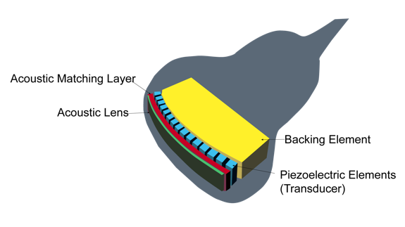
Ultrasound devices
Different probes with different frequencies can be used depending on the field of application.
- Backing material decreases the pulse length
- Acoustic matching layer increases transmission
Figure 1: Ultrasound transducer components
- Acoustic lens important for beam focusing

Doppler effect
= apparent change in received frequency due to a relative motion between a sound source and sound receiver.
- Sound toward receiver = á frequency
- Sound away from receiver = â frequency
Doppler used in ultrasound to evaluate and quantify blood flow. The flow is relative to the transducer, which is sound source and receiver.
Doppler shift produced by moving blood flow can be calculated by the following equation:
$$F_{D}=\frac{F_{output}∙v∙cos⁡(θ)}{c}$$
If the direction of flow is 90 °, no doppler shift can be detected as cos(90°) = 0.
But cos(60°) = 0.5
The spectral waveform represents the audible signal and provides information about
- Direction of flow:
  - Flow towards the transducer is represented positive
  - Flow away from the transducer is represented negative
- Velocity of flow
  - By measurement of spectral trace
  - Represented by amplitude
- Quality of flow (normal vs. abnormal)
If the velocity it too high to display, a so-called “aliasing (wraparound)” effect can be observed. The Doppler sampling rate is not adequate for high velocity shifts and therefore the peaks are cut off and displayed below the baseline.
Spectral analysis provides information about the quality of flow. Spectral window is the area under the curve. Measurement of the trace provides information such as
- Maximum and mean velocity
- Resistance index (RI)
- Pulsatility index (PI)
- Acceleration and deceleration times
- Volume flows, shunts, pressure gradients
In a laminar flow, the blood velocity is smallest at vessel wall and fastest within the center of the vessel. In disease states, the laminar flow is disrupted.

Color Doppler
Often colors are used to visualize the blood flow and to differentiate it from surrounding tissue. It provides a map for placing a Doppler sample volume. Basic questions are about flow, direction and velocity.
- Utilizes pulse-echo Doppler flow principle to generate a color image
- Image is superimposed in 2D image
- Red and blue color give information about direction and velocity
Linear array transducers display a square shaped color box which steers from left to right to provide a Doppler angle. All other transducers display a sector shaped color box which is adjusted in position by using the tracking ball. Region of interest:
- Position:
  - Box must approach the vessel/heart chamber at an angle other than 90 °
  - Only little or no color display at perpendicular incidence
- Size:
  - The larger the ROI the lower the frame rate
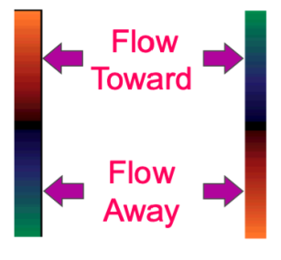
Regardless of color, the top of the bars represent flow coming towards the transducer and bottom of the bar represents flow away from the transducer.
Figure 2: Color Doppler
Color represents velocity of the flow
- Deeper shade = slower
- Lighter shade = faster

Types of Doppler
- Continous wave (CW)
  - Uses different crystals to send and receive signal
  - One crystal constantly sends a sound wave of a single frequency, the other constantly receives the reflected signal
  - Advantage: accurate display flow of any velocity without aliasing
  - Disadvantages:
    - samples everything along doppler line
    - cannot position doppler to listen at a specific area along its path
  - Widely used in cardiology applications: requires ability to display high velocities without aliasing
- Pulsed wave (PW)
  - Produces short bursts/pulses of sound
  - Uses the same crystals to send and receive signal
  - Follows the same pulse-echo technique used in 2D image transformation
  - Advantage: can sample at a specific site along Doppler line. Location is represented by the sample volume
  - Disadvantage: maximum velocity which can be displayed is limited. Signal will always alias at a given point, based on transducer frequency.
  - Used in all clinical applications
What defines a good Doppler display?
- No background noise
- Clean window/envelope in normal flow states
- Clear audible signal
- Accurate display of velocities
Clinical challenges?
- Obtaining the appropriate Doppler angle
- Doppler in deep vessels/large patients
- Displayig without aliasing, found in abnormal flow states (PW Doppler)
- Exact site for sampling

Laparoscopy
Different goals are followed in the transaction of a laparoscopy.

Get first access
Blind puncture is associated with the danger of bowel injury and bleeding and the risk increases with inexperience of the surgeon. The complication rate is about 40 %.
Nowadays, the Veress needle is the most important instrument to create a pneumoperitoneum. It was developed 1938 by Janos Veress and is a spring-loaded needle for draining ascites. The included spring enables differentiation of tissues through different resistance.

Get space
To gain space in the peritoneum insufflation with CO2 gas is mainly performed. CO2 is used because it has the same refractive index as air, so it does not distort the image and is non-combustible. The intraabdominal pressure normally runs between 9 to 10 mmHg and is increased through insufflation up to 10 to 13 mmHg. It is important to use disposable filter and tubing for each patient, as the CO2 pressure is not decreasing linear in the gas bottle. High flow insufflators output is determined by the size of the outlet.

Get visual access
To get visual access, different light sources can be used, such as LED, halogen, or xenon. Therefore, telescopes with different angles in between 0 to 45 ° can be used. The optic chain contains a fiber optic cable for light transmission, a camera head, an optical controller for imaging and a monitor. Fiber optic cables show several advantages such as a high transmission of light, resistance and they enable special applications like fluorescence.

Get working access
Working access is achieved by using laparoscopy trocars with 5 to 10 mm standard size (bigger/smaller size for children or adipositas surgery possible). They are normally covered by a valve to prevent leakage of the insufflated gas. A correct trocar placement should provide direct access to the target organs, an optimal view and the operative field and minimize mental and muscular fatigue. It is important to avoid competing for the same space with two different trocars. In addition, epigastric vessels and nerves as well as areas of prior surgery need to be avoided. Additional trocars can be placed along a semicircular line.
Trocar tips can have different shapes such as sharp for cutting, conic or blunt depending on the application.

Do surgery
Instruments are offered in different sizes, such as scissors in diameters from 2 to 10 mm in diameter. Their shapes differ from hook scissors to Metzenbaum and straight scissors with different application targets. Also grasping forceps have different shapes and functions. In 1977 Kurt Semm demonstrated the first time the endoloop suturing technique in laparoscopic surgery to achieve hemostasis. He performed his first laparoscopic appendectomy in 1980. In 1985 the first laparoscopic cholecystectomy was performed by Erich Mühle.

Important tools
- Flushing and suction
- HF surgery, energy-based systems
- Clip application
- Stapler
- Tissue retrieval

Conclusions
- First lap cholecystectomy in the US in 1988
- Now, almost every organ is accessible
- > 90 % of cholecystectomies are done laparoscopically
- Benefits of laparoscopic surgery:
- Cosmetic
- Less pain
- Speedier recovery/shorter hospital stay
- Fewer adhesions (scar tissue)
- Fewer post-operative complications
- Photographs/video/magnified view
Further developments:
- Single port access surgery, but has several disadvantages (takes longer, high cost, restricted degree of movement)
- Robotic surgery
  - Benefits: more precise/range of motion, 3D vision, less bleeding, more comfortable for surgeon, can be done remotely
  - Disadvantages: lack of haptics, cost?, long set-up, higher learning curve
  - EndoWrist instruments: device memorizes position, surgeon can choose applied force, instruments can be easily switched
  - Commonly used for urology, cardicac surgery, gynecology
- Single-Site robotic surgery
- NOTES Surgery (natural orifice translumenal endoscopic surgery)
  - Orifice can be mouth to stomach, vagina, rectum
  - Benefits: cosmetic, less pain, faster recovery, less risk of wound infections and hernias
  - Disadvantages: learning curve, longer procedure time, problems with closing enterotomies, sterility?

Artificial ventilation in anesthesia and intensive care medicine

Physiology of breathing
Inspiration (Breathing in): Air passively follows the pressure gradient from the environment (higher pressure) into the lung (lower pressure).
Expiration (Breathing out): Due to elastic reset forces, the lung is compressed, and air is pressed out again.

Artificial ventilation
Artificial ventilation reverses the previously described physiological processes: Air is actively pressed into the patients’ lungs by the ventilator.
When do we need artificial ventilation?
- General anesthesia (i.e. opioid-induced depression of respiratory function)
- When the patients breathing fails/is insufficient because of lung failure due to infection, acute respiratory distress syndrome (ARDS), chest trauma, …
There are different ways of connecting a patient to artificial ventilation, including ventilation via endotracheal breathing tube, laryngeal tube and laryngeal mask.
One differs between two modes of artificial ventilation:
- Modes for patients without spontaneous breathing activity
- Modes for patients with spontaneous breathing activity
Main parameters for setting up artificial ventilation include
- Tidal volume (6-8 ml/kg bodyweight) if too small increase pressure
- Respiration frequency (age-dependent; about 10 AZ/min, 6l/min)
As control value the expiratory CO₂ should be in a range of 33-43 mmHg.

Modes of artificial ventilation for patients without spontaneous breathing activity

Pressure controlled ventilation mode (PCV)
Parameters:
- Frequency 25 AZ/min
- Control pressure 17 mbar pressure
- PEEP pressure after expiration 5-8 mbar, 10 mbar heavy people, 15 mbar Covid
- Oxygen saturation 100 %
The positive end-expiratory pressure (PEEP) is the pressure in the lungs above the atmospheric pressure that exists at the end of expiration. The extrinsic PEEP is PEEP applied by a ventilator; the intrinsic PEEP is PEED caused by an incomplete exhalation.

Volume controlled ventilation mode (S-CMV/VCV)
- Frequency 25 AZ/min
- Volume 400 ml
- PEEP pressure after expiration 13 mbar
- Oxygen saturation 55 %

Comparison pressure-controlled ventilation (PCV) and volume-controlled ventilation (VCV)
- Pressure plateau in PCV is better than extreme pressure decrease
- Oxygenation in PCV better than in VCV because CO₂-O₂-exchange takes place in the plateau phase
- VCV is better for short time ventilation as it is easier and more comfortable, but PCV is the safer method
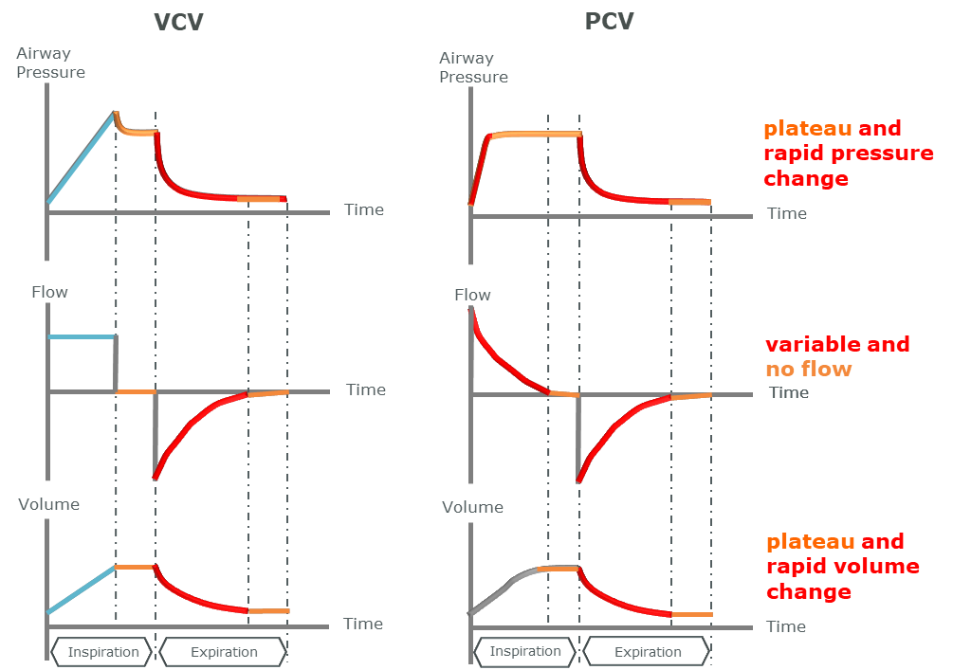
Figure 3: PCV vs. VCV

Modes of artificial ventilation for patients with spontaneous activity
I.e. used during weaning from ventilator.

Dual positive airway pressure ventilation (DuoPAP)
- Frequency 10 AZ/min
- Pressure 19 mbar
- PEEP pressure after expiration 5 mbar
- Oxygen saturation 40 %
As the name indicates DuoPAP works with two different pressure levels: the lower pressure stays in the lug, the higher pressure is for breathing. Between those two pressure levels, patients are contributing to breathe in and out. The ventilator recognizes when a patient tries to breath in and supports the process of inspiration. Thus, ventilation and spontaneous breathing are not coupled. An increase in spontaneous breathing leads to an increase of ventilator assist. This also means, that the ventilator does not assist in apnoea. The possibilities for individual adaption are little.
Ideally ventilator support of spontaneous breathing should be possible in between 0 to 100 %.

Spontaneous ventilation (SPONT)
- Patient-initiated and sustained breathing
- Ventilator controls pressure and oxygen
Parameters:
- Support pressure 2 mbar
- PEEP pressure after expiration 5 mbar
- Oxygen saturation 45 %

Noninvasive ventilation (NIV) per face mask
This ventilation method is most often used before invasive ventilation and is not for permanent application.
Parameters:
- Support pressure 8 mbar
- PEEP pressure after expiration 8 mbar
Most ventilation modes differ rather in small details regarding their physical/physiological parameters. Most of the modes can be applied by one and the same machine.

Cardiac pacemaker systems

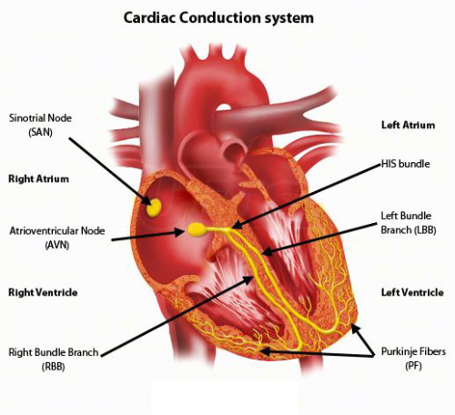
Anatomy and electrical conduction of the heart
- 50 – 100 beats/minute
- Most important blood vessel of heart is right coronary artery (RCA)
- Sinus node: Pacemaker center
- AV-node:
- HIS bundle exclusive for electrical conduction
- Purkinje fibers
Figure 4: Cardiac conduction system
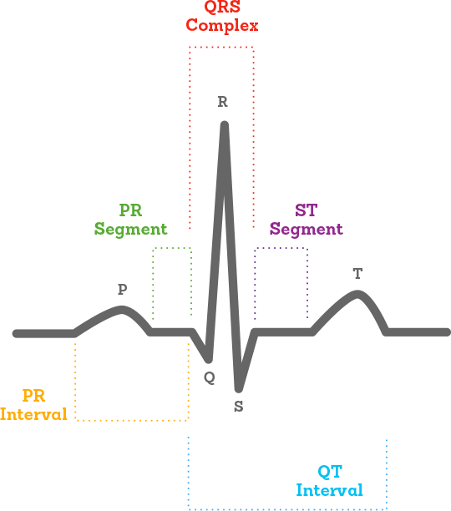

- P wave = atrial depolarization
- QRS complex = ventricular depolarization
- T wave = ventricular repolarization
- U wave = papillary muscle repolarization

Figure 5: Electrocardiogram (ECG)

Rhythm disorders
Bradycardia:
- Sick sinus syndrome:
  - SA-Block I, II, III
  - Brachycardial artrial fibrillation
  - Brachy-tachy-syndome
  - Pre-automatic pause
  - Chonotropic imcompetence
- Atrioventricular Block:
  - II° or III° AV-Block
- Rare causes
SA-Block III: No conduction of the sinus node activation to the atrium. Results are pauses of heartbeat (asystole).
ECG: pauses of heartbeat visible
AV-Block III: Blockage of conduction from atrium to ventricles, resulting in independent beats of atrium and ventricles. Escape rhythm tries to compensate blockage, but is not sufficient for blood transport.
ECG: no connection between P wave and QRS complex. Escape rhythm visible.

Diagnostics
- 12-channel ECG
- Exercise ergometry
- 24 – 72 h Holter ECG
- Echocardiography
- Subcutaneous eventrecorder
- Electrophysiology study
- Coronary angiogram

Pacemakers
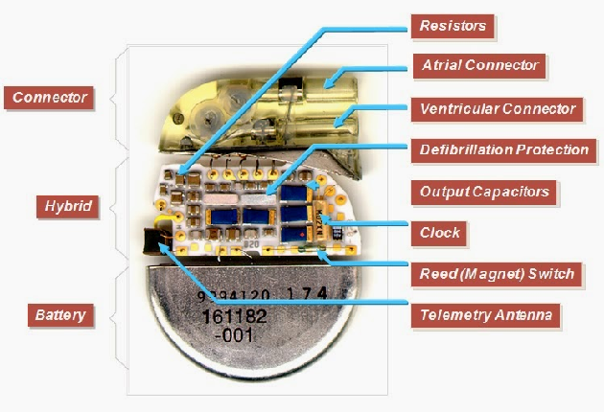
Anatomy of a cardiac pacemaker

8 – 12 years lifespan

Figure 6: Anatomy of a cardiac pacemaker
Indications for pacemaker implantation:
- Bradycardia: slow heart rhythm
- Syncope: fainting spells
- Heart failure
- Hypertrophic cardiomyopathy: hearts ventricular walls excessively thick

Basic principles: pacing
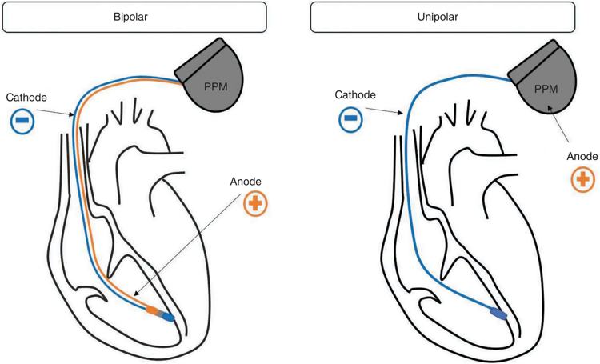
- Bipolar electrodes:
  - Small spike
  - Sensing: advantage with small signals
  - Less external noise
- Unipolar electrodes
  - Big spike
  - Thinner leads
  - Flexible
Figure 7: Unipolar and bipolar pacemakers
  - Safe, long lasting
Electrodes can be epimyocardial, myocardial, transvenous. Examples:
- Epimyocardial steroideluating electrodes
- Myocardial screw- and bool electrodes
- Fractal-coated screw electrode
- Transvenous: Active fixation screw electrode or passive fixation anchor electrode

Ventricular demand pacing (VVI)
- Bipolar pacemaker
- Ventricular stimulation ventricular sensing ventricular sensing (if event sensed, stimulation is inhibited)

Dual chamber rate adaptive pacemaker (DDD-R)
- Dual chamber stimulation (atrial and ventricular) dual chamber sensing dual response to detection (inhibition and triggering)
- F.e. used in AV-block

Nomenclature of pacing: NASPE/BPG pacemaker coding
Table 1: NASPE/BGE pacemaker coding
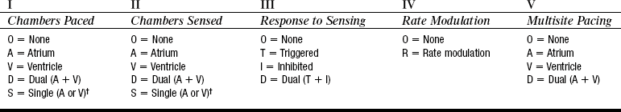

Left bundle branch block (LBBB)
= activation of the left ventricle of the heart is delayed, which causes the left ventricle to contract later than the right ventricle.
To resynchronize contraction of the ventricles, pacemaker is positioned in the veins of the left ventricle. Pacemakers are in general not positioned in the left ventricle, as bleeding is very dangerous due to high blood pressure.
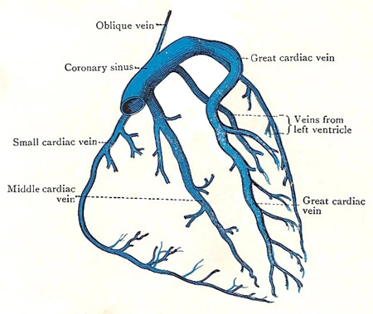

- LV electrode is placed in the transvenous in the coronary sinus
- No need to access arterial vessels
Figure 8: Coronary sinus

Cardiac resynchronization therapy (CRT)
Prospective randomized landmark trials for CRT:
- Early studies with cross-over or parallel design
- Different studies evaluating morbidity and mortality
Indication for CRT:
- Left ventricular ejection fraction (LVEF) ≥ 35 %
- Examples:
  - Left bundle branch block (LBBB) and non-LBBB with QRS > 130 ms
  - Atrial fibrillation and heart insufficiency (NYHA III/IV)
  - Deterioration during pacemaker or ICD therapy
  - QRS < 130 ms
Follow-ups are necessary every 6 – 12 months to check stimulus threshold, sensing, battery status, lead resistance, ECG episodes, programming, lead position. Shorter follow-up peroids are necessary after initial implantation and when battery is close to ERI.

Data integration

Motivation
Information about a patient’s health state and diseases should ideally be summarized in a clinical database, in which clinicians and medical researchers have insight. The basic problem of this approach is that clinical databases from different hospitals/localizations/doctors are not stored centrally.
Challenges:
- Collect all available data, add further data sources and obtain more accurate information
- Allow easier access for researchers and caregivers
- Combine data to gain new insight in clinical and biomedical research questions
- Deal with heterogenous data at different clinics and multiple hospitals
  - Patient data stored at different sites
  - How to access this distributed data, how to combine it?
  - One difficult example: rare diseases

Theory and general concepts in a nutshell
What needs to be done?
- Data needs to be collected
- Data needs to be stored
- May need to be transferred to different departments/hospitals
Automated data collection is important
Integration and processing are required
What is clinical data?
- Measurements from patient monitors
- Laboratory analyses
- Results of imaging procedures
- Caregivers notes
- Genetic data, image data
- Billing information
Complex and heterogenous information

Patient data
Patient record contains
- Patient information
- Patient history
- Measurements and procedures
- Therapeutic notes
Paper record or digital version
Hand-written paper record
+ complex information can be stored in tight space
- not easily retrieved/single point of access, data entries sometime illegible, no automated processing
Electronic health record (HER)
+ improve information storage and exchange
- Available to multiple users at the same time
- Timely access to patient data
- Combines past and current information
- Useful for building a clinical data repository
+ in integrated systems
- Support clinical decision making
- Improve patient safety
- Promote quality improvement
+ strict specifications, precise information
- yet: transfer between systems and departments often still performed manually/in paper form
- limited complexity and freedom How to store additional and complex information? Free-text comments can hardly be further processed

Quantification: EMRAM model
= 8 stages to define the level of integration and digitalization on the way from no digitalization (stage 0) to a paperless environment (stage 7)
- Average score of 2.3 of the participating German hospitals

Database
= organized collection of data. In the digital world: system/software to store and retrieve information.
Example: Often relational databases Interconnected tables
Automated processing and interconnection is usually used to perform data collection and integration. Advantages:
- No need for manual entry
- Less human resource-intensive
- More accurate and reliable
- Higher frequency
- Time-critical information is transferred faster

Information systems
Requirements:
- Data collection
- Data storage
- Data reporting and presentation
- Communication
- Interconnection
Different system types:
- Department-based systems
- Information-source systems
- Administrative
- …
EHR system
- Includes:
  - Data entry
  - Storage
  - Presentation
- Entry:
  - Keyboard, dictation, transcription, voice recognition, touchscreen, hand-held systems
  - Direct instrumentation from medical devices, barcodes, RFID, laboratory analyzers, ICU monitors
- Presentation:
  - Text, tables, graphs, sound, images, videos
  - Electronic, paper

Clinical decision support systems (CDDS)
= computer software to aid clinical desicion making. Provide caregiver with medical knowledge, such as diagnostic suggestions, testing prompts, therapeutic protocols, guidelines, alerts, …

Hospital information sytem (HIS)
= entity of all integrated systems
- Administrative systems e.g. financial system
- Clinical information system (CIS) e.g. ICU system, respiratory care system,
nursing system
- Departmental systems e.g. pharmacy system, radiology system
- Other systems e.g. patient records, decision support
Limited scope: one dimensional, focus on individual aspects
Isolated deployment: specific needs of individual units

Sytem interconnection
- Interconnection required for full EHR and HIS
- Systems need to exchange information
- Have a universal language or translations understand each other, coding standards

Usage of clinical data
Patient data needs to be maintained for various purposes, such as legal documentation, research, decision support, telemedicine, automated therapy, …
The importance of different data aspects is highly dependent on the intended usage and futher processing. One of the most challenging topics for data integration is decision making, as precise real-time information are required.
Further integration layers include interactions between different hospitals, with healthcare insurers and government, and with other national or international levels.

Types of data integration
- Structural integration:
  - Harmonize structure and representation of the information (common data format/same structure to be stored and compared)
Squeeze data in the compatible format, link it to each other
- Segmantic integration:
  - Harmonize the content of heterogenous data sources (same ontologies, coding concepts)
Bring things meaning the same together

Reality: Challenges of data collection and integration
Some challenges:
- Compartmentalization and heterogenous landscape
  - Complex information
  - Numerous different devices, standards, formats and protocols
  - Security and privacy concerns
  - Data harmonization needed
- Limitations in reliability
  - Various levels of reliability
- Limited availability of data
  - Measurement of data and notation is required
- Complexity and storage
  - E.g. artifacts and missing data
- Data processing and storage
  - Number of electronic devices steadily increasing
  - Various types of measurements matching of different data sources is required
  - Mostly independent devices/screens/interfaces with distributed, compartmented information same entitiy but different encodings, e.g. different terms and units
- Heterogenous landscape
  - Devices developed independently
  - Different manufacturers
limited interconnection
- Privacy
The challenges can further be categorized into
- Compartmentalization: privacy, integration, harmony
- Corruption: erroneous data, missing data, imprecise data
- Complexity: prediction, state estimation, multimedia tool

National and global efforts
There are several clinical standardization and harmonization approaches. Examples:
- Health Level Seven (HL7)
  - Still very common
  - Originally created in 1989, but further improved in the recent years
  - Message-based standard
- ISO/IEEE 11073
- DICOM
- Systemized Nomenclature of Medicine Clinical Terms (SNOMED)
  - Comprehensive, multilingual clinical healthcare terminilogy
  - Core components: concepts, descriptions, relationships
- OMOP
- Logical Observation Identifiers Names and Codes (LOINC)
  - Common language for identifying health measurements, observations and documents
  - Unique, permanent numeric codes
  - Full specified name
  - Long common name
  - Stored for different languages
- Unified Code for Units of Measure (UCUM)
  - System for measurement units, e.g. used in LOINC and FHIR
  - 7 base units (meter, seconds, gram, radian, Kelvin, Coulomb, candela)
  - Approx. 30 standard prefixes/multipliers (kilo, milli, …)
  - Units derived from base units and multipliers
defined structure for further processing is an important step to integrate and compare different datasets
Nevertheless, there are some remaining challenges:
- Complex, heterogeneous environment
- Complex, incorrect and corrupted data
- Different data needs
Data integration is an important challenge for the next decades. Main need is to use standardized and structured data entry and collection. The challenges are an interplay of good, fast and cheap.

Current research and data integration challenges
Today: two aspects of data collection and integration:
- “Medical engineering”-ish
  - Data collection and integration at the bedside
  - First-hand experiences and challenges for medical devices and primary systems
- “Medical informatics”-ish
  - Data collection and integration on hospital and national levels
  - First-hand experiences and challenges for data integration at the UKT and at national level in Germany

Data Collection, Integration and Automation in the ICU
Experimental research:
- Establishment of data collection
  - Accessing device interfaces
  - Novel data collection (ACT, diuresis, …)
- Development of integrated frameworks
  - Bridging the information gap
  - Interconnection of various medical devices
- Assisted/Automated therapies
  - Goal-directed therapies, e.g. automated glucose management, automated heparinization, automated temperature management
  - Closed-loop management
Examples of current problems and possible solutions:
- Problem: Availability of data
  - Real-time transmission of ACT measurement results via ethernet
  - Weight measurement of urine collection bag to determine amount
- Problem: Distributed information
  - Data integration into a central patient interface
- Problem: How to control medical devices?
  - Data integration into a central patient interface moitoring and control
  - Integrated ICU framework Inclusion of application, interfaces and device
- Problem: Overview over patients health parameters
  - One patient = one screen with all relevant patient information, additionally used to control medical devices and therapies
  - Portable on hand-held devices
- Problem: Data visualization

Hospital-wide and national efforts
- Medical Informatics Initiative
  - Sponsored by the German Federal Ministry of Education and Research
  - Goals
    - Consolidating patient-oriented clinical data
    - Establishing the IT framework for tailored treatments
    - Acquiring insights from patients’ data
    - Making new findings immediately available for patient care
    - Strengthening medical informatics in Germany
  - 4 consortia for developing data integration solutions
    - All university clinics and more are involved
- National working groups and Task Forces in the medical infomatics Initiative
- Working on a nationwide, uniform patient consent
- Working on data integration concepts and solution for Germany
  - National HL7 FHIR-Dataset for clinical data
  - Standardized methods for data access and exchange
- Data Integration for Future Medicine (DIFUTURE)
  - Use-case driven for patient benefit
  - E.g. for multiple sclerosis or Parkinson’s disease
- COVID-19 research
  - Mainly with FHIR/LOINC standardization
  - Collection of pandemic related datasets

Endoscopy

Historical background
1806 Phillipp Bozzini constructs the first rigid endoscope
- Illumination by a candle attached to a spring
- Optical waveguide concave mirror with small slit for observer
- Mechanical part offering attachment of different specula for varying anatomical regions
Major design problems:
- Heat and candles smoke
- Pain and time-consuming application
1855 further development of “Bozzinis” endoscope by French Antonin Desormeaux
- Enhanced illumination using gas as light source
- Specula less heated
- Introduction of term endoscopy ”Father of endoscopy”
1879 Maximilian Nitze presents the first Cytoscope
1881 Johann von Mikulicz founder of „Esophagoscopy“ and „Gastroscopy”
- First endoscopes with working channels, e.g. flushing
- Introducing of long rigid endoscopes can cause tissue irritations and are hardly tolerated
- Blind spots
1912 Urological Cystoscopy by Otto Ringleb
1950-1960’s Karl Storz, Harold Hopkins: rigid endoscopes with rod lenses, invention of cold light source
1958 Development of the first flexible endoscope by Basil Hirschowitz
- Multiples glass fibers as basis for flexible endoscopes
- Examiner still very close to patient due to eyepiece
1967 Gynecologist Kurt Semm found the modern endoscope
1976 Development of first disinfection machine for flexible endoscopes by Siegfried Ernst Miederer
2000 introduction of capsule endoscopy into the clinical routine

Concave mirror
Different constellations of object-image pairs:

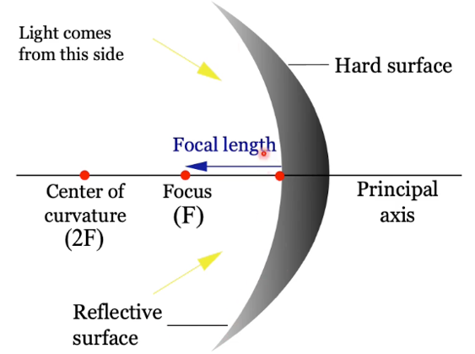
- Object position O < F
Figure 9: Concave mirror
- Generated image behind the mirror, light rays are divergent virtual image, upright, bigger than object

- Object position O = 2F
- Generated image in front of mirror, inverted, not magnified

- Object position F < O < 2F
- Generated image in front of mirror, inverted, bigger than object

- Object position O > 2F
- Generated image in front of mirror, inverted, smaller than object

General information
- “Endo” is Greek for “within”, “scope” comes from Greek “skopos” meaning to look out or to target
- Major problems:
  - Constructing instruments to access anatomical structures through narrow passages
  - Illumination and optical transmission to the examiners eyes

Optics and light sources

Glass Fiber – Principle of total Reflection
- Light beam passing from n₁ to n₂ is refracted away from perpendicular axis
- Toral internal reflection at distinct angle θ_{c} requires radiation coming from the side with higher optical density (n₁ to n₂)
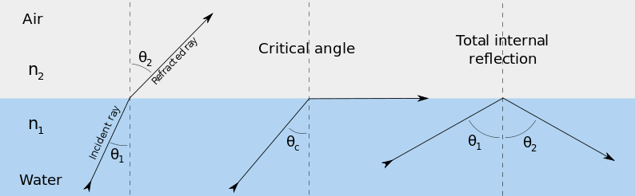
Figure 10: Principle of total reflection
- Total reflection is used in glass fibers for propagation and coupling of light beams
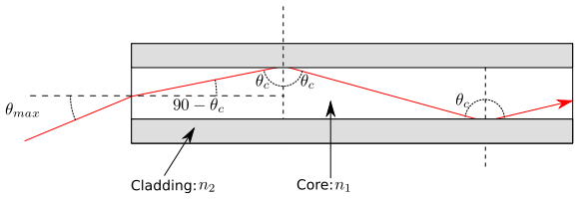
Figure 11: Total reflection in optical fiber
- Angle for total reflection θ_{c} can be calculated as $θ_{c}=arcsin⁡(\frac{n_{cladding}}{n_{core}})$
with n_{core} > n_{cladding}
- Angle of entering light beam θ_{E} can be calculated as
$θ_{E}≤arcsin⁡(\frac{n_{cladding}}{n_{external}}\sqrt{1-{\left(\frac{n_{cladding}}{n_{core}}\right)}^{2}})$

Cold light source
Halogen light:
- Infrared spectrum undesired because of heat conduction
  - Filtered by concave mirror
  - Heat is accumulating around the source
- Light with visible spectrum is focused on a flass fiber
Cold light sources:
- Cooling of light source
- Condenser changes light intensity

Signal transmission
Charged coupled device (CCD):
- Lenses and CCD-Chip mounted on tip of endoscope
- Signal transformation (optical to electrical) analogue or digital signal transmission
- Mostly used as all-in-one solution with tower
- Many forms of digital signal processing possible
Principles of modern endoscopes:
- Rigid endoscopes with a light guiding system of different lenses observation with eyes
- Glass fibers observation with eyes
- Cable signal transmission through TV-chip and processor to a monitor

General design of endoscopes
Two different general designs:
- Rigid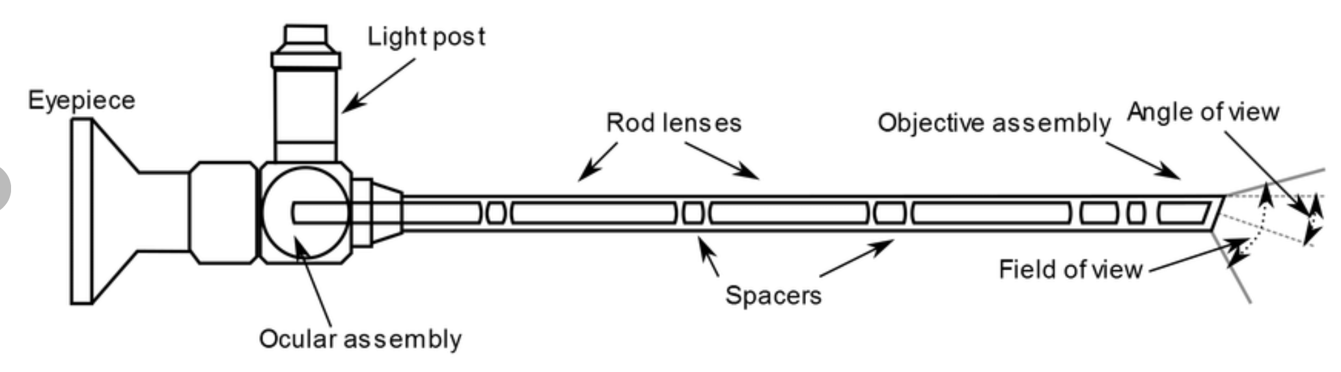
Figure 12: Design of a rigid endoscope
  - Angle of view (= Blickwinkel)
  - Field of view (= Sichtwinkel)
- Flexible: Fiber optics or CCD

Fields of application
Endoscopy can be applicated in different fields:
- GI-Tract
- Respiratory tract
- Salivary glands
- Urinary tract
- Female reproduction system
- Abdominal cavity
- Joints
- Chest
For the different applications different requirements are set to the endoscope, e.g. rigid, rigid combined with microscope, flexible.
Examples: Laparoscopy, Gastroscopy and endoscopic retrograde cholangiopancreatography (Technique that combines the use of endoscopy and fluoroscopy to diagnose and treat problems in the biliary or pancreatic ductual system).

Defibrillators and ICD systems
Defibrillation = non-synchronized electrical shock to restore cardiac function in the event of tachycardia

Implantable Cardioverter-Defibrillator-System (ICD)
Primary goal of ICD-therapy is the reduction of mortality due to sudden cardiac death. Cardiac arrest is supposed to be terminated through automatic detection and termination of hemodynamic relevant ventricular tachycardias.
Risk and problem: An ICD shock is very powerful and really painful (about 41 J). Therefore, patients for ICD implantation should be chosen very careful.

Indications for ICD treatment
- Primary prophylaxis if left ventricular ejection fraction (LVEF) ≤ 35 %
  - E.g. coronary heart disease (CAD), dilatative cardiomyopathy, reduced LV-function
- Secondary prophylaxis
  - After cardiac arrest, sustained ventricular tachycardia, after syncope of presumably ventricular tachycardia
ICD therapy is applicated in patients with CAD, without sufficient vascularization, and reduced LV function.
Different studies on ICD therapy performed:
- AVID: ICD vs. Amiodarone reduction of mortality: 31 %
- MADITT II: ICD vs. conventional therapy reduction of mortality: 30 %
ICDs should not be implanted in patients directly after acute myocardial infarction. Only after 2 – 3 months in case of a severely reduced ventricular function.

Implantation of ICDs
- mostly implanted from the left side of the patient via big thoracic veins due to a better shock field between ICD and heart, e.g. left vena subclavia, vena cava superior
- Mostly in local anesthesia
- 20 % of implanted leads develop defects within the first 10 years after implantation

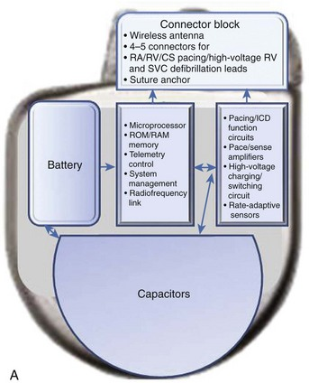
Anatomy of an ICD
Basic components:
- Header
- Two batteries: low-voltage energy (3.2 V)
- Capacitor: stores energy before shock
- Transformer: multiplies voltage (up to 750 V)
- Circuitry
Figure 13: Anatomy of ICD

ICD leads
Lead design:
- Insulation: Polyurethane, silicone, opium
- PIS electrode and coil: metal alloys
- Covered coils for less tissue ingrowth (backfill between coils or coating)
- Shock coils with low impedance
Leads are always bipolar (truly bipolar or integrated bipolar) with one or two shock coils. They can be composed out of a single or dual coil, whereas dual coils have a slower defibrillation threshold (DFT) but are usually more difficult to extract and therefore are not used anymore.
Leads connection:
- Connected to ICD device via the header and fixed with screws
- Can be disconnected from ICD device by liberating fixation screws
- Standard connector: DF-4 with single port connection

Sensing systems
Different system compared to pacemaker system to avoid under sensing of low amplitude signals (such as ventricular fibrillation), but without over sensing signals (such as T wave).
- Threshold low muscles can trigger ICD, what is really painful
- Threshold high no ICD initiation
Sensing threshold is decreasing over time if it does not sense a signal to ensure to give a shock in case of tachycardia.
The heart rate zones are adapted depending on the ventricular system (bmp). Problem here is that physiological heart rate can differ for young and old people, therefore programming is always strongly dependent on the patient.
Discriminators are algorithms that can increase the specificity of arrythmia detection, e.g. ventricular tachycardia vs. supraventricular tachycardia or atrial tachycardia (AT) vs. ventricular tachycardia (VT). These discriminators can be combined differently to reduce inappropriate shocks. The discrimination could be based on stored rhythm templates, whereas the decision of shocking is dependent on matching to the pre-defined templates.
Interval stability is achieved through specific features that are able to discriminate between VT and AT.

Cardioversion
= procedure to return an abnormal heartbeat to a normal rhythm
- Shock leads to depolarization of all cardiomyocytes at the same time
- Shock synchronized to the R-wave
Defibrillation:
- Shock not synchronized to the R-wave
Threshold: DFT is lowest shock energy at which ventricular fibrillation is reliably converted into sinus rhythm
- Always maximum energy is delivered, as it does not hurt much more with less energy
- Therapy needs to be applicated as early as possible
Shocks can either be monophasic or biphasic:

Figure 14: Monophasic vs. biphasic electrical ICD shock
Influence of RV polarity on DFT: RV as anode (+) in ventricle

Pulmonary function testing
Respiratory medicine includes the diagnosis and treatment of many different diseases, such as infectious lung diseases, interstitial lung diseases, asthma bronchiole, pulmonary hypertension, ventilatory disorders and sleep apnea, oncology, occupational diseases, COPD and weaning.
The main causes of death worldwide include several diseases related to the lung:
- Malign tumors within the bronchia (4.)
- Chronic obstructive lung diseases (COPDs) (6.)
- Pneumonia (7.)

Lung anatomy
- Ventral part of the trachea is protected by cartilage, whereas the dorsal part is flexible
  - Example: Coughing leads to an increase of pressure in the theoretic cavity and therefore causes the dorsal part of the trachea to go ventral. Then the area of air is reduced, and the mucus can come out.
- Two lobes are subdivided into segments
  - Left lung contains 8 segments
  - Right lung contains 10 segments
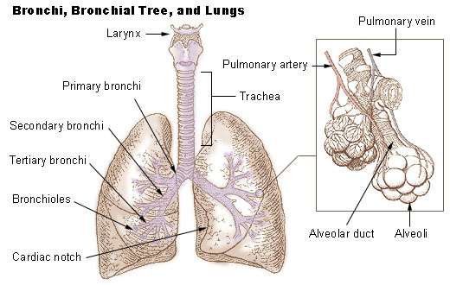
Figure 15: Anatomy of lung and bronchioles
Bronchoscopy enables to directly investigate the airways of the larynx, trachea, bronchi and smaller branches of the bronchi (bronchioles). BUT the majority of the lungs cannot be visualized with the bronchoscope.
- Alveolar system
  - 500 million alveoli in a human lung
  - Per alveolus 1000 capillary segments
  - Whole surface of the alveoli 200 m²
The only natural way of oxygen uptake is achieved by the lungs. By ventilation, oxygen is breathed in and transferred to the blood by alveolar diffusion in the lungs. The oxygen rich blood from the lung is transported to the tissue.
Deficiency of the lung cannot be overcome, as no bypass is possible.

Lung function
Important measures for lung function:
- Oxygen supply
- Carbon dioxide removal
- Lung volumes
- Obstruction

Oxygen content
To measure the oxygen content in the blood, two different samples of oxygen-rich and oxygen-poor blood are taken. Therefore, the radial artery or the ear lobe are punctured for oxygen-rich blood: For oxygen-poor blood, a vein right before the right heart is punctured.
Blood gas analysis aims to detect the oxygen content in the blood. This includes
- Oxygen bound to hemoglobin
  - Binding capacity 1.34 ml O₂ per g Hb
  - E.g., 100 % saturation and Hb 16 g/dl 21 ml O₂ per 100 ml blood
- Oxygen dissolved in water
  - 0.00031 ml O₂ per mmHg in 100 ml blood
  - E.g., pO₂ 100 mmHg 0.31 ml O₂ per 100 ml blood
Oxygen content dissolved in water can be neglected
The oxygen content depends on two factors
- Hemoglobin concentration
- Oxygen saturation
Normal oxygen value is 15 – 20 O₂ per 100 ml blood. Reduction of oxygen content is called hypoxemia.

Oxygen saturation and pressure
Different measures of oxygen in the blood, including
- Hemoglobin saturation curve:
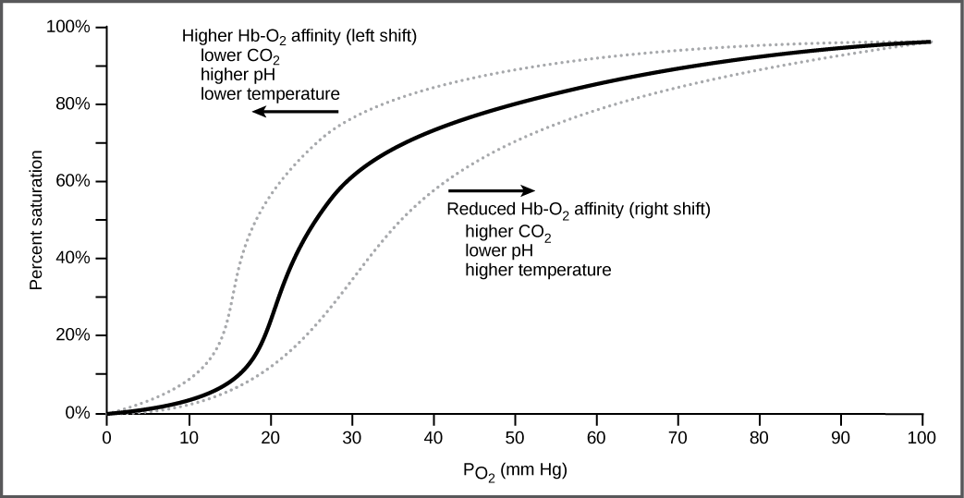
Figure 16: Hemoglobin saturation curve
- Oxygen saturation SO₂ [%] = proportion of hemoglobin which is saturated with oxygen
- Oxygen pressure pO₂ [mmHg]
  - Low pO₂ = hypoxia and indicates a reduced diffusion capacity of the alveolar-capillary barrier
  - Values are age-dependent
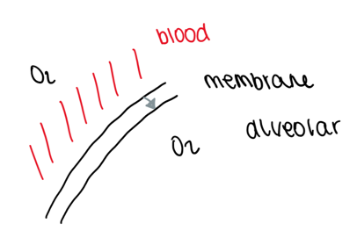
  - pO₂ < 60 % is always pathological
Blood oxygenation (pO₂) is additionally dependent on
- Membrane thickness
- Alveolar surface
- Time of passing of red blood cells
Oxygen saturation can be measured in blood as well as by pulse oximetry. The main disadvantage of pulse oximetry is that this method does not distinguish between oxyhemoglobin and carboxyhemoglobin. But it can monitor a hemodynamic status.

Carbon dioxide pressure
- Normal value 35 – 45 mmHg
- Indicates the alveolar ventilation = ventilation of pulmonary alveoli
  - Compared to oxygen: 20-fold easier diffusion
  - Influencing factors: tidal volume, dead space, breathing frequency

- Low pCO₂ = alveolar hyperventilation
  - Due to psychological reasons, compensation of a hypoxia, metabolic reasons e.g. acidic pH in diabetes
- High pCO₂ = Hypoventilation
  - Due to central disturbance, neuromuscular disease, deformation of the chest, exhaustion of the muscle pump caused by chronic lung diseases

Lung function testing

Spirometry
= most common type of pulmonary function testing
- Measures how much air can be breathed in and out, as well as how easy and fast the air can be blown out of the lung
- Working principle:
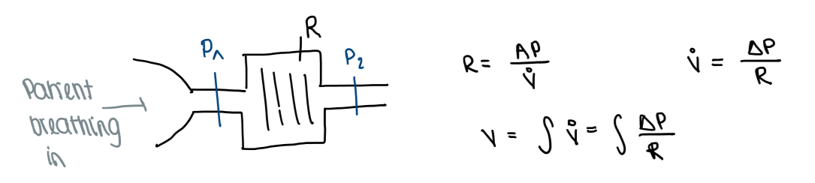
- Measured parameters:
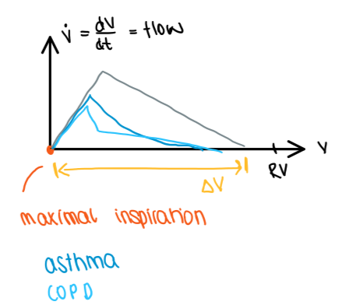
- Volume over time 2) Flow over volume
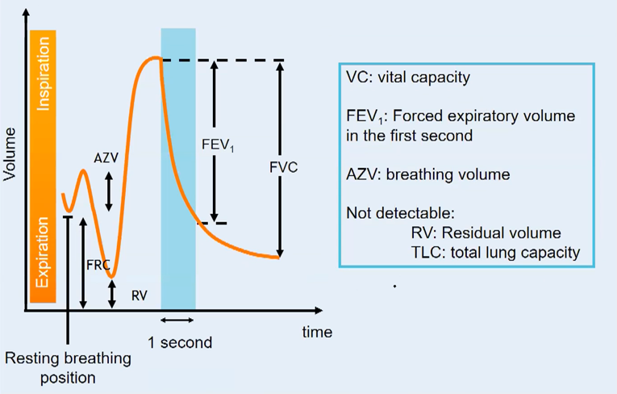

Pathophysiology
- Chronic obstructive pulmonary disease (COPD): deep outbreathing is almost impossible as it leads to a collapse of the alveolars
Increase of residual volume (RV) and decrease of vital capacity (VC)
Reduction of the lung volume helps patients to breathe better
  - e.g. by specific valves that only enable air to flow out but not to flow in
  - e.g. by nitinol forms with shape memory properties
- Interventional bronchoscopy can be performed for different obstructions
  - Exophytic: Tumor only grows in the lumen of the lung
  - Extraluminal: Tumor grows outside the lung but leads to restriction
  - Mixed
- Different methods to remove tumor tissue and increase lumen again, such as cryorecanalisation, APC, mechanical, electrosurgery, laser, cryotherapy, stents, etc.
- In restrictive lung diseases, the main problem is that the typical TLC decrease cannot be detected by spirometry
A typical curve only gives a hint on restrictive lung disease

Diagnosis techniques
- Malignancy of a lung nodule is estimated by the growth over time and size, other methods are difficult
  - > 8 mm 18 % risk of malignancy
  - All nodules are considered as malignant until proven otherwise
- Tissue diagnosis is important and should be pursued because of
  - Medical inoperability
  - Patient preference
  - Specific benign diagnosis
- Biopsy can be performed bronchoscopically or percutaneously
- CT – guided transthoracic biopsy enables real time monitoring and high sensitivity, but shows an increased risk of a pneumothorax and treatment of unexpected bleeding is difficult
- Bronchoscopy with fluoroscopic guidance is difficult, because only 2D

Devices and Methods in Neurophysiology I

Definition of neurophysiology
Clinical neurophysiology = medical specialty that studies the central and peripheral nervous systems through the recording of bioelectrical activity whether stimulated or unstimulated.
- Encompasses research regarding pathophysiology along with clinical methods used to diagnose diseases
- Involves therapeutic approaches that alter the neurophysiological activity by adequate stimulation of the nervous system

Neurons

Composition of neurons
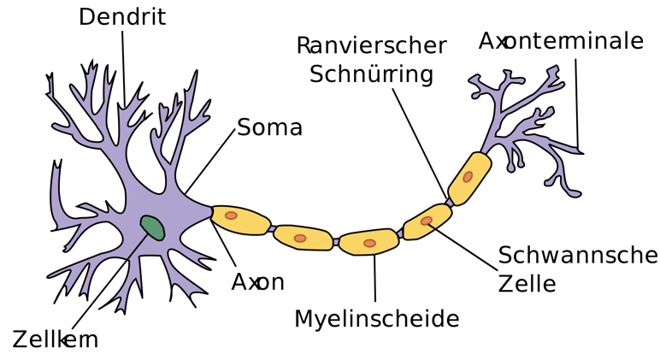
Figure 17: Neuron

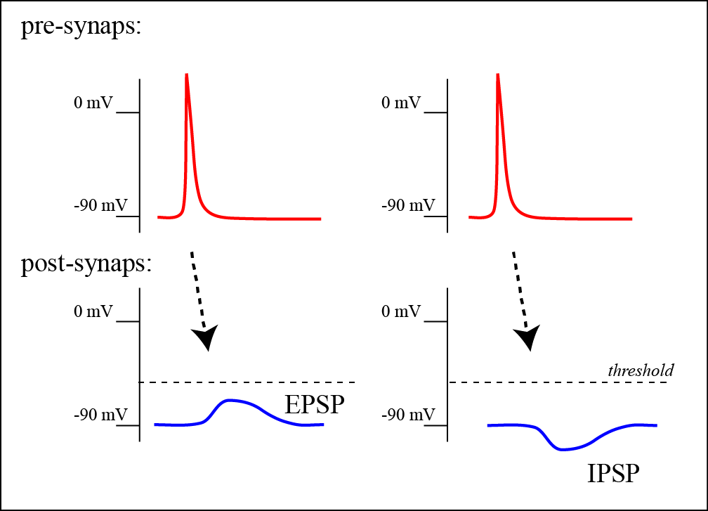
Activation of neurons
Figure 18: EPSP and IPSP
- Action potential
- EPSP: Excitatory postsynaptic potential
- IPSP: Inhibitory postsynaptic potential
Detection of the action potential of neurons is not possible in a non-invasive way, because the signal is too short, multiple signals are not superposed and the axons are aligned in different directions. Thus, the EPSP and IPSP are measured in neurophysiology in order to detect the neurons’ function.

Electrical phenomena in neurons
In a non-stimulated dendrite, an equilibrium of ions in the surrounding and in the cell is formed. But, in response to signal transduction from a synapse to a dendrite, the dendrite membrane changes its permeability for sodium ions and therefore cause an influx of ions. The ion influx leads to a primary current within the dendrite. This further leads to a leakage of the ions again. Resulting from this is a current flow in the dendrite as well as outside of the dendrite, leading to the production of an electrical field as well as an magnetic field.
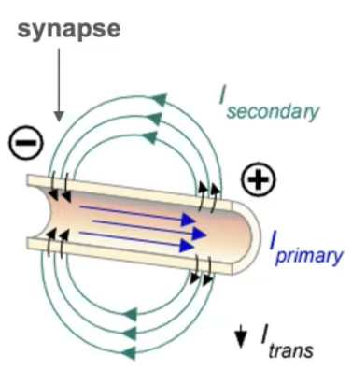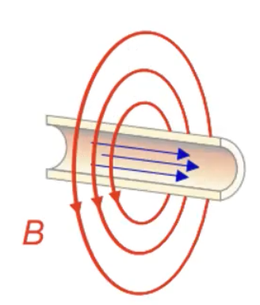
Figure 19: Electrical field as a basis for EEG and Magnetic field as basis of MEG

Clinical Neurophysiology

Methods and Diseases in Neurophysiology
Methods:
- EEG and MEG
- EMG and TMS
- tDCS and tACS
- MRI and fMRI
- NIRS
Diseases: Sensory and motory functions, chronic pain, neuropathy (diabetes), stroke and paralysis, amyotrophic lateral sclerosis, Parkinson’s disease, epilepsy, brain tumors, Alzheimer’s disease, cognitive disorders.

Nervous system
- Central (brain and spinal cord)
  - Humoral system
- Peripheral nervous system
  - somatic nervous system (neurons that bring signals from periphery to the central nervous system)
  - autonomic nervous system (neurons that control automatic human functions)
    - parasympathetic nervous system
    - sympathetic nervous system
The central nervous system consists of the brain, the cerebellum, the brain stem and the spinal cord.

Brain anatomy
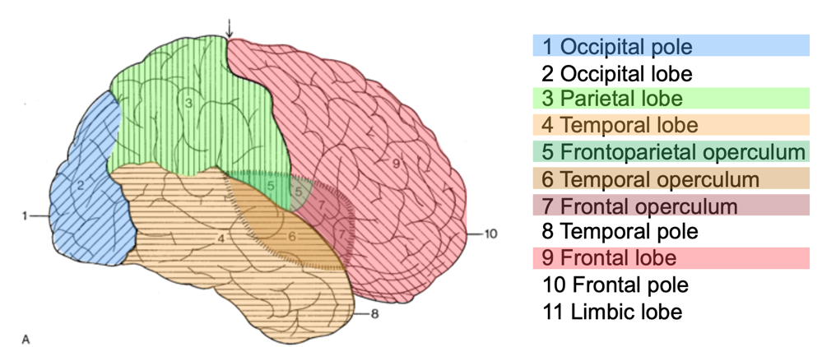
Organisation of the brain:

Sub-division in different brain lobes

Figure 20: Organization of the brain
- Gyrus = ridge on the surface of the brain increase of brain surface
- Sulcus = Fissure surrounding gyrus
- Brain stem connects brain to spinal cord
- Limbic system = part of brain that is involved in our behavioral and emotional responses
- Brain anatomy can be studied with structural MRI shows cross sections
- Brodman areas: Division of the brain in areas of different histology and function Different layers of brain tissue have different heights depending on their localization
- Phrenology: brain is sub-divided into different segments depending on mental faculties
- Brain functions inferred from injury: severe personality changes after frontal lobe damage
- Development of the brain:
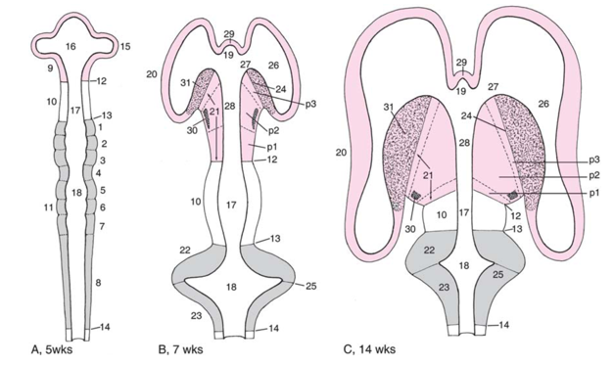
Figure 21: Development of the human brain
Different brain regions are responsible for different functions:
- Sensory and motor function
- Language
- Visual processing: information is split in “where” and “what” and then brought together again

Physical basics of Neuroimaging
Electricity and magnetism:
- EEG is based on the Ohm’s law: U = RI
  - Drop of the voltage across a resistor
  - Current in a spherical superconductor
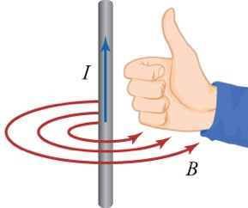
- Dipole field can either be static or dynamic
- MEG is based on Biot-Savart’s Law (right hand rule)
  - Magnetic field generated by electrical current
  - Can also be applicated in a current flow coil
- Magnetic induction is based on Faraday’s law
Figure 22: Right hand rule
  - Changing magnetic field induces voltage

Transcranial magnetic stimulation
= non-invasive form of brain stimulation in which a changing magnetic field is used to cause electric current at a specific area of the brain through electromagnetic induction.

Superconductivity
- Cooling down electrical conductors close to 0 K any resistance vanishes
  - Strong magnets
  - Magnetic field sensors
  - Magnetic shielding
Strong magnetic fields can be generated by cooling them until they become superconducting

Shielding of electrical and magnetic fields
- Shielding of electrical fields:
  - Faraday cage = formed by continuous covering of conductive material
- Shielding of magnetic fields:
  - Meissner effect = expulsion of a magnetic field from a superconductor during its transition to the superconducting state when it is cooled below the critical temperature
  - Mu-metal = nickel-iron soft ferromagnetic alloy with very high permeability
  - Eddy currents = loops of electrical current induced within conductors by changing a magnetic field in the conductor according to Faradays law of induction

Brain imaging methods
Type of functional imaging methods:
- Biochemical activity
- Neurometabolic activity
- Neuroelectric activity
Different neuroimaging methods can be applicated, differing in their spatial and temporal resolution.

Electroencephalography (EEG)
= non-invasive method to record an electrogram of the electrical activity on the scalp that represents the macroscopic activity of the surface layer of the brain
- Electrodes placed along the scalp
EEG recording:
- EEG-traces are recorded from each electrode
- Differences of frequency give typographical information
- In spontaneous EEG different frequency bands can be detected:
  - β = 12 – 20 Hz e.g. excited state
  - α = 8 – 12 Hz e.g. relaxed, eyes closed
  - θ = 4 – 8 Hz e.g. drowsy, asleep
  - δ < 4 Hz e.g. deep sleep, coma
- Examples:
  - Alpha block: Alpha rhythm is reduced by attention to a visual, auditory, tactile, cognitive stimulus
  - Detection of sleep stages
  - Clinical application: Epilepsy localization of neuronal sources possible
- EEG signals are individually varying
- Eye blinks and movements lead to artifacts within EEG recordings
  - Signal-noise ratio ~$\frac{1}{\sqrt{n}}$ for n measurements
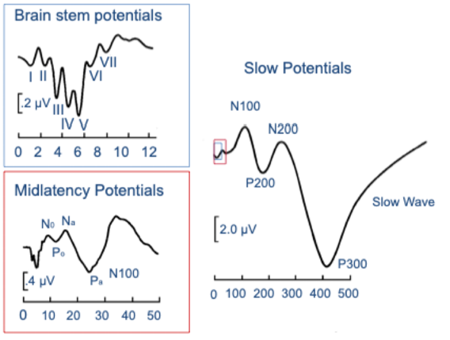
- Event-related potentials, e.g. somatosensory evoked potential
Figure 23: Types of event-related potentials
  - Brain stem potentials
  - Midlatency potentials
  - Slow potentials
EEG application: Multiple sclerosis (MS)
- Shift of EEG peak in patients with MS visible

Bereitschaftspotential = visible EEG signal right before a special movement, for example left hand movement.

Devices and Methods in Neurophysiology II

Magnetoencephalography (MEG)
= non-invasive neuroimaging technique for mapping brain activity by recording magnetic fields produced by electrical currents occurring naturally in the brain
- Animal magnetism was hypothesized by F. A. Mesmer as a consequence of Galvani’s experiments on animal electricity
- Curative effects of magnets on humans and influence on human behavior?

Physiological electro-magnetic signals – history
- At the beginning of 20th century electric signals associated with cardiac and cerebral activity were recorded the first time
  - ECG 1903 by Einthoven
  - EEG 1929 by Berger
- At the beginning of the 60s magnetic signals associated with cardiac structures were first described
  - MCG 1963 by Baule and McFee
- MCG was measured the first time
  - Firstly recorded 168 by Cohen
  - MCG 1970 by Edelsack, Cohen and Zimmermann
In the last few years a huge progress in MEG devices was made. The single channel progressed to some hundreds of channels. Presently about 100 MEG systems worldwide.
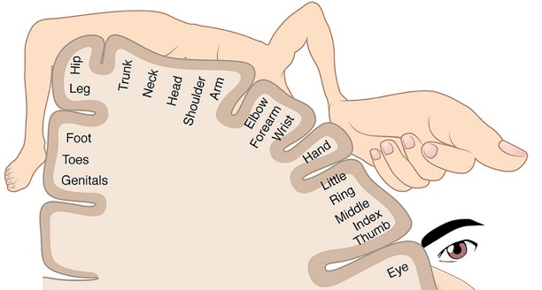
The cortical homunculus shows the representation of the human body in different party of the brain:

Figure 24: Cortical homunculus
After an amputation patients often feel so-called phantom pain in the missing body part.
Explanation: reduced input causes decrease in representation zones and therefore leads to shift. This activity in missing body part zone makes patient feel pain.

SQUID: Superconducting Quantum Interference Device
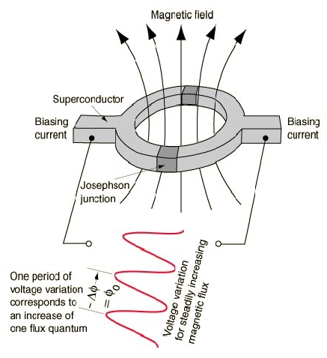
Superconducting ring:
- External magnetic field creates a current in the coll
- Current creates magnetic field opposite to the original fields
- No magnetic field inside the ring
Superconducting ring with Josephson conjunction:
- Differences between multiples of flux quanta
- Only multiplate of flux quanta can pass and generate a current
- Current causes a voltage drop at the Josephson conjunction
Figure 25: SQUID

Noise suppression: Shielding
Strength of magnetic fields:
- 10⁻¹⁴ T = evoked brain activity
- 10⁻¹³ – 10⁻¹² = IC Chip in 2m
- 10⁻⁸ to 10⁻⁷ = environment
Noise suppression is very important, what is achieved by shielding.
Basis of magnetic shielded room is an aluminum frame. The inner layer consists of copper coated aluminum, the middle layer of Mu metal with high magnetic susceptibility and the outer layer consists again of aluminum.
Gradiometers and Magnetometers can be used to measure the magnetic field:
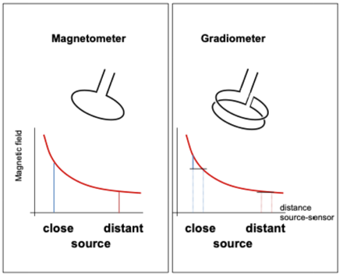
- Magnetometer:
  - Consists of one coil
  - Distance to source is very important for good measurement
- Gardiometer:
  - Consists of two coils difference of two coils is measured
Figure 26: Magnetometer and Gradiometer
  - Lower intensities can be measured
  - Separation of sources closer and more distant is better
  - Axial or planar
MEG sensors are usually cooled with liquid helium to prevent the patient from heat produced by the SQUIDs. But this is inefficient, as it comes to losses due to the phase change of He from liquid to gaseous within the cooling process.

New developments

Atomic magnetometers
- Several advantages compared to conventional MEGs with SQUID technique (very expensive and do not enable flexible configurations)
- Can detect very small magnetic fields by detecting the modification of energy levels of atoms by an external magnetic field
- Applicated in sleeve or in a 25-channel CSAM helmet
- Disadvantage: CSAM are less sensitive
- Advantage: no temperature difference, therefore can be applicated closer to the skin
Working principle:
- Spins of the atoms in a gas can be aligned with resonant light “Optical pumping”
- Atoms with spin and magnetic moment rotate in a magnetic field “Precession”
- Absorption of resonant light depends on the orientation of atomic spins “Optical probing”

Optically pumped magnetometers
- Gaseous atoms are used as sensitive magnetic field probes
  - Quantum-mechanical state of the atoms is prepared by laser light
  - Effect oof a magnetic field on this state is read out by laser light
  - During preparation spins of the atoms in a vapor cell are “pumped” into a certain spin state and driven to a coherent rotation
  - In magnetic field, spins then precess collectively with Lamor frequency (proportional to magnetic field)
- Application: detection of evoked response after median nerve stimulation
  - Generation of a spectrogram possible
- Application: detection of movements

MEGs for Babys and Children
BabySQUID Neonatal Biomagnetometer:
- Superconducting (SQUID) amplifiers used to amplify magnetic signals
- Detection coils can be placed extremely neat the patient without loss of sensitivity or risk to the patient
  - Device takes advantage that infants scalp and skull are thin
  - MEG signals can be measured in 5 – 6 mm from the brains surface
- Gradiometers are connected by thermal conductors to the liquid helium bath
Fetal MEG:
- Measurement of activity of fetus brain through the skin possible
- Stimulation of fetus brain possible
  - Peak at 250 ms

Brain controlled Neuroprosthesis
- Training with orthosis to help recovery of a patient after a stroke
  - E.g. regain possibility of hand movement
- Feedback of µ-rhythm activity in the brain
  - Constant increase after lessons visible

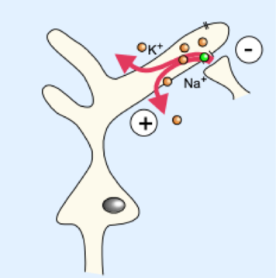
Physiological background of EEG and MEG
Figure 27: Synaptic activity

Physiological basis
- Synaptic activity causes shift in electrical currents
- A postsynaptic potential emerges
- Polarization can be described physically by a dipole
- Simultaneous activation of multiple neurons superimposes
- Prerequisite for a measurable EEG- or MEG-signal is the coordinated activity of about 10,000 neurons
Synaptic activity causes an intracellular primary current and an extra-cellular secondary current.
EEG measures the voltage changes of the secondary current at the head surface (Ohms law). EEG can measure radial (more sensitive) and tangential components.
MEG records magnetic fields of the primary currents (Biot-Savarts law). MEG can only measure tangential components.

Inverse problem
Problem: The estimate of the strength and the location of neuronal sources for a given topography of electrical potential and magnetic field. Combination of EEG and MEG.
Generation of magnetic fields:
- Depolarization of the dendritic membrane of pyramidal cells generates extra- and intracellular currents
- In EEG voltage differences of extra-cellular currents are measured at the heads surface
- In MEG only magnetic effects of the summated intracellular currents are measured

EEG – Dipole source localisation
Steps of dipole source analysis:
      - Try to fit the measured filed by a set of dipoles
      - Chose arbitrary dipoles
      - Calculate corresponding magnetic field
      - Calculate difference between measured and calculated field (error)
      - Chose other set of dipoles and minimize error
Examples:
- Very good localization of the primary somatosensory cortex is possible
- Use Dipoles as functional markers in neurosurgery
- Localization of epileptic focus

MEG – Minimal Norm localization
- Equation system remains undetermined
- Minimum norm is equivalent to last square error

EEG – Beamforming
Assumption: Sources in different parts of the brain are not temporally correlated
Steps:
- Brain is subdivided into areas of a mesh/grid
- Compute the leadfield for each gridpoint
- Define a spatial filter that is compatible with the leadfield and that suppresses all activity that originates from other sources
- Solution depends not only on the leadfield but also on the covariance of the measured data
- A tomogram is computed
- Local maxima of activity are regarded as sources, their temporal activation can be calculated
Applications:
- WLAN
- Radar
- Mobile phones

Coherence
Differentiation between coherent and non-coherent activity is possible. Coherent activity can be translated into functional connectivity, e.g. in intracortical communication or cortico-spinal interaction.
Applications:
- Cortico-muscular coherence: Simultaneous recordings of magnetic brain activity and electrical muscle activity during isometric muscle contraction (crossed signals)
Source localization possible by frequency analysis
- Cortico-muscular coherence: in patients with good motor recovery after stroke
  - Stroke during adulthood: regeneration of brain function
  - Prenatal periventricular lesions: reorganization of brain regions, leading f.e. to passive movement of other hand hand if one hand is moved
motor system develops first prenatally. If a lesion occurs the fibers follow their “old” way to the brain and regenerate.
- Visuo-motor integration: relation of produced force by pressing a sensor together in response to visible signal
Aim: learn about the connectivity of different brain regions to e.g. motor functions.

Functional imaging methods
Different types of methods:
- Biochemical activity
  - Single photon emission tomography (SPECT) e.g. to monitor transmitter release in respond to sugar consumption
  - Positron emission tomography (PET): use of radioactive substances and detection of accumulation γ-radiation in 180° makes use for brain easy
  - Magnetic resonance spectroscopy
- Neurometabolic activity
  - PET, e.g. measurement of oxygen consumption, detection of involved brain regions in reading, speaking, talking, etc.
  - Magnetic resonance imaging (MRI), e.g. relaxation gives information about oxygen supply in certain area
  - NMR
  - fMRI, e.g. to measure blood oxygen, analysis of functional connectivity and resting state networks
  - Near infrared spectroscopy (NIRS), e.g. to detect reaction of primary visual area in response to a stimulus, measurement of absorption
- Neuroelectric activity
  - Transcranial magnetic stimulation (TMS), e.g. for stimulation of the cerebral cortex
  - EEG
  - MEG

Transcranial magnetic stimulation (TMS)
= non-invasive procedure that uses magnetic fields to stimulate nerve cells in the brain
- Shape of coil “shapes” the magnetic field and electrical field
determines the way of brain tissue stimulation
Different paradigms:
- Three-dimensional TMS signals depend on:
  - The intensitiy of the conditioning stimulus
  - The intensity of the test stimulus
  - ISI
- rTMS:
  - Low frequency rTMS 0.2 Hz and 1 Hz: inhibitory effects over the motor cortex
  - High frequency rTMS > 5 Hz: faciliatory effects
  - Patterned TMS: Theta-burst stimulation (TBS)
- Online Virtual Lesion
  - Hypothesis: anteriomost part of IPS in humans in the homologue of monkey AIP and mediates visually guided grasping
  - Conditional stimulus: TMS
  - Test stimulus: target object perturbations
  - Measurements: finger kinematics of grasping
  - Results: only TMS over the rostral IPS in the time window around 65 ms from object perturbation reduces the capacity of online adjustment of grasping

Transcranial Alternating Current Stimulation (tACS):
- Alternating current is applied to the scalp
- Stimulation frequency is in the alpha and beta band
- Stimulation of visual cortex induces phosphenes
- Stimulation of motor cortex induces cortico-spinal connectivity
- Further reseach:
  - Theta entrainment of hippocampus for spatial memory
  - Deep sleep is required for consolidation of memory, induction by theta stimulation

Point-of-Care diagnostics
Point-of-Care diagnostic tools include analysis methods of coagulation and blood gas. This is needed to get a fast overview over a patient’s state in case of a serious situation, e.g. polytrauma.

Coagulation
Point-of-Care monitoring of coagulation is necessary if the coagulation system is activated. It is useful for perioperative analysis (liver, heart, unanticipated bleeding), trauma, pre- and in-theatre, obstetrics, ICU.
The coagulation system is complicated, but it is very important to actively control and inhibit/promote coagulation.

Multiplate platelet function analyzer
- Based on the principle of impedance aggregometry
- Whole blood function analysis of thrombocytes
Platelets are the smallest colorless cells of whole blood and help to build coagulation clots. Their main function is to clump and form plugs in blood vessel injury.
- count range 150,000 to 450,000 platelets/µl
  - > 450,000 platelets/µl = thrombocytosis (primary or secondary)
  - < 150,000 platelets/µl = thrombocytopenia
Advantages of multiplate platelet analyzer
- Less blood drawn
- Quick performance (10 minutes)
- Fast answers
- Easy assessment
- Consistent results
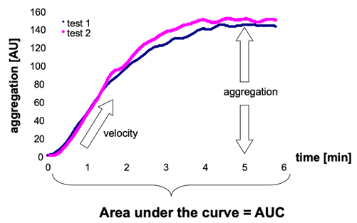
Procedure: 300 µl blood + 300 µl NaCl 0.9 % Application of activators
- Activated platelets adhere on the surface of the sensor
- Platelets aggregates form an insulation layer Impedance between electrodes rises
- Aggregation over time is measured
Figure 28: Multiplate platelet analyzer
Different coagulation pathways can be used for analysis, including the following tests:
- TRAPtest
- ASPItest
- ADPtest
- [COLtest, GpIIb/IIIa receptor exposure]
The coagulation system in general can be subdivided into the intrinsic and extrinsic system.
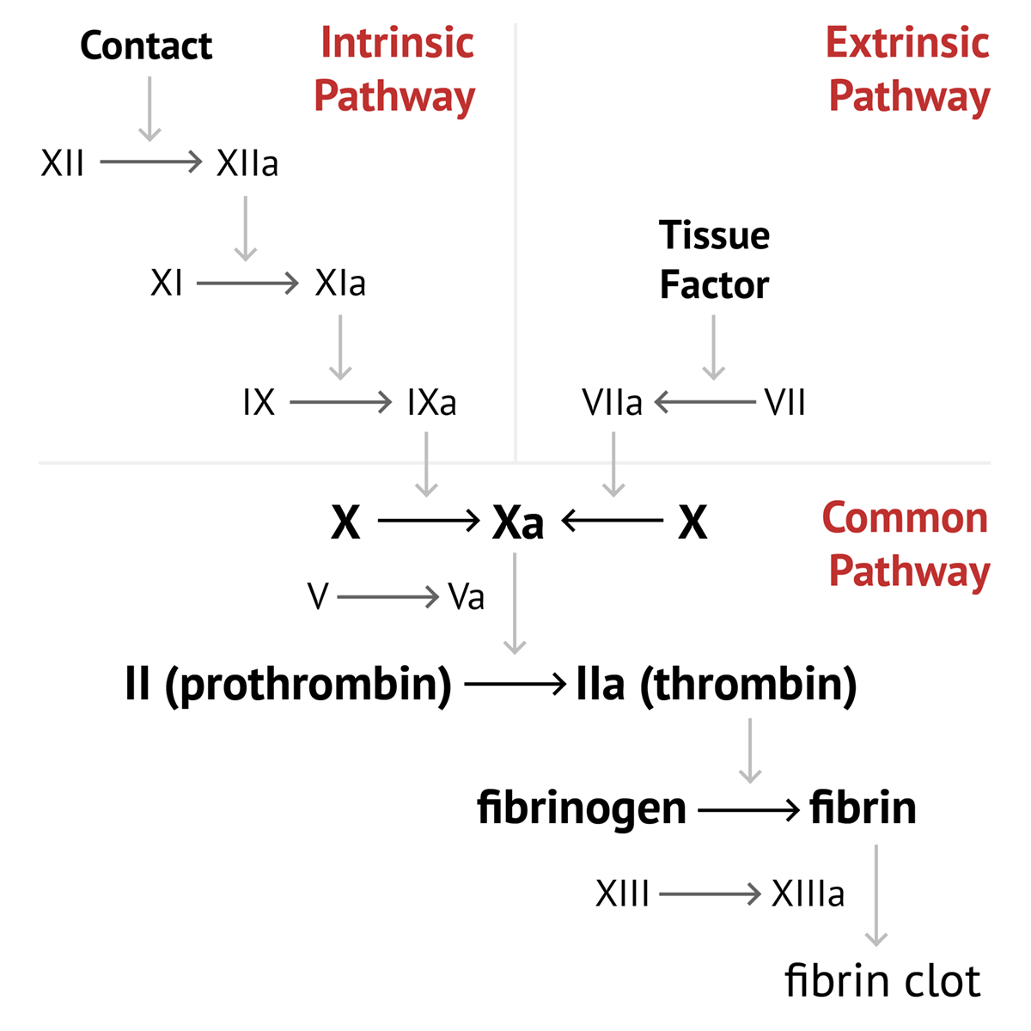
- Intrinsic system activated by injuries from inside, e.g. endothelial injury
Figure 29: Clotting cascade
- Extrinsic system activated through tissue injury from outside, e.g. normal cut
Resulting from this, different coagulation tests can be performed:
- Activated partial thromboplastin time (aPTT) = time of coagulation in intrinsic pathway
- Prothrombin time (Quick/INR) = time of coagulation in extrinsic pathway
- Fibrinogen level
- Factor XIII level

Rotem/TEG
Rotem = Rotational thromboelastometry
TEG = Thromboelastography
Different coagulation tests can be performed:
- inTEM/hepTEM = activation of coagulation by contact phase, intrinsic pathway
- exTEM = activation of coagulation by thromboplastin, extrinsic pathway
- fibTEM = fibrinogen function
- apTEM = function of aprotinin for clot stabilization
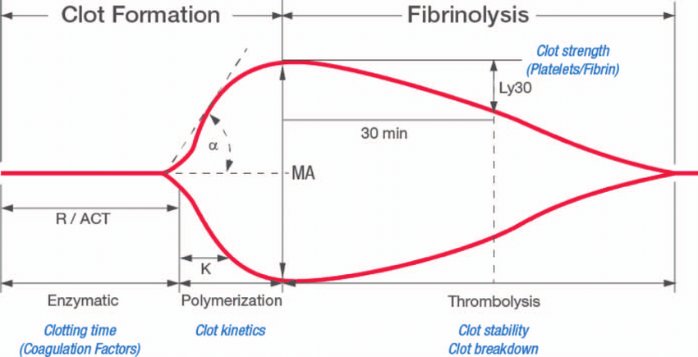
Shape of thromboelastogram dependent on different factors:
- Initiation phase
- Propagation phase
- Thrombin
- Fibrin
- Fibrinolysis

Figure 30: Thromboelastogram

Blood gas analysis
Different information can be taken out of a blood gas analysis:
- pH á alkalemia â acidemia
- pCO₂ á respiratory acidosis â respiratory alkalosis
- base excess á metabolic alkalosis â metabolic acidosis
The analysis of oxygen in the blood is important, as we need oxygen for the production of ATP as energy source as well as for muscle work.
Respiration can be sub-divided into four following processes:
- Ventilation: Movement of air between the environment and the lungs via inhalation
and exhalation. Inhalation leads to down-movement of diaphragm, Exhalation leads to up-movement of diaphragm.
- Gas exchange: Diffusion of O₂ into the blood, diffusion of CO₂ out of blood. Takes
place in alveolars. Oxygen bound to erythrocytes.
- Oxygen transport: Perfusion is the process by which the CV system pumps blood
throughout the lungs to place of oxygen consumption.
- Oxygen consumption: By muscles, brain, heart, gut and intestine.
Parameters to control ventilation:
- Respiratory rate = 12 – 15 / min
- Respiratory volume ~ 7 ml/kg
- Respiratory pressure = 15 – 20 mmHg
- Inspiratory time : expiratory time = 1 : 2
- Inspiratory flow = 30 l/min
- End-exspiratory pressure = 5 – 10 mml
Arterial blood gases are mainly measured in blood of the arteria radialis. Normal blood gas values:
Table 2: Normal blood gas values
 | Arterial | Venous | Capillary
pH | 7.35 – 7.45 | 7.31 – 7.41 | 7.35 – 7.45
pCO₂ | 35 – 45 mmHg | 40 – 50 mmHg | Same
pO₂ | 75 – 100 mmHg | 36 – 42 mmHg | < arterial
HCO₃ | 22 – 26 mmol/l | Same | Same
BE | - 2 to + 2 mmol/l | Same | Same
Oxygen saturation | > 95 % | 60 – 80 % | < arterial
An imbalance of oxygen, carbon dioxide and pH levels can be observed in different diseases, such as kidney failure, heart failure, uncontrolled diabetes, hemorrhage, chemical poisoning, drug overdose, shock.

Take-Home Messages
Point of care tools:
- Bedside
- Quick performance and fast results
- Quick re-evaluation of the case
- Economical
Important for the exam:
- Blood gas measures and what increase/decrease means
- Parameters from respiratory rate, respiratory volume, respiratory pressure
- Parameters from normal blood gas analysis

Laboratory Medicine

What is Laborarory Medicine?
= uses biochemical, electrochemical, physical, and molecular biological methods in order to confirm or disprove a suspected diagnosis by analysis of patient samples as well as to monitor the course of disease and/or therapy.

What is the use of Laboratory Medicine?
- Possibility to measure > 600 different parameters
- 70 – 85 % of clinical decisions are based on results of laboratory analyses

What is measured in Laboratory Medicine?
From a principal point of view:
- Blood samples
  - Arterial blood whole blood
  - Capillary blood plasma (blood with coagulation factors)
  - Venous blood serum (blood without coagulation factors)
- Aspirate samples
- Liquor samples
- Urine samples
- Stool samples
- Nasal discharges
- Sudor samples
- …
In blood samples, the caps of the blood tubes have different colors, which are used to determine the contained anticoagulant:
- Red: EDTA used for blood count analysis
- Yellow: Heparin used for clinical chemistry
- Green: Citrate used for coagulation analysis
- Light yellow: Fluoride used for glucose and lactate analysis
- Purple: Erythrocyte sedimentation tube used to determine erythrocyte sedimentation rate
Example: Measurement of electrolytes is normally performed with heparin blood. If EDTA blood is used, the contained Mg²⁺ and Ca²⁺ are releasing K⁺ out of the EDTA complex, what leads to an increase in measured K⁺ and a decrease in measured Mg²⁺ and Ca²⁺ concentrations. The other parameters to be determined are not disturbed.
From a medical point of view:
- In screenings: Evidence for
  - Running out
  - (early) diagnosis of a disease
- In the event of illness: Evidence for
  - Confirmation
  - Disprove
  - Differential diagnosis
The definition of “healthy” and “sick” is based on a reference interval determined via Gaussian normal distribution of measurement values from healthy objects. In clinical medicine, a reference interval of μ ± 2 σ is chosen to include about 95 % of the values.
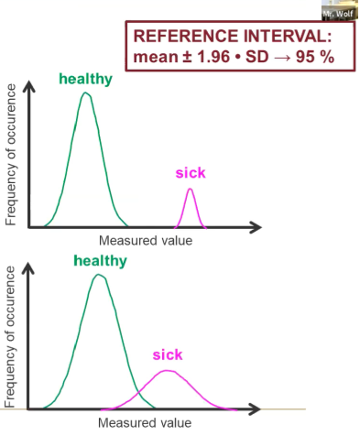
Diagnostic performance:
- Diagnostic sensitivity = $\frac{N(true positive)}{N(total sick subjects)}$
= chance that a sick patient indeed receives a positive result
- Diagnostic specificity = $\frac{N\left(true negatives\right)}{N\left(total healthy subjects\right)}$
= chance that a healthy patient indeed receives a negative result
- Positive predictive value = $\frac{N\left(true positives\right)}{N\left(total positive results\right)}$
= chance that a positive result indeed identifies a sick patient
- Negative predictive value = $\frac{N\left(true negatives\right)}{N\left(total negative results\right)}$
= chance that a negative result indeed identifies a healthy person
Analytical performance: Accuracy
- Precision coefficient of variation
- Trueness difference to target value
From a pathobiochemical/pathophysiolocial point of view: Adaptions, changes or disturbances of the body (function) because of and/or in consequence of pathological circumstances. Possible changes:
- (Increased) Release of cell components into the blood following cellular damage
  - Organ-specific enzymes: exclusively (or predominantly) in specific tissues
  - Structural proteins
  - E.g. Pancreatitis: increase of α-amylase, lipase
  - E.g. myocardial infarction or muscle damage: increase of LDH, AST, CK
Enzyme pattern for acute severe organ injury with cell necrosis
- Impaired synthesis/secretion because of insufficiency of organ functionality
- Impaired excretion because of insufficiency of organ functionality
- Pathophysiologic synthesis/secretion in the context of a disease
  - E.g. tumor markers, acute phase proteins
- Decrease of concentration due to
  - Complexation
  - Increased consumption/expenditure
  - Accelerated/anticipated degradation
  - Increased depletion and/or
  - Downregulation
- Change in concentrations of metabolites due to metabolic disorders
  - E.g. diabetes mellitus, disorders of lipid metabolism, disorders of metabolism of amino acids, peptides and proteins, heme biosynthesis disorders, vitamins, trance minerals
From a biochemical point of view:
- Cell counts
  - Erythrocytes
  - leukocytes (granulocytes, lymphocytes, monocytes)
  - thrombocytes
- Concentrations
  - Structural molecules
  - Metabolites
  - Drugs
  - Toxic substances
- Enzyme activities

From a physical point of view:
- Light intensities
- Light scattering
- Electrochemical potentials
- Impedance
- Mechanical resistance
In case of blood, different interfering factors can be measured. This includes hemolysis, lipemia, and jaundice.
60 – 70 % of the errors occur preanalytical, only 15 – 25 % postanalytical and 8 – 15 % analytical.

Which methodologies are used?
1. For separation or isolation:
- Mechanical (acceleration)
Examples: centrifugy, flow cytometry
- Physicochemical Chromatography
=differential partitioning between a stationary phase and a mobile phase based on
  - Molecular size
  - Polarity/ionic charge (density)
  - Solubility
  - Chemical binding affinity
  - Adsorption
Examples: Liquid and gas chromatography
- Electrochemical
Example: Electrophoresis
= differential motion of dispersed molecules in an electric field based on
  - Molecular size
  - Molecular charge density
Examples: gel and capillary electrophoresis
2. For detection and measurement
- Optical measurements
  - Light absorption, e.g. color of chlorophyll
Lambert-Beer law
Examples: photometry, atomic absorption spectroscopy
  - Light emission
Examples: luminescence, fluorometry, atomic emission spectroscopy
  - Light scattering
Examples: flow cytometry, nephelometry, turbidimetry
  - Microscopy
- Mechanical measurements
  - Coagulometry
  - adioactivity measurements
- Electrochemical measurements
  - Electric voltage
  - Changes in electric current
  - Electric charge quantity
  - Electrical impedance
  - Electrochemical carge density
- Calorimetric measurements
  - Osmometry
- Moleculargenetic measurements
- Immunological methodologies
  - Antigen-antibody agglutination
  - Complement-binding reaction

What is important to know?
- Many different laboratory parameters can be analyzed in different sample materials and by different measurement methods
  - Results obtained by different methods are not necessarily comparable
  - Influencing factors like age or gender may have an influence on the results
  - Interference factors like hemolysis, lipemia and icterus (jaundice) may have an influence on the results with the severity depending on the methodology
- Results of medical measurements are interpreted in the context of reference intervals covering ≈ 95 % of the subjects in a healthy cohort
  - Results outside the reference interval are not necessarily proof of a pathological circumstance
  - Sick patients do not necessarily present with results outside the reference interval
  - Clinical performance of a diagnostic test can be described with features of sensitivity, specificity, positive predictive value and negative predictive value
  - Analytical performance of a diagnostic test can be described with features coefficient variation (indicating precision) and deviation of the mean from the target value (indicating trueness)
- Many different biochemical and physiological methodologies are applied in clinical chemistry

Example exam questions
- Sonography: What is needed for sound to travel?
  - Mechanical and longitudinal waves transduce a medium.
- Point-of-care diagnostic tools. Which is wrong?
  - Multiplate platelets function analyzer
  - Capnography
  - TEG
  - Rotem
  - Blood gas analysis
- Benefits of point-of-care diagnostic tools. Which is wrong?
  - Fast performance
  - Quick results
  - High costs
  - Less blood drawn
  - Bedside performance
- Normal artery blood gas values. Which value is correct?
  - pH 7.35 – 7.45
  - pO₂ 35 – 45 mmHg
  - pCO₂ 75 – 145 mmHg
  - oxygen saturation < 90 %
  - BE – 8 to – 4

