Block Lecture Statistics 1
Winter 2014/2015
Exam 24.3.2015

Name | Matrikel Number | Affiliation

Exercise 1

A fair coin ("Head" or "Tail") is tossed four times. Write down two probability spaces (set Ω, Probability function P) to describe this experiment:

Probability Space 1 (taking into account the sequence of Heads and Tails).

Ω = {(0,0,0,1),(0,0,1,0),(0,0,1,1),(0,1,0,0),(0,1,0,1),(0,1,1,0),(0,1,1,1), (1,0,0,1),(1,0,1,0),(1,0,1,1),(1,1,0,0),(1,1,0,1),(1,1,1,0),(1,1,1,1)}

Anmerkung Eric: Hier fehlen 2: (0000) und (1000)

P: P(i,j,k,l) = 1/16

Probability Space 2 (counting the number of Heads)

Ω={(0,0,0,0),(0,0,0,1),(0,0,1,1),(0,1,1,1),(1,1,1,1)} oder ist Ω gleich wie in Space 1?

Anmerkung Eric: Ich habe hier einfach {0,1,2,3,4}, also die Anzahl der Heads

P:
- P(0xH) = 1/16
- P(1xH) = 4/16
- P(2xH) = 6/16
- P(3xH) = 4/16
- P(4xH) = 1/16

Exercise 2:

Which of both spaces from Exercise 1 is a Laplace Probability Space?
Justify your decision.

Space 1 – since each single event hast he same probability

Exercise 3:

In an experiment tumor growth in mice for two genotypes (wild type, mutation) is observed.

(1) Without taking into account effect of time, all measurements of mutated mice are compared to all measurements of wildtype mice.

(2) For a fixed time point we compare tumor size between wild type and mutation.

(3) Separately for each genotype we compare tumor size after 1 week with tumor size after 3 months

Classify (1) - (3) into „independent samples“, „dependent samples“, „repeated measurements".

Experiment

Independent samples dependent samples repeated measurements

(1) O O X

(2) X O O

(3) O X O

Exercise 4:

Define the following parameters which are needed for diagnostic tests:

Sensitivity = TP/(TP+FN) ; P(T+|D+) bzw TruePos./Diseased

Specificity= TN/(TN+FP) ; P(T-|D-) bzw TrueNeg./Healthy

Positive Predictive Value = TP/(TP+FP) ; P(D+|T+) bzw TruePos./Positives

Negative Predictive Value = TN/(TN+FN) ; P(D-|T-) bzw TrueNeg./Negatives

Prevalence = TP+FN ; P(D+) bzw Diseased/All
You may formulate the definitions in terms of probabilities or observed frequencies, both is correct.
Exercise 5:

Give a formula for the calculation of the positive predictive value in terms of prevalence, sensitivity and specificity.

Pos. pred. Value = $\frac{prevalence x sensitivity}{prevalen x sensitivity+\left(1-prevalence\right)x(1-specificity)}$

The Bayesian Formula in its general form is:

Exercise 6

For the following variables decide which type of scale they have:

Nominal scale Ordinal Scale Interval Scale

Eye colour X O O
[blue, green, brown, black]

Body Weight O X O
[underweight, normal weight, overweight]

Body Height [cm] O O X

Exercise 7

For the following sample, calculate mean, variance, standard deviation, median, and quartiles. Square Roots have not to be calculated explicitly.

Sample: 2 4 6 8 10 12 14 16

Mean 72/8 = 9

Variance 2*(49+25+9+1)/8 = 168/8 = 21
Anmerkung Eric: Ich habe für die Varianz Var=24 raus, da ich mit 1/(n-1) also mit 1/7 multipliziert habe. (Handelt sich ja um eine Statistik, also der Faktor 1/(n-1)

Standard Deviation = sqrt(21)

Median = 9

Quartiles = 5, 13 (or 4 and 12(?) In Lab Technologies mussten wir den Mittelwert nehmen, also 5 und 13)

Exercise 8

Write down two possible criteria (parameters, graphical tools) to check for normal distribution.

Criterion 1: skewness and kurtosis within [-1;+1]

Criterion 2: QQ-Plot n obig differences to the diagonal

Anmerkung Eric: Evtl. Histogramms?

Exercise 9

For each of the following four examples decide whether they are valid/not and reliable/not reliable.
Richtig= valid, reliable = präzise
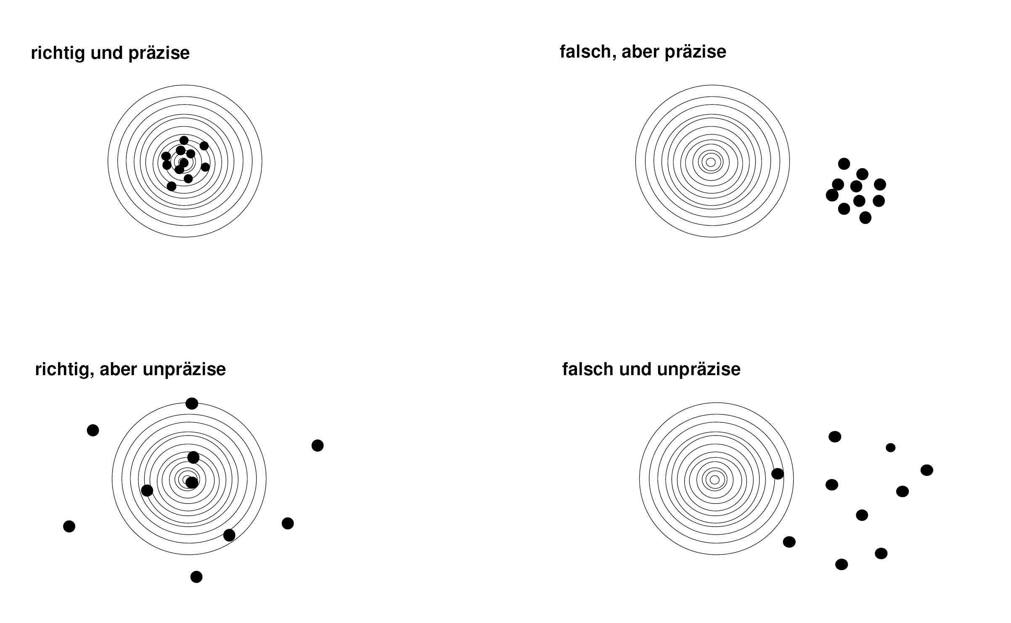

Exercise 10

Which of both limits
confidence limits
reference limits.
becomes systematically smaller if the sample size is increased?
Confidence limit!
R.L = mean+/- SD
C.L = mean+/- SD/sqrt(n)
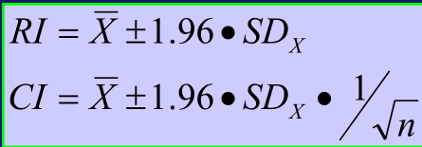
Exercise 11

In two studies correlation coefficients r between the concentrations of two metabolites were determined. In the first study, the correlation coefficient was 0.7, in the second study it was 0.3.

In the second study the result was claimed to be significant, in the first study the result was claimed not to be significant.

For both studies, the null hypothesis was r = 0 and the level of significance was 0.05 (two-sided).

Decide whether this is possible or whether there has to be an error in at least one of both studies.

Error X Possible O

If the second result is significant also the first hast to be significant, since it is further away from H0 (r=0) or in other words: The second result is closer to H0, so if the second is rejected, also the first hast to be rejected

Exercise 12

Note one advantage and one disadvantage of the cross over design as compared to the parallel group design.

Advantage: the influence of confounding covariates is reduced because each crossover patient serves as his or her own control

Disadvantage: - Carry-over-effect (need of wash-out period)
- The order of treatments may effect the result

Exercise 13

Perform the chi-square test for the following example.

 | Success | Failure | Total
Therapy A | 40=h11 | 60=h12 | 100=h1
Therapy B | 20=h21 | 80=h22 | 100=h2
Total | 60=h1 | 140=h2 | 200=h

e11 = 60*100/200 = 30
e12 = 140*100/200 = 70
e21 = 60*100/200 = 30
e22 = 140*100/200 = 70

H0: Therapy B shows no difference to Therapy A
H1: Therapy B is different to Therapy A

Chi-Square: (40-30)²/30 + (60-70)²/70 + (20-30)²/30 + (80-70)²/70 = 2*10/3+2*10/7=2*(100/21) ~10

Critical Value = 3.84

Interpretation: Therapies show no significant difference (10>> 3.84)

Exercise 14
Fill in the following Table for the choice of a statistical test:

2 Samples  Outcome | Independent | dependent
Categorical | Chi-Squar | McNemar
Ordinal | Mann-Whitney | Wilcoxon
Quantitatively not normal | Mann-Whitney | Wilcoxon
Quantitatively normal | t-test for independent sample | T-Test for dependent sample

