Block Lecture Statistics 1
Winter 2014/2015
Exam 24.3.2015

Name | Matrikel Number | Affiliation

Exercise 1

A fair coin ("Head" or "Tail") is tossed four times. Write down two probability spaces (set Ω, Probability function P) to describe this experiment:

Probability Space 1 (taking into account the sequence of Heads and Tails).

Müssen 2^n also 16 verschiedene Möglichkeiten sein. Sind aber nur 14. (Stimmt danke :D)
Ω = {(0,0,0,0),(1,0,0,0)(0,0,0,1),(0,0,1,0),(0,0,1,1),(0,1,0,0),(0,1,0,1),(0,1,1,0),(0,1,1,1), (1,0,0,1),(1,0,1,0),(1,0,1,1),(1,1,0,0),(1,1,0,1),(1,1,1,0),(1,1,1,1)}

P: P(i,j,k,l) = 1/16 Ich hätte geschrieben P(0)=P(1)=P(Head)=P(Number)= 1/16. Aber P(i,j,k,l) ist bestimmt auch ok…P(0) wäre doch 0,5 (?)

Probability Space 2 (counting the number of Heads)

Ω={(0,0,0,0),(0,0,0,1),(0,0,1,1),(0,1,1,1),(1,1,1,1)} oder ist Ω gleich wie in Space 1?
Eric : Ω={0*H,1*H,2*H,3*H,4*H}
P:
- P(0xH) = 1/16
- P(1xH) = 4/16
- P(2xH) = 6/16
- P(3xH) = 4/16
- P(4xH) = 1/16

Ich würde da schon die Fromel für die Binominalverteilung reinsetzten. Also:

P(wk) = (4 über k) * p ^k * (1-p)^(4-k) Wobei p = 0,5 und wk Teilmenge von Ω

Und k natürlich die Anzahl von Heads

Aber ich mags auch gern kompliziert ;-)
Exercise 2:

Which of both spaces from Exercise 1 is a Laplace Probability Space?
Justify your decision.

Space 1 – since each single event hast the same probability

Exercise 3:

In an experiment tumor growth in mice for two genotypes (wild type, mutation) is observed.

(1) Without taking into account effect of time, all measurements of mutated mice are compared to all measurements of wildtype mice.

(2) For a fixed time point we compare tumor size between wild type and mutation.

(3) Separately for each genotype we compare tumor size after 1 week with tumor size after 3 months

Classify (1) - (3) into „independent samples“, „dependent samples“, „repeated measurements".

Experiment

Independent samples dependent samples repeated measurements

(1) O X X

(2) X O O

(3) O X O

Anmerkung Eric: so hat er mir heute die Lösung gegeben. 1 ist dependent & repeated (da die Zeit nicht in Betracht gezogen wird). 2 ist independent. 3 ist dependent und wäre zudem intraindividiual comparison, weil wir innerhalb der Gruppen separate vergleichen.

Wichtig: repeated & intraindividual sind gleichzeitig damit auch immer dependent!

Exercise 4:

Define the following parameters which are needed for diagnostic tests:
Würde sagen beides richtig(?) Siehe Formel zu bedingten Wahrscheinlichkeiten, da muss man nicht nochmal teilen:
Sensitivity = TP/(TP+FN) = True positive/diseased = (T+|D+)/(D+) Also wenn bedingt dann so: (T+|D+) oder (T+ und D+)/(D+)

Specificity= TN/(TN+FP) = True negative/healthy(not diseased) = (T-|D-)/(D-) Also wenn bedingt dann so: (T-|D-) oder (T- und D-)/(D-)

Positive Predictive Value = TP/(TP+FP) = (D+|T+)/(T+) = True positive/positive tested Also wenn bedingt dann so: (D+|T+) oder (T+ und D+)/(T+)

Negative Predictive Value = TN/(TN+FN) = (D-|T-)/(T-) = True negative/negative tested Also wenn bedingt dann so: (T-|D-) oder (T- und D-)/(D-)

Prevalence = TP+FN =(D+) = diseased
You may formulate the definitions in terms of probabilities or observed frequencies, both is correct.
Exercise 5:

Give a formula for the calculation of the positive predictive value in terms of prevalence, sensitivity and specificity.

Pos. pred. Value = $\frac{prevalence x sensitivity}{prevalen x sensitivity+\left(1-prevalence\right)x(1-specificity)}$

The Bayesian Formula in its general form is:

Exercise 6

For the following variables decide which type of scale they have:

Nominal scale Ordinal Scale Interval Scale

Eye colour X O O
[blue, green, brown, black]

Body Weight O X O
[underweight, normal weight, overweight]

Body Height [cm] O O X

Exercise 7

For the following sample, calculate mean, variance, standard deviation, median, and quartiles. Square Roots have not to be calculated explicitly.

Sample: 2 4 6 8 10 12 14 16

Mean 72/8 = 9

Variance 2*(49+25+9+1)/8 = 168/8 = 21 Variance = 49/7 + 25/7 + 9/7 + 1/7 + 1/7 + 9/7 + 25/7 + 49/7 = 2*(49+25+9+1)/7 =168/7 ?? = 24 ja hast recht (n-1)…

Standard Deviation = sqrt(21) SD=Wurzel(24)= 4,9

Median = 9

Quartiles = 5, 13 (or 4 and 12(?) In Lab Technologies mussten wir den Mittelwert nehmen, also 5 und 13) Bei 25% und 75% nimmt man soweit ich weiß den kleineren Wert, also 4 & 12

Exercise 8

Write down two possible criteria (parameters, graphical tools) to check for normal distribution.

Criterion 1: skewness and kurtosis within [-1;+1]

Criterion 2: QQ-Plot no big differences to the diagonal

Exercise 9

For each of the following four examples decide whether they are valid/not and reliable/not reliable.
Richtig= valid, reliable = präzise
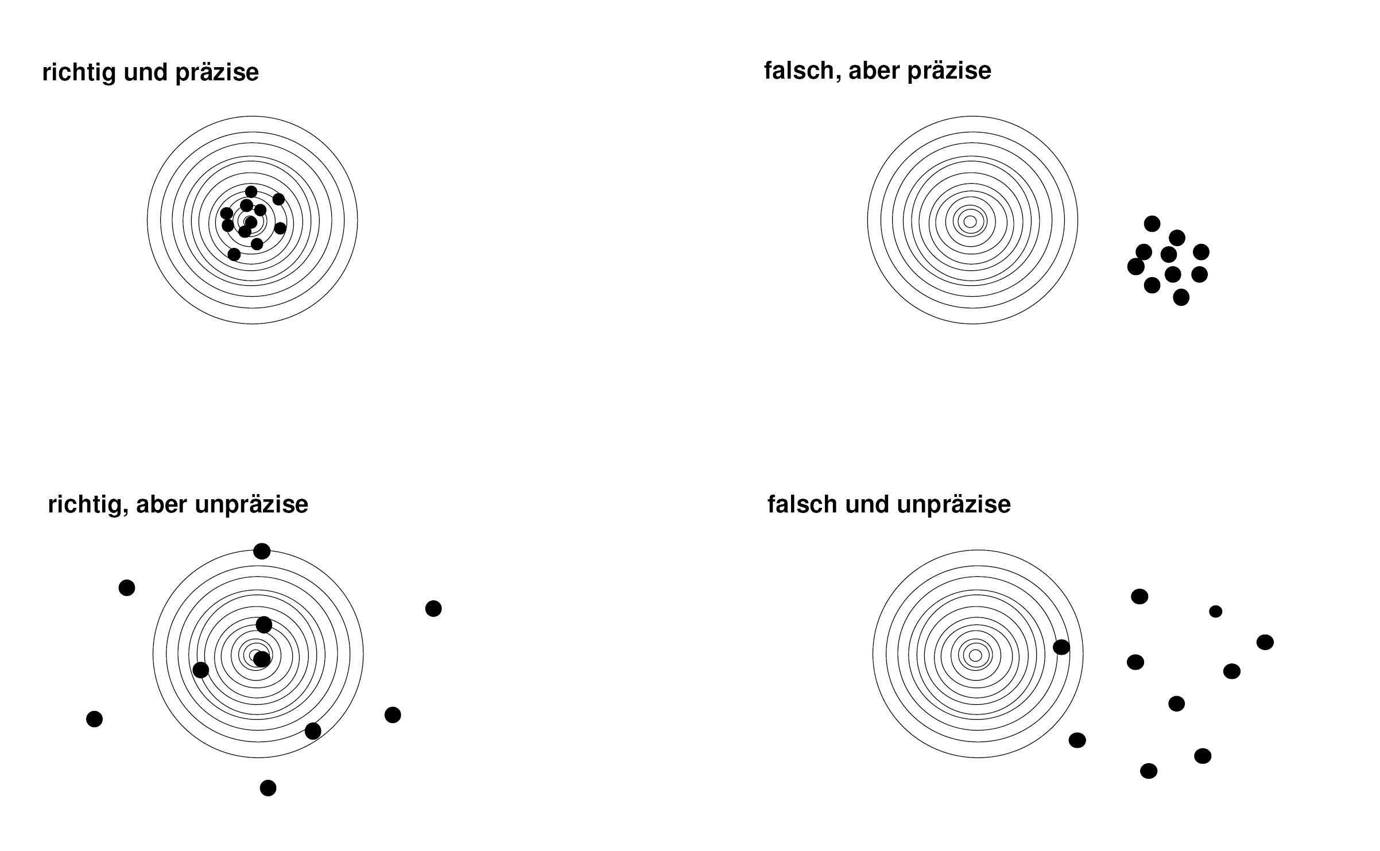

Exercise 10

Which of both limits
confidence limits
reference limits.
becomes systematically smaller if the sample size is increased?
Confidence limit!
R.L = mean+/- SD
C.L = mean+/- SD/sqrt(n)
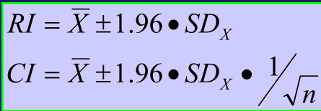

The Cl names the borders of the intervall in which the Mean is in with a probability of about 95 %. If there are more samples, the mean gets more and more valid to the true value and the Cl decreases. For n -> unendlich the mean becomes the true value and the cl becomes 0.

Son bisschen Text will der bestimmt haben und nicht nur die Formel. Wer Fehler in meinem Englisch findet darf sie zusammen mit einem neck Steak zu sich nehmen ;-)
Exercise 11

In two studies correlation coefficients r between the concentrations of two metabolites were determined. In the first study, the correlation coefficient was 0.7, in the second study it was 0.3.

In the second study the result was claimed to be significant, in the first study the result was claimed not to be significant.

For both studies, the null hypothesis was r = 0 and the level of significance was 0.05 (two-sided).

Decide whether this is possible or whether there has to be an error in at least one of both studies.

Error X Possible X

If the second result is significant also the first hast to be significant, since it is further away from H0 (r=0) or in other words: The second result is closer to H0, so if the second is rejected, also the first hast to be rejected

Das Signifikanzlevel ist abhängig von der Sample Zahl n. Während der Korrelationskoeffizient unabhängig von n ist. Es ist daher möglich, wenn sich Versuch 1 und Versuch 2 in ihrer Samplezahl unterscheiden (ich glaube n1<<n2), dass das Signifikanzlevel für Versuch 1 oberhalb der gegebenen 0,7 liegt während es im zweiten Versuch (auf Grund der größeren Samplezahl) unterhalb von 0,3 liegt (Also jetzt absolut gesprochen. Relativ gesehen ist das Signifikanzlevel bei beiden Versuchen wie gefordert 0.05). Damit wäre das Ergebnis des ersten Versuchs nicht signifikant wärend das des zweiten sehr wohl signifikant seien könnte. Das Ganze ist also möglich und muss nicht zwangsweise durch einen Fehler verursacht worden sein.

Ich würde sagen es ist möglich, durch eine Vergrößerung der Messungen. Hast vollkommen recht, hat er ja 1000x gesagt…

Exercise 12

Note one advantage and one disadvantage of the cross over design as compared to the parallel group design.

Advantage: the influence of confounding covariates is reduced because each crossover patient serves as his or her own control

Disadvantage: - Carry-over-effect (need of wash-out period)
- The order of treatments may effect the result

Exercise 13

Perform the chi-square test for the following example.

 | Success | Failure | Total
Therapy A | 40=h11 | 60=h12 | 100=h1.
Therapy B | 20=h21 | 80=h22 | 100=h2.
Total | 60=h.1 | 140=h.2 | 200=h..

e11 = 60*100/200 = 30
e12 = 140*100/200 = 70
e21 = 60*100/200 = 30
e22 = 140*100/200 = 70
H0: Therapy B shows no difference to Therapy A
H1: Therapy B is different to Therapy A

Chi-Square: (40-30)²/30 + (60-70)²/70 + (20-30)²/30 + (80-70)²/70 = 2*10/3+2*10/7=2*(100/21) ~10 =9,52

Critical Value = 3.84

Interpretation: Therapies show no significant difference (10>> 3.84) X^2 ist größer als X^2-kritisch, also wird die Nullhypothese verworfen. Somit unterschiedet sich Therapie A signifikant von Therapie B. Logisch, wenn die Therapien gleich wären wäre X^2 0

Exercise 14
Fill in the following Table for the choice of a statistical test:

2 Samples  Outcome | Independent | dependent
Categorical | Chi-Squar | McNemar
Ordinal | Mann-Whitney | Wilcoxon
Quantitatively not normal | Mann-Whitney | Wilcoxon
Quantitatively normal | t-test for independent sample | T-Test for dependent sample

