BMT II SoSe 2019
This is just my self-made script. No guarantee for completeness and correctness!

Biomedical Sensors
- Biomedical instrument: Physiologic system sensor processor display storage observer

Sensor characteristics
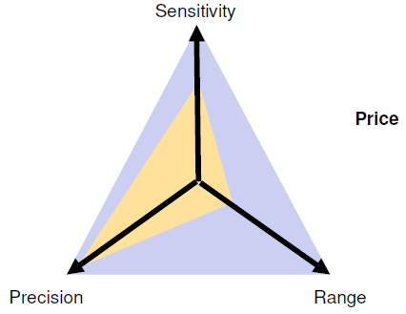

Classification of biomedical sensors
- Physical sensors
  - Displacement, mechanical, hydraulic, thermal, electrical, optical
- Chemical sensors
  - Gas, electrochemical, bioanalytic, photometric

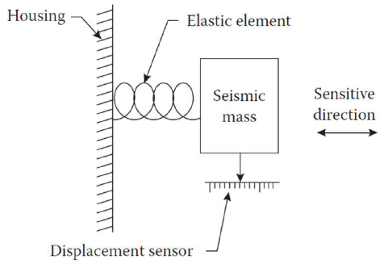
Physical sensors
- Geometric
  - Sense strain, displacement
- Kinematic
  - Sense velocity, acceleration
- Force-torque
  - Sense applied force or torque
- Fluidic
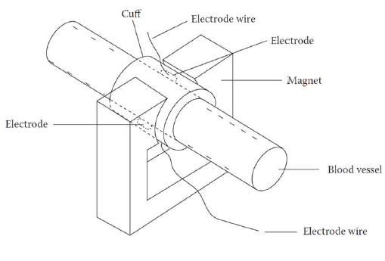
  - Sense pressure (left image), flow (right image)
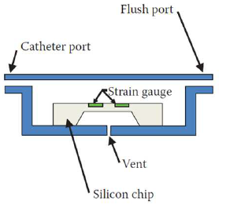

- Thermal
  - Sense temperature, heat flux

Examples for Applications of physical sensors
- Liquid metal strain gauge breathing movement, limb plethysmography
- Magnetic displacement sensor breathing movement
- LVDT Muscle contraction, uterine contraction sensor
- Load cell electronic scale
- Accelerator subject activity
- Miniature silicon pressure sensor intraaterial blood pressure, urinary bladder pressure, intrauterine pressure
- Electromagnetic flow sensor cardiac output (with integrator), organ blood flow

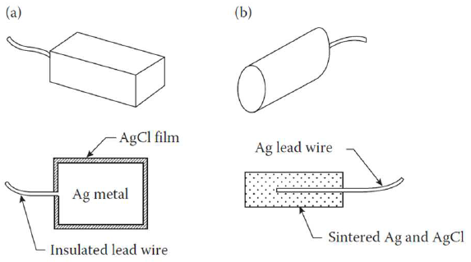
Bipotential Electrodes
- Bioelectric Signals Sensed by Biopotential Electrodes
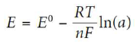

Application of bipotential electrodes
- Cardiac monitoring
  - ECG measured with Ag/AgCl electrode (with sponge/hydrogel)
- Infant cardiopulmonary monitoring
  - ECG impedance measured with Ag/AgCl electrode (with sponge/hydrogel)
- Sleep encephalography
  - EEG measured with gold or Ag/AgCl cups, active electrodes
- Cardiac electrograms
  - Measured by intracardiac probe
- Implanted telemetry of biopotentials
  - ECG measured with stainless-steel wire loops, EMG measured with platinum disks
- Eye movement
  - EOG measure with Ag/AgCl electrode (with hydrogel)

Optical Sensors
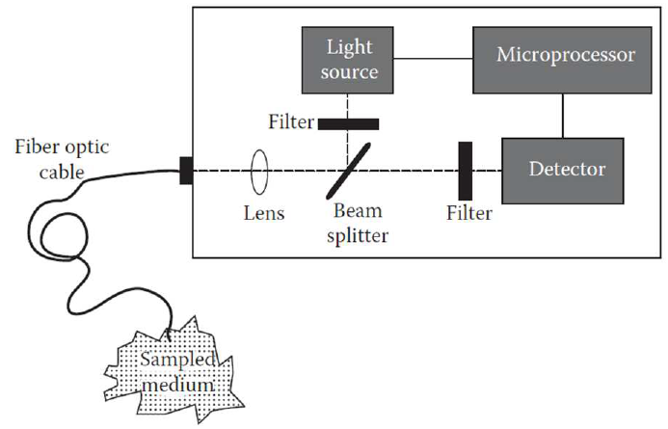
Fiber Optic Sensors for Oxygen Saturation:
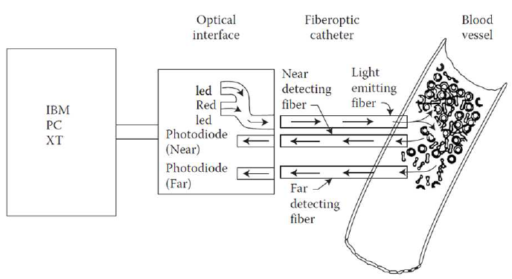
Indicator-mediated Fiber Optic Sensors:
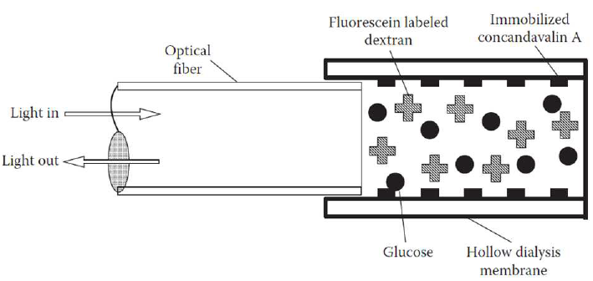
Own research:
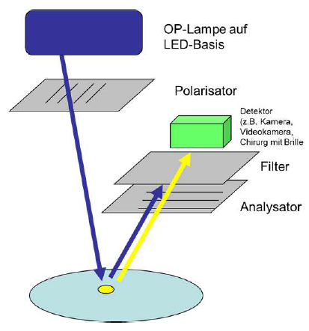

Electrosurgery (29.04.19)

Hemostasis
- Tissue shrinks due to desiccation and denaturation
- Blood and proteins clot

Cutting
- Cut with a coagulation seam at the edges of the cut low blood loss

Influencing physical quantities
- Duration of the current flow
- Resistance (material, …)
- Current density (J)
  - Amount of current
  - Diameter of the conductor
  - Small cross-section high current density HOT
- Joule Heating: (Q= F*R*t)

Technical principle of the neutral electrode
- The neutral electrode closes the electric circuit
- designed very big to have a low current density and no heating
- must have effective skin contact

Effect/Voltage
- using the effect button, the voltage can be adjusted as required
- increasing the voltage leads to more intensive sparks, greater current density broader coagulation zone

Voltage and sparks – cutting effect
- Sparks are required for cutting (needs approx. > 200 V)
- The voltage ionizes the air and makes it electrically conductive
- The extremely thin sparks conduct the current and cause the required very high current density
- Higher voltages result in a broader coagulation seam and increased hemostasis
- With higher voltages the sparks get more intense and longer
- Longer sparks may spread over the surface and thus cause a less deep, broarder coagulation
- By using pulsating currents, the “cutting of the sparks” is reduced and only coagulation is happening

Resistance (Impedance) R
- Well perfused tissue (muscle) has a low resistance
- Fatty tissue, bones and dry, coagulated tissue have a high resistance

Why high frequency current?
- From ~100kHz on the neuromuscular stimulation is very low no electric shock
- HF-standard: > 200kHz, Erbe 350 kHz
- High voltages generate electrical fields and may affect nearby devices, …

Capacitive coupling
- transfer of energy within an electrical network or between distant networks by means of displacement current between circuit(s) nodes, induced by the electric field.
- The current caused by capacitive couplings is proportional to the voltage, frequency, surface
- Inverse proportional to the distance
- Soft coagulation: no sparks, cutting because of cooking effect

Dielectric strength
- maximum electric field that the material can withstand under ideal conditions without breaking down (i.e. without failure of its insulating properties)
- The selected voltage may not exceed the given dielectric strength [Vp] of the instrument

Modes
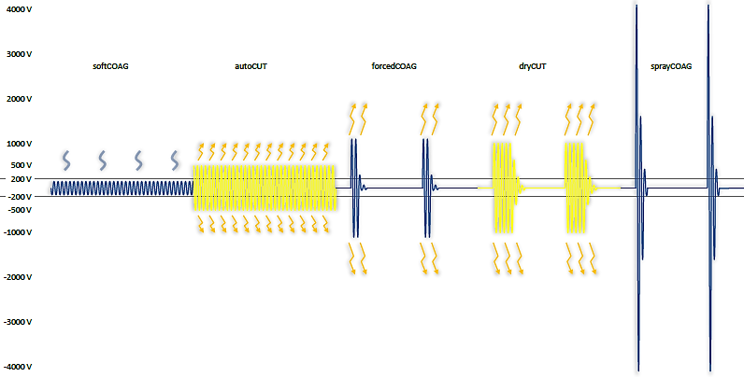

Crest factor
- Maximum voltage divided by Effective voltage (U_{peak}/U_{eff}.), for normal sign wave: 1.414
  - The higher the number the more “modulated” the voltage is (e.g. for the spray mode)

Control technology
- The tissue effect cannot be controlled without controls
- Changing electrical resistance affects voltage and current and thus tissue effect
- Control technology responds to changing resistance, continuously adjusts other electr. Parameters (power, voltage, …) automatically and quickly to compensate

Constant voltage control
- To achieve homogeneous tissue effect, most modes keep voltage constant
- Resulting power (P=U*I) is variable

Power P
- Generator automatically adjusts the power
- Power limitation settings prevent unwanted power peaks
- $P=\frac{U^{2}}{R}$

Argon plasma coagulation APC
- Argon gas is ionized using high voltage, approx. 4000 V (electrically conductive plasma)
- Argon plasma bridges the gap from electrode to tissue and closes electr. circuit
- Better ionization then in air
- Used in flexible endoscopy in GIT
- Benefits:
  - Particularly superficial coagulation
  - Fast, broad coagulation
  - Contactless – tissue does not stick to electrode
  - Adjustable penetration depth
  - In gastroenterology less risks of perforation
  - Reduced carbonization and development of smoke

Safety
- Leakage current has to be prevented
- Patient must be positioned electrically insulated
- Avoid contact with metal parts risk of burning skin
- Remove jewelry
- Remove hair
- Caution with implants higher current density
- Recommendations for patients with active implants:
  - Preferably bipolar instrument
  - If monopolar:
    - Position neutral electrode at a position that does not let the current flow across the active implant
    - Select low voltages and low power limitation
    - Use short activation times with pauses in between
- Place neutral electrode correctly diagonal alignment my result in higher current density in one of the corners, long side of the pad must face the operating field
- Fire hazard: gases that contain alcohol and other flammable gases (disinfection, oxygen, …) etc. may ignite must dry properly before patient is covered with sheets!
- Do not use indirect forceps coagulation surgical gloves do not provide reliable electrical insulation

Life Support Machines (13.05.19)

Pump Basics
- Roller Pump
  - Principle of displacement
  - Works occclusively, no backflow in open systems, i.e. no retrograde flow possible
  - Mech. alteration of blood components
  - Microemboli due to tubing abrasion over a long period of time??
- Centrifugal pump:
  - Transport of blood by centrifugal acceleration
  - Not occlusive, i.e. retrograde flow possible in principle
  - Less damage to corpuscular blood components

HLM
- Heart beat is stopped to allow operations e.g. inside the heart
- Patient is cooled down to 28-30°C in heart operation to reduce metabolic action
- Pump brings venous blood from right atrium (vena cava inferior) to oxygenator (+O2, -CO2) and then back to aorta ascendens (secure blood supply of the head)
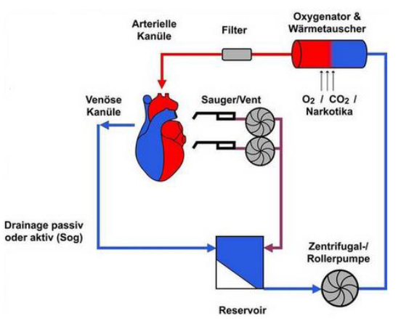

When do we need a heart lung machine?
- New aortic valve
- Bypass (e.g. when there are a lot of obstructions, but bypass can also be done with beating heart)
- Replacement of mitral valve
- congenital heart surgery, 1 of 125 babies has a heart defect (most common ventricular septum defect)

cardiogenic shock
- Definition: life threatening condition in which the blood circulation in the capillaries is reduced. As a result, the tissues are undersupplied with oxygen and, ultimately, metabolic disorders occur ORGANS die off
- heart failure, not enough blood circulation
- 40-50% Mortality
- causes:
  - Myocardial infarction
  - Acutely decompensated Heart Valve Defects
  - Acute Decompensated Heart Failure
  - Acute Pulmonary Embolism
  - Acute Myocarditis / Takotsubo Cardiomyopathy
  - Therapy refractory arrhythmias
- therapy: Intra-Aortic balloon pump (IABP) (exam!!!)
  - balloon brought into aorta brought near to a. subclavia sinistra
  - blown up in diastole increased blood pressure in the aortic arc increased blood flow in coronary arteries and head
  - in systole deflated flow in abdomen etc.
  - BUT: no significant improvement with this therapy
- Extra-corporal life support system (ECSL): bring out blood from vein and back into an artery can add blood pressure, … heart + lung machine
  - Can be attached to the patient everywhere (also at home in emergencies, …)
    - Further development of HLM, e.g. Smaller compared to HLM
  - Only called ECSL when veno-arterial (VA) connection is used.
  - Blood either drained from v. femoralis communis where tip is brought up to the heart or in patients with open chest directly from right atrium
  - Blood given back in a. femoralis communis (tip also brought up to the heart)
- Extra corporal membrane oxygenation (ECMO): supports lung, brings in oxygen without the lungs only lung machine
  - Veno-venous pulmonary support
  - Catheter brought in the v. femoralis communis and tip is brought up to the heart
  - Blood back in V. subclavia dextra
  - Moderate circulatory load (volume deprivation) "Lung Protective."

Complications of ECLS/ECMO
- Vascular:
  - Bleeding
  - Vascular injury
  - Thrombosis, pulmonary embolism
  - Ischemia, compartment syndrome
- Systemic:
  - Hemolysis
  - Microembolization
  - Thrombocytopenia
  - Increased bleeding tendency
- Mechanical:
  - Thrombus in the system
  - Air-bubbles in the system
  - Disconnection of the system
  - Dislocation of the cannula
- Divers:
  - Infection of the oxygenator
  - Activation of the coagulation cascade
  - Activation of the inflammation cascade
  - Increased occurrence of a HIT

Intracorporal systems
- Total artificial heart (TAH) Cardiowest: intracorporal

Left ventricle assist device (LVAD):
- only replaces the left heart (right heart has to function still able to pump the blood sufficiently to the lung)
  - Draws blood from apex of left ventricle (?), brings back the blood to aorta ascendens
  - Complications: bleedings (because of anticoagulative drugs) and thrombi
- centrifugal pump
- Implantation of pump via Thoracotomy
- Implantation criteria for LVAD:
  - Left ventricular ejection fraction < 25%
  - More than 3 inpatient admissions per year due to decompensated heart failure
  - Dependence on i.a. therapy
  - Increasing organ failure attributed to reduced perfusion pressure
  - Decreasing right ventricular function
  - Missing transplant or unsuitability for transplantation

Paracorporal Ventricular Assist Device
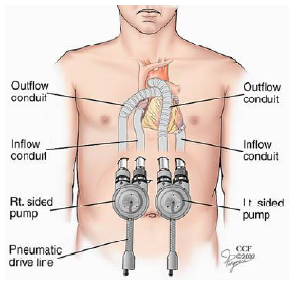

Thrombembolic Complications
- If a thrombus sticks in the pump, the device does not work anymore
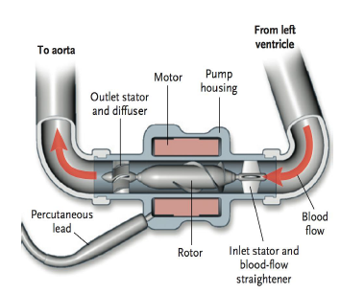

Thermofusion (Erbe, 27.05.)

Bipolar electrosurgery
- Like a tweezer
- For small vessel coagulation
For bigger vessels: Ligature (Abschnüren), sewing, clipping
Or: bipolar sealing of the vessel with a “BiClamp”
- Advantages:
  - no suture material or clips remain in the patient
  - Easy handling
  - Shorter operation time
  - Less blood loss
  - Less pain, better healing
- Disadvantages:
  - heating of lateral tissue
  - handling of hot instrument

Bipolar coagulation:
- hemostasis influenced by user, depending on:
  - activation time
  - pressure
  - distance of the jaws
- no substitute for clips or structure
- coagulation of small vessels and surface capillary bleeding

Vessel sealing:
- Largely defined hemostasis
  - Larger area
  - Higher pressure
  - Higher current up to 5.4A
  - Dynamic regulation
  - Energy input controlled by AUTO STOP (device starts beeping when you have a reliable sealing)
- Reliable fusion of larger vessels (up to 7mm diameter, then risk of bursting, sergeants use it for less than 7, maybe 5 mm)

Instruments and Indications
Bipolar vessel sealing equipment:
- Instrument
- Generator
- Footswitch
Examples:
- Thyroidectomy:
  - Narrow instruments
  - Micro-incision under 3cm
  - MIVAT: Minimally Invasive Video-Assisted Thyroidectomy
- Hysterectomy:
  - Long handles
  - Less acuminate (pointed) jaws
  - Vaginal or
- Cystectomy:
  - Long handles
  - Long, curved and narrow jaws
- Depending on indication you used different optimized instruments

Trends
- Miniaturization
- Ergonomics
- Multifunctionality
  - Dissection, Sealing & Coagulation, Cutting
- Simplification
- Protection of intellectual property (patents lot of competitors, …)
- Single-use instruments
- 5 functions in one instrument:
  - Dissecting and mobilizing tissue
  - Sealing vessels
  - Cutting tissue mechanically
  - Coagulating capillary bleedings
  - Holding and gripping
- Lot of technical things inside the handpiece difficult to sterilize ( single-use instruments)

Structure of a vessel
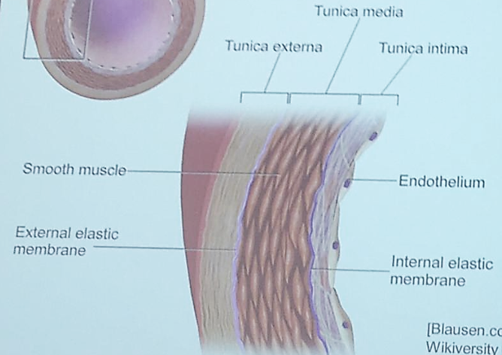
- Intima (endothelium, …), internal membrane, Tunica media (smooth muscle), external membrane, Tunica externa

Collagen molecules
- Hydrogen bonds twist groups of 3 amino acid strands to form a triple helix (requires vitamin C)
- Cross-links connect the ends of the molecules to create an ordered collagen structure with considerable tensile strength
- Devitalization:
  - Breaking of the hydrogen bonds, resulting in the disintegration of the triple helix
  - Cross-links remain largely intact
  - Agglutination of the molecules and modified tensile strength
  - Amorphous structure
- Vessel sealing:
  - Separation of the amino acid strands and cross-links
  - Reorganization: Amino acids and cross-links of both tissue components form a combined tissue structure
  - Scar tissue with modified properties
  - Renewal of the modified molecules to form collagen takes several months
- Biochemical factors
  - 28 different collagens
  - Glucose content
  - Tissue age
  - …
varying behavior with regard to temperature and application time

- By heating the tissue the collagen fibers are getting shorter (bis ca. 55°C)
- At 65-70°C Collagen “melts”, the smaller structures reorganize in the sealed vessel

Biophysical system

Interactions:
- Electrical system heats the tissue thermal system (conductivity changes during coagulation) interacts with bio-chemical system TS expands, BCS has conformational changes has all an impact on mechanical and then also electrical system
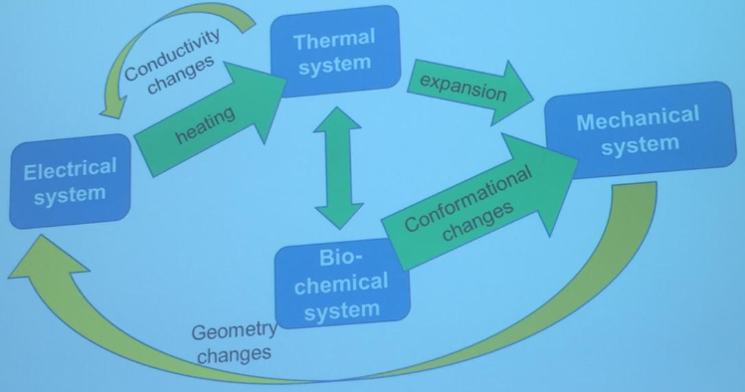
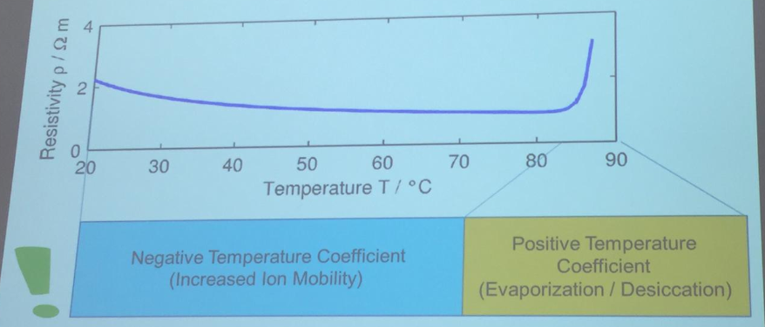
- Until 85°C negative temperature coefficient (because of increased ion mobility) decreased resistance
- For > 85°C positive temperature coefficient (because of evaporation, desiccation) higher resistance

Voltage & Current profile
- Voltage in pulses
- Current increases fast in beginning because resistance of the tissue decreases, then current decreases because of the cooking of the tissue (vapor, ...)
- If the voltage is switched of boiling stops immediately some vaper goes out of the tissue, some condenses again
- In the next pulse the current is not so high anymore
- Tissue normally has a negative temperature coefficient, but at ~85°C it gets positive

Research
- Mathematical modelling of heat distribution, …
- try to decrease the damage in surrounding tissue (lateral damage)
- …

Summary

What is electrosurgery?
- Application of high-frequency current to biological tissue as a means to generate a thermal effect for surgical purposes
- “intrinsic heating”
- Is NOT physiotherapeutic heat
  - Therapeutic heat of tissue for muscle relaxation, … no surgery
- Since 1920
- World-wide
- Used in < 90 % of all surgical interventions
- In all branches of surgery:
  - Visceral, gynecology, urology, cardiology, GIT

Why electrosurgery?
- Hemostasis (reduction of bleeding)
- Devitalization / Ablation (Tumors and other lesions)
- Cutting with hemostasis (reduced bleeding)
- Advantages:
  - Reduced blood loss
  - better view
  - shorter procedure time
  - faster recover faster dismission from hospital

Hemostasis
- Tissue shrinks due to desiccation (water vaporizes) and denaturation

Non-contact argon plasma coagulation (APC)
- Argon gas around electrode
- With approx. 4000V (important) you get argon plasma sparks

Thermic effect
- Depends on current density (current strength/application area)
- Occurs mainly on active electrode
- Ca. 60°C: Coagulation, devitalization, irreversible
- Ca. 100°C Cutting/Desiccation

Why high frequency current?
- DC Electrolytic Effect (and electr. Muscle stimulation and heating)
- Low frequency AC electrical muscle stimulation (and heating)
- High frequency AC (> 300 Hz) does not interact with neurons and muscle cells only heating

Bipolar vessel sealing
- Advantages
  - No suture material or clips remain in the patient
  - Easy handling
  - Shorter operation time
  - Less blood loss
  - Less pain and improved post-operative healing
- Disadvantages
  - Heating of lateral tissue
  - Handling of hot instruments
- Difference bipolar coagulation & vessel sealing
- Bipolar:
  - hemostasis is influenced by the user, depending on
    - Activation time
    - Pressure
    - Distance
  - No substitute for clips or suture
  - Coagulation of small vessels and surface capillary bleeding
- Vessel sealing:
  - Largerly defined hemostasis
    - Larger areas
    - Higher pressure
    - Higher current up to 5.4 A
    - Dynamic regulation
    - Energy input controlled by AUTO STOP
    - Reliable fusion of larger vessels
- Tissue impedance and temperature
  - Resistivity decreases from 20 to 85 °C, then it increases strongly because of desiccation

Audiometry 2 (03.06.19)
Buch von Springer: Audiometrie im Kindesalter (S. Hoth)
Questions typically with respect to:
- Click-ABR
- TEOAE/DPOAE
- Tympanometry
- Basic understanding of signal processing

- Stapedius reflex (between brainstem and middle ear)
  - Change in impedance
- OHT amplifier
- Signal amplification only happens in the certain frequency region of cochlea, because only there the basilar membrane and tectorial membrane resonate without phase shift (oder so ähnlich)
- Hair cells are non-linear amplifiers
  - In the beginning ion channels closed, in the end opened and saturation reached
    - In the beginning amplitude of input and output same, later output is less then input when you reach saturation

Classification of audiometry
- Subjective
  - Psychophysical, e.g. pure-tone audiometry, speech audiometry, masking/ TEN-test
- Objective
  - Electrical, e.g. ABR, ASSR (auditory steady state response), ECoC/CAP (compound action potential)
  - Acoustical, e.g. OAE, Tympanometry, reflectance/impedance
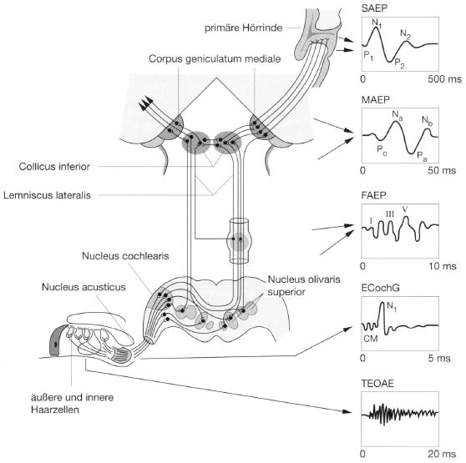

auditory brainstem response (ABR)
- auditory evoked potential extracted from ongoing electrical activity in the brain and recorded via electrodes placed on the scalp
- measured recording is a series of six to seven vertex positive waves of which I through V are evaluated.
  - Wave I through III: generated by the auditory branch of cranial nerve VIII and lower
  - Wave IV and V: generated by the upper brainstem
  - More in depth location : wave I originates from the dendrites of the auditory nerve fibers, wave II from the cochlear nucleus, III showing activity in the superior olivary complex, and wave IV–V associated with the lateral lemniscus.
- These waves occur in the first 10 milliseconds after onset of an auditory stimulus
- ABR is considered an exogenous response because it is dependent upon external factors
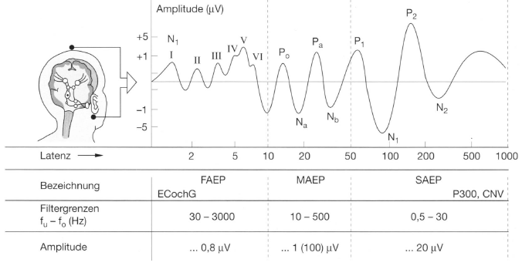
- ABR = FAEP, MAEP, SAEP (früh, mittel, spät)

Frühe akustisch evozierte Potentiale (FAEP)
- Electrical source in the auditory pathway between the cochlea, the auditory nerve and various core areas of the brain stem.

ECoC (ECochG)
- recording electrical potentials generated in the inner ear (cochlea) and auditory nerve using an electrode placed in the ear canal or tympanic membrane, in response to sound stimulation.
- placing few surface electrodes on the patient’s head.
- Insert tiny microphone and an earphone into the outer ear canal, so that it is close to the eardrum.
- ear is stimulated with alternating polarity clicks
- measure the ECochG response with the help of a computer that uses signal filtering and averaging to isolate neural activity from the cochlea.
- look for the presence of a larger waveform which contains two components: the Summating Potential (SP) and the Action Potential (AP). Both of these waveforms are direct results of providing sound stimulation to the cochlea. A calculation of the SP/AP ratio is made. An increased SP/AP ratio can indicate excessive fluid pressure in the ear.
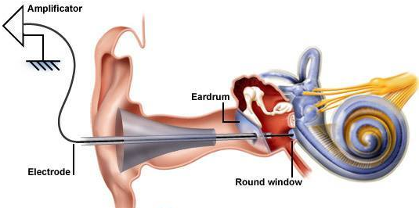

click-evoked electrical response audiometry (ERA)
- click: spectrum of all frequencies
- gives diverse electric potentials
- (short time potentials are more important)
- For measurement one electrode is placed behind the ear and one at the forehead (sometimes two)

Electrocochleogram (ECochG)
- Needle in the ear
- Potential look very different
- Peak V is the most important, highest peak, from brain stem
- From low to high dB, the peak is seen earlier at high dB almost no amplification
  - Higher latency sharper filters
  - Higher frequencies have a little lower latency than higher ones
Click spectrum?
How to achieve frequency specificity? Advantages/disadvantages?

Otoactustic emission (OAE)
- Spontaneous SOAE
- Evoked
  - TEOAE (transitory evoked OAE)
  - SFOAE (stimulus-frequency OAE)
  - DPOAE (distortion product OAE)
- Put a microphone in the ear

Transitory evoked otoacoustic emissions (TEOAE)
Kurze Schallreize, sogenannte Klicks, führen zu einer mechanischen Reaktion des Innenohrs, die als Schall wieder nach außen übertragen wird. Da die Haarzellen ihre Schwingungen leicht verzögert abgeben und nach kurzen Ereignissen noch nachschwingen, kann im Gehörgang nach einem kurzen Schallereignis ein etwas längeres Antwortsignal gemessen werden. Da dieses Signal bei einer Schädigung der äußeren Haarzellen des Innenohres schwächer wird oder sogar verschwindet, kann die Messung der TEOAE zur Diagnose von Erkrankungen des Innenohrs verwendet werden.
- Measurement Methods:
  - “linear” stimulus block (e.g. 4 clicks)
  - Record ear canal response
  - Then same with non-linear stimulus
- Artifact rejection
- Synchronous averaging
- Reproducibility (cross-correlation/coherence)
- Nonlinear differential technique
- If you are able to measure this, you have less than 30dB hearing loss

DPOAE (distortion product OAE)
- Two tones
- You adjust intensities so that the amplitude is the same for both tones at the peak of the lower frequency
  - Nonlinear interaction here
- Amplitude is also high in the base region, but neglectable in the apex direction behind the peak
- Preferred at high frequencies (2-4kHZ), vs. TEOAE: 1kHz
- DP-gram: frequency characteristic of impairment
- Dichotomous decision
- If you are able to measure this, you have less than 50dB hearing loss (?)
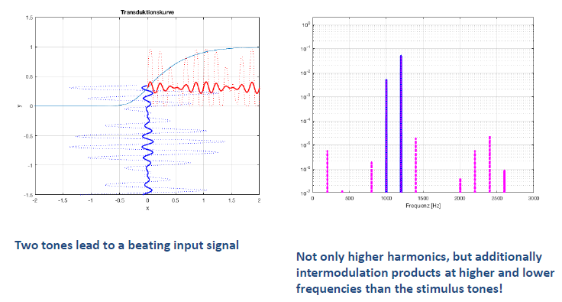
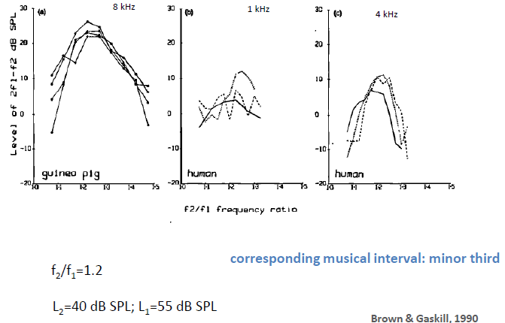
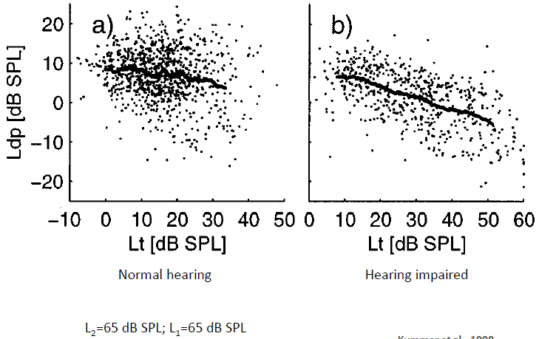

Acoustic input impedance
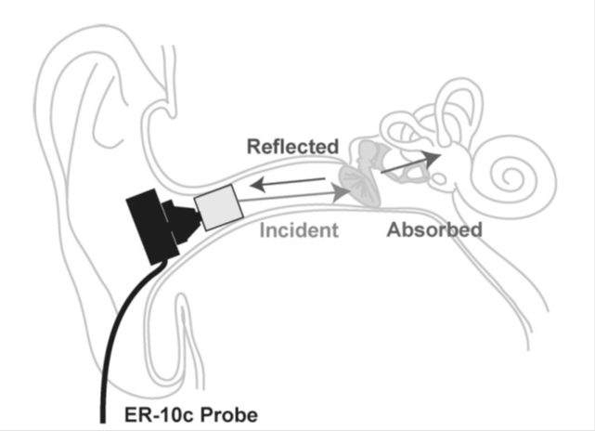
- Resistance is not frequency dependent
- Impedance is frequency dependent
- Capacitor: high impedance at low freq., low imp. At high freq.
- In hearing: voltage = force (pressure), current = volume velocity

Acoustical Impedance: recording methods

Tympanometry
- 220Hz tone generator
- Microphone, recorder
- Air pump to induce static pressure membrane is stiffened
- Can diagnose if patient is able to equalize pressure (?)

Hygiene in Biomedical Technology (15.07.)

Microbiology and Infection
- Every infectious disease is caused by a microorganism (= infectious agent = pathogen)
- Only a minority of all microorganisms has a pathogenic potential
- Simple presence of a microorganism does not equal infection
- Colonization with bacteria is normal for many compartments of the human body (skin, upper respiratory tract, gut, vagina) „normal flora“
- Infection requires recognition by the immune system and initiation of a host immune response
- Opportunistic pathogens:
  - causes disease under certain circumstances (immunosuppression, age, underlying conditions etc.)
  - often part of the normal flora
- Nosocomial infection:
- acquired in the hospital („healthcare-associated“)
- ca. 500.000 cases/year in Germany (ca. 15.000 deaths)
- 1/3 are avoidable
- not necessarily transmitted in the hospital! (e.g. some people just tend to disease very fast because of immunosuppression etc.)
- example: infection with a common hospital bacterium after blood transplantation
  - test in the lab which antibiotics are working on that bacterium
  - problem: what if bacteria are resistant to all antibiotics?

Transmission of pathogens
- contact (very frequently):
  - direct: from person to person, e.g. hands
  - indirect: inanimate surfaces
- air-borne:
  - droplets: >5 μm, sedimentation radius <5m
  - aerosol: <5 μm, direct deposition in lower airways, no sedimentation (e.g. measles, chicken pox) person exhales pathogen and it is spread in a radius of a few meters
- fecal-oral:
  - contaminated food or water (quiet easy to control)
- parenteral:
  - blood or other bodily fluids
- vector:
  - e.g. mosquitoes (malaria), ticks (borreliosis)

Infection control measures within the hospital (Standard procedures)
- HAND HYGIENE!!!
- Adequate re-processing of instruments
- Aseptic procedures
- Working under hygienic conditions
- Cleaning and disinfection of inanimate areas
- Isolation in single-bed rooms (sometimes)
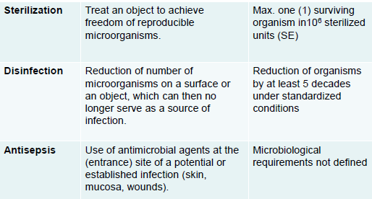
- Sterilization: all organisms are dead
- Disinfection: only reduction of the number of microorganisms, but the few remaining are no longer capable to cause an infection (you need a certain number of microorganisms to cause an infection)
- Antisepsis: has to do with human body substances to “clean” area before surgery, disinfection of part of human body

Re-utilization of medical devices:
- Preliminaries (coarse cleaning, disassembly etc.)
- Cleaning, disinfection (if necessary) and water-flushing
- Checking (cleanness, intactness)
- Maintenance, checking of function
- Labeling (if necessary)
- Packaging and sterilization (if necessary)
- Approval
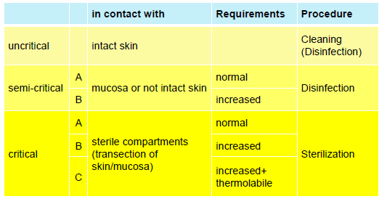

Validation
Food and Drug Administration (FDA): “Validation is the documented act of demonstrating that a procedure, process, and activity will consistently lead to the expected results.”

Disinfection
- Physical procedures:
  - Boiling (ca. 100 °C, 15 min)
    - Washer-disinfectors (WD) „Dishwasher“ (80-95°C, e.g. 90°C/5 min holding time), common in hospital
  - Ultraviolet rays (UV-C)
- Chemical procedures
  - Chemical compounds for wiping, spraying, or submerging
- Chemical-thermal procedures
  - Washer-disinfectors (WD) (40-65 °C + chem. disinfectant), common in hospital
- All these are only disinfection, because spores etc. can still be there

Requirements of disinfectants
- Microbiological Activity
  - broad spectrum
  - short residence time
  - irreversible action
  - reliable activity also with contaminants (blood, dirt)
- Properties during usage
  - compatibility with materials (e.g. corrosion)
  - security (flashpoint)
  - dosage adjustment
  - acceptance (e.g. smell, feel on skin etc.)
- Toxicology
  - compatibility on skin and mucous membranes
  - low acute oral toxicity
  - low dermal toxicity
- Environmental safety
  - biodegradable
  - low toxicity in wastewater

Disinfection: Spectrum of activity
- Low to intermediate resistance:
  - enveloped viruses, vegetative bacteria; characteristic organisms: E. faecium, S. aureus, P. aeruginosa
  - fungi incl. fungal spores; characteristic organism: Aspergillus niger
- Intermediate to high resistance: mycobacteria, Hepatitis B-Virus, hydrophile viruses
  - characteristic organisms: polio virus, Mycobacterium terrae
- High to very high resistance: bacterial spores, prions commonly not covered by disinfection

Substances
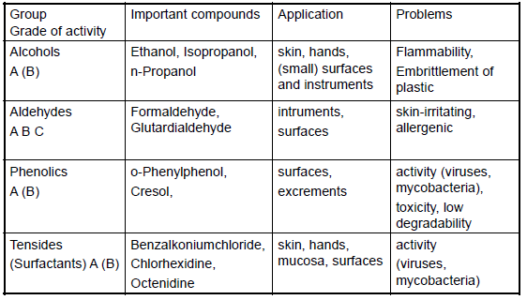
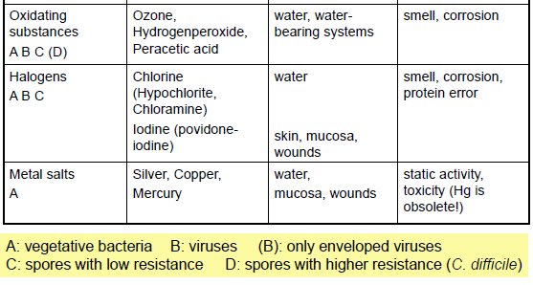
- No ideal disinfectant, depends on field of use

Sources of error in disinfection
- Dosage: too low loss of action; too high smell
- Temperature: evaporation
- soap error: flocculation when mixing with soap
- protein error: consumption by proteins
- insufficient moistening: e.g. inclusions of air or skin creases
- insufficient residence time

Sterilization
Requirements for sterilizing procedures
- Comprehensive and fast mode of action
- Penetration (packaging, porous material, cavities)
- Toxicological and environmental harmlessness
- Compatibility with material
- Possibility of validation and documentation

Sterilization is one step of reprocessing!
- Re-processing of a critical medical device always comprises:
  - Cleaning
  - Disinfection
  - Sterilization
- One can clean without sterilizing, but one can never sterilize without previous cleaning!

Sterilizing procedures
- Physical procedures
  - Humid heat (steam sterilization) : saturated steam e.g. 121°C/15 min or 134°C/3 min holding time (most common)
- Dry heat: circulating hot air, 180°C/30min residence time
- Ionizing Radiation: Gamma-rays (Co60), electron beam processing (not usable in hospital)
- Physical-chemical procedures („low temperature procedures “)
  - Ethylene oxide
  - Formaldehyd-Wasserdampf
  - Hydrogen peroxide plasma sterilization
- Other procedures (infrequently used in Germany)
  - Ozone
  - Vaporized hydrogen peroxide
  - Chlorine dioxide
  - Peracetic acid
- Not approved: Bead sterilizer, UV-sterilizer

Steam sterilization
- Conditioning phase:
- Heating
- Air removal and steam generation
- Equilibration (= reach temperature in all parts of sterilizing good)
- Sterilization phase:
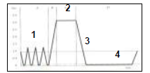
- Holding time (Sterilization time) = Killing time + Safety margin
Figure 2: pressure diagram
- Decompression phase:
- Pressure removal
- Cooling phase:
- Drying in vacuum
- Pressure equilibration

- Sterilization is defined as 10⁻⁶ microorganisms you have a statistic curve, when this number is achieved:

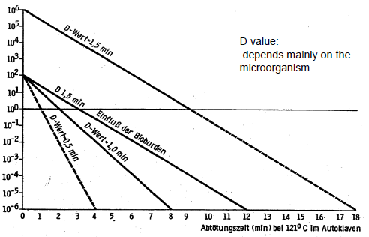

Application of steam sterilization
- Suitable for: metal objects (corrosion), glas, ceramics, aqueous solutions (hot steam also penetrates solutions), cotton, linen, rubber, thermostable polymeres (plastic)
- Not suitable for: electric and electronic objects, water-free oils, grease, wax, powder and granulate

Ethylene oxide (EO)-sterilization (only mentioned briefly)
- Pure EO (negative pressure) or EO-CO2-mix (high pressure), Temperature ca.40 – 55°C, fully automated process
- EO is a biohazard! (carcinogen, mutagenic, teratogenic, caustic), therefore extensive safety measures
- Increased absorption in plastic controlled desorption phase before use of sterilized goods
- use only for thermo-labile goods (e.g. cameras, optical fiber, cables)

Formaldehyde (FA)-steam sterilization (only mentioned briefly)
- Formaldehyde-steam mixture with negative pressure, Temperature up to 65°C, fully automated process
- FA is a biohazard (potential carcinogen, caustic), but less problematic than EO, therefore less stringent safety measures
- Low penetration in hollow parts, low absorption in plastic
- area of application similar to EO

Verifying of sterilization processes
- Physical methods
  - Parametric controls: Temperature/pressure/time-relation (Proof of holding time and steam saturation); Documentation of sterilization cycle by recording devices
  - Thermologgers in different positions within the chamber or the sterilizing good (process validation)
  - gas concentration (EO), relative moisture (EO, FA)
- Chemical indicators
  - indicate compliance with several parameters. Different types as defined by standards:
    - e.g. sterilizing tapes
    - indicators in combination with test bodies („process challenge device“ PCD) for penetration of steam into hollow parts
    - Chemical indicators do not allow conclusion with respect to sterility!
- 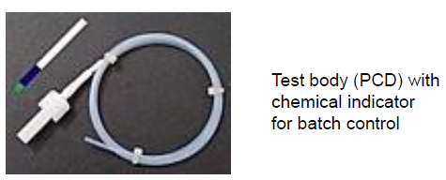(nachschauen)
- Biological processes (bioindicators)
  - Bioindicators contain bacterial spores with standardized density with defined D-value; dependent on sterilization method
  - Requirements for test organism:
    - not pathogenic
    - D-value higher than most resistant pathogenic microorganism

Packaging of medical products
- for shipping and storage
- Maintaining sterility
- Physical protection (from damage)
- Easy handling
- Labeling (content, sterilization procedure, expiration date)
- Steam has to go in somehow and you don’t want recontamination
- Examples:
  - Rigid containers (with filter or valve)
    - Steam can go in through little pores
    - Pro: re-usable, robust, stackable
    - Contra: weight, fixed volume, expensive
  - Soft wrapping
    - Sterilization paper, transparent bags
    - Cotton is not allowed
    - Pro: flexible, light, cheap
    - Contra: easily damaged, not space-saving, constant costs, waste

Storage of sterilized goods
- protected storage (storage time adapted to occasion of use): clean, closed, dry, 20-25°C, protected from dust and light
- industrial sterilized material in storage packaging: expiration date given by the manufacturer (normally 5 years)

Legal Regulations
- many regulations, don’t have to know

