Clinical Cases II (SoSe 2019)
This is just my self-made script. No guarantee for completeness and correctness!

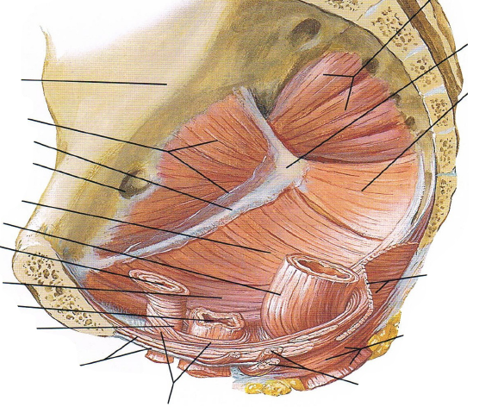
Benign disorders of the anorectum (22.05.)

Pelvic Floor (Beckenboden)
- Very different from one person to the other
- Much bigger in women
- Muscles are the important structures
- Image of pelvis: women because there is a urethra, a vagina and a rectum visible
- M. puborectalis is lying around the rectum „bends” the rectum when it contracts
  - Very important for continence
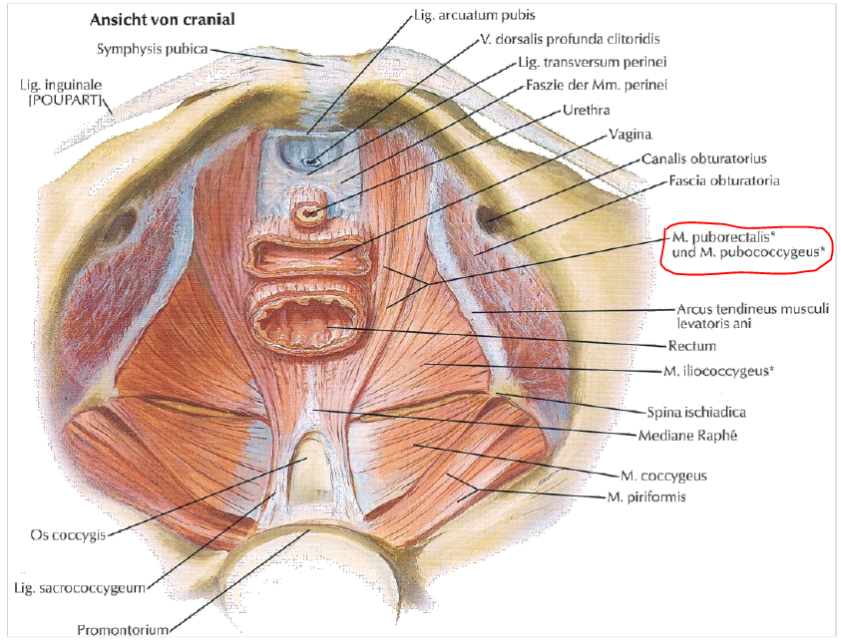
- levator ani muscles (M. levator ani)
  - M. puborectalis (the anterior posterior angle / anorectal flexure)
  - Pars pubica (M. pubococcygeus) median
  - Pars iliaca (M. iliococcygeus) lateral

Sphincter:
- Muscles:
  - M. sphincter ani internus (rectoanal inhibitory reflex)
  - lntersphincteric layer
  - M. sphincter ani externus
  - pars profunda, pars superficialis, pars subcutanea
- internal (autonomic) & external (somatic) muscle
- 80 % of continence because of autonomous nervous system
- Hemorrhoids: can fill and contract again
  - If a person has diarrhea all the time, hemorrhoids are getting bigger
  - Same if you have to press the stool out all the time
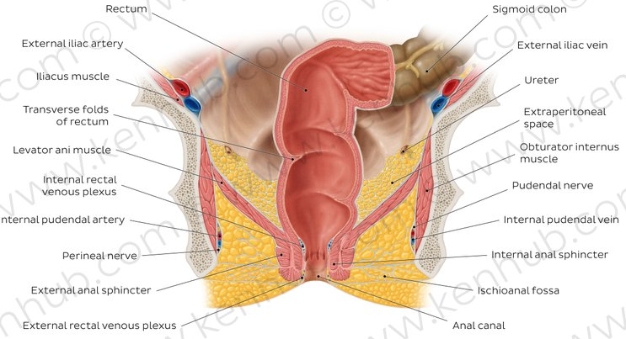
- vascularization
  - superior rectal artery (inferior mesenteric artery)
  - middle rectal artery (iliac artery, twofold)
  - inferior rectal artery (iliac artery, twofold)
  - the veins accompany the arteries
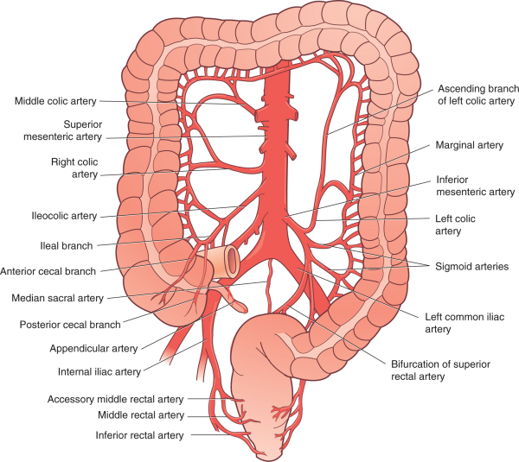
- Proctoscopy: look through a device in the rectum
- Rectoscope: rigid proctoscope is inserted into the anal canal

Hemorrhoids
- Stage 1: can only see in rectoscopy (enlargement of the corpus cavernosum recti)
- Stage 2: prolapse during bowel movements, spontaneous reposition
- Stage 3: prolapse that can be pushed back (manual repositioning necessary)
- Stage 4: fixed prolapse, Fibrosis, thrombosed - irreducible
- Not really painful
- Epidemiology
  - 70% of adults in industrialized countries (treated 4%)
    - Only 4% of the patients with symptoms get treatment, because many don’t go to the doctor
  - Incidence of hemorrhoidectomy 40-50 / 100.000
- Pathogenesis
  - Corpus cavernosum recti (fine continence) circularly arranged arteriovenous vascular convolute
  - Hemorrhoids at hyperplasia
  - clinical relevance if symptomatic (if there are no problems, you don’t treat them)
  - common sites at 3°, 7° and 11° (lithotomy position, Hemorrhoid position is described clockwise)
- Differential diagnosis: anal vein thrombosis, very painful!
- Etiology: only have to know constipation, diarrhea, pregnancy
- Symptoms:
- unspecific / not depending on the size
- deposits of blood / peranal bleeding (most common)
- moisture (disturbance of fine continence)
- itching (anal eczema)
- anal prolapse
- fecal incontinence
- pressure sensation (pain)
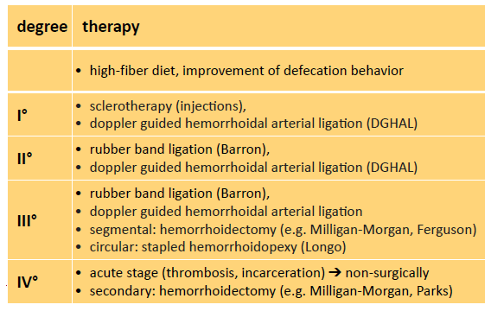

Surgery
- Hemorrhoidectomy: removal
- Stapled hemorrhoidopexy: use a stapler
  - Stapler = “Tacker”
  - Hemorrhoids are “squeezed” between the stapler
    - First sew a ring in mucosa, then put in stapler so that the ring is in between und then pull the string to narrow the ring to put hemorrhoid in the middle of the stapler

Perianal/ perirectal Abscess & anal fistula
- Abscess: acute inflammation
- Fistula: chronic inflammation

Causes and clinical course
- origin of the abscess is usually the proctodeal gland in the intersphincteric space (up to 98%)
- spread in preformed layers
- infrequently other causes (CBD, atypical infections)
- spontaneous regression is no longer possible
- untreated: perforation (rectum, anal canal, external)
- If an abscess is too big, can’t treat it with antibiotics, have to operate
- Cause: fistula
  - A fistula is an abnormal connection between two hollow spaces (technically, two epithelialized surfaces), such as blood vessels, intestines, or other hollow organs. Fistulas are usually caused by injury or surgery, but they can also result from an infection or inflammation.
  - Intersphincteric: 45% (in between the sphincteric muscles are kind of glands that flow to the rectum, if some are occluded abscess (also because of many bacteria in the gut))
  - Transsphincteric: 30 %
  - Suprasphincteric: 20%
  - Extraspincteric: 5%

VAAFT
- Endoscopy inside the fistula
- Italian guy put stitches around internal opening and pull it to the outside
- In Tübingen: put endoscopy inside until you get to the internal opening, move back and destroy the walls of the fistula so they can heal together again (wound healing)
  - Internal opening: first tissue around the area is opened (by cutting) and then internal opening is sewed

Summary
- Anatomy of anorectum & pelvic floor
- Physiology & pathophysiology
- available methods of investigation
- clinical cases of coloproctology
  - Hemorrhoids and differential diagnoses
  - Perianal /perirectal abscess & Anal fistula
- individual approach
- technology: support / standardization

Cancer/Hematology & Oncology (05.06.19)
- Hematology: Study of the diseases of the blood, bone marrow and the lymphatic system.
- Benign Hematology
  - Thrombophilia, Hemophilia (Hemostaseology)
  - Immune Thrombocytopenias
  - Anemias
- Malignant Hematology
  - Non Hodgkin´s Lymphoma
  - Hodgkin´s Disease
  - Leukemias
- Oncology: Study of malignant diseases (e.g. brain tumors, breast cancer, …)

Therapy Goals
- Curative Therapy: The cure of the patient is the goal of the therapy.
- Palliative Therapy: The cure of the patient is not possible due to advanced disease. The goal is to prolong life and to ameliorate symptoms.
- Best Supportive Care: No cancer-specific therapy. Main goal is the amelioration of disease symptoms like pain etc.

Is Oncology important?
- Every 2nd person will develop cancer.
- Every 4th person will die of cancer.
- Cancer is a disease of advanced age.
- The proportion of elderly people in society increases.
- Lower tolerance towards therapy in elderly people.
- Most common cancers
  - Men: prostate, lung, colon & rectum
  - Women: breast, lung, colon & rectum

Diagnostic Modalities
- Classic X-Ray (1895)
- Ultrasound (1942)
- Computed Tomography/CT (1971)
- Magnetic Resonance Imaging/MRI (1985)
  - CT/MR Morphology/Anatomy
- Positron-Emission-Tomography/PET (1975)
- PET-CT (2000)
- PET-MRI (2009)
  - PET Metabolic Activity of Tissue

Development of cancer
- Healthy cell: external signaling cascade cell growth
- Protein biosynthesis: transcription (RNA), translation (protein)
- Cancer is a ”DNA disease”
  - Tumor stem cells, which differentiate into tumor cells and replicate themselves
- DNA defects:
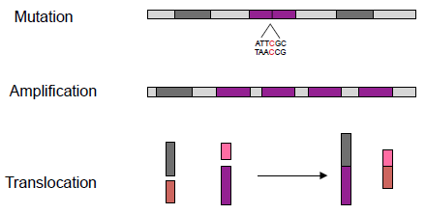

Consequences of genetic accidents
- Growth independent of growth factors
- insensibility towards growth inhibitory signals
- Prevention of apoptosis
- Inhibition of immune rejection
- Angiogenesis
- Infiltration and metastasis

Targeted therapy
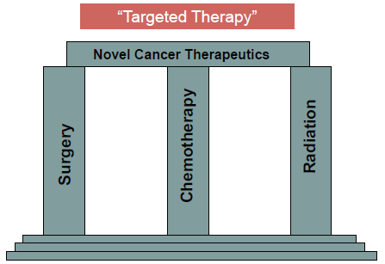
- DNA with defect deregulated growth
- Gene mutation protein with defect

Mutation

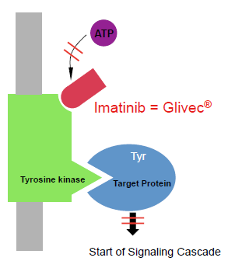
Gastrointestinal Stroma Tumor (GIST)
- Gene mutation which leads to mutated Growth factor receptor (c-kit receptor)
- Growth factor receptor (c-kit receptor) which constantly fires signal to grow
- Receptor bound to tyrosine kinase
  - Binds to target protein and starts signaling cascade
- Drugs act right at this point an inhibit the ATP connection and therefore the reaction of tyrosine kinase with target protein
  - cancer growth is only inhibited, not cured, …
    - but tumor cells die, and less new ones proliferate tumor size decreases
    - will increase again if drug is not taken

Malignant Melanoma
- EGF Receptor
- BRAF in the cell constantly fires signal to grow
- Again, a drug (Vemurafenib), which binds to BRAF
  - Prolongation of survival from 6.4 Months to > 10 month
  - Costs > 100.000€/year
  - Certain Patients benefit much longer

Amplification
- No mutation, but gene amplification leads to overexpression of a protein

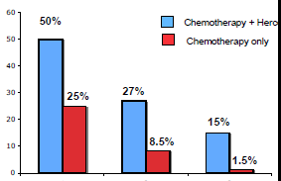
Breast cancer
- Her-2 growth factor receptor overexpression
- Therapeutic Strategy: Monoclonal Antibodies
  - Herceptin binds to Her-2/neu blocks the receptors and inhibits cell growth
  - In comparison with chemo only, the combination of chemo and Herceptin leads to ~ double survival

Translocation
- Leads to generation of fusion protein

Chronic Myeloid Leukemia (CML)
- Philadelphia Chromosome: translocation from chr. 9 to chr. 22
Expression of BCR-ABL protein
  - Act with tyrosine kinase again cell growth

Further Mechanisms and Therapeutic Agents
- VEGF (vascular endothelial growth factor)
  - Avastin® (Bevacizumab)
  - For Colon, Lung, Breast, Kidney, Brain
- EGFR (epidermal growth factor receptor)
  - Erbitux® (Cetuximab) For Colon, Head/Neck
  - Iressa® (Gefitinib) Lung
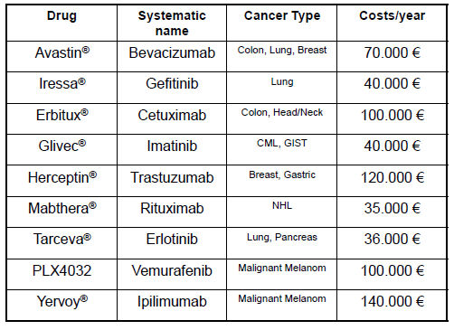

Disorders of the lower GI (19.06.)
- Anamnesis:
  - Ask for kind of pain, defecation, micturition (Balsenentleerung), …
- Investigation:
  - Inspection, auscultation, percussion, palpation, …
- Radiological examinations
  - Sonography, X-ray, CT, MRI
  - In X-ray it is easy to see air
    - An infection could lead to a perforation and consequently free air in the abdomen
- Invasive Examination
  - Colonoscopy only if there is no inflammation, because of risk of perforation

Diverticulosis
- Diverticula:
  - Real Diverticula:
    - Protuberances of all layers of the intestinal wall
    - Especially in the area of the Coecum
  - Pseudo Diverticula:
    - Protuberances of the mucosal layer through gaps of the muscle layer
    - Especially in the area of the descending colon and the sigmoid colon

Epidemiology
- Prevalence total population: 20-30 %
- Prevalence of the over 65-year olds: 50 %
- Gender distribution: m = f
- Disease of the „industrial revolution“
- no reports of this disease before this time
- Incidence: 3,4 to 4,5 per 100.000 persons per year
- most common disease affecting the large bowel in the Western world
- large majority of patients (80-85 %) will remain entirely asymptomatic throughout their life

Pathogenesis
- Lack of fiber
  - Elongated gastrointestinal trans time
- Increased intraluminal pressure
- Increased intestinal motility
- Diets that are low in dietary fiber and high in refined carbohydrates
- Current medication
  - Nonsteroidal anti-inflammatory drugs (NSAIDs), corticosteroids
- Diverticulosis = uninflamed diverticula

Diverticulitis
- Diverticulitis = inflammation
- Around 1–2 % of the patients need hospitalization and 0.5 % will require surgery
- 80% of patients who present with diverticulitis are 50 or older
  - 30-day mortality rate was 5.1 %
  - 1-year mortality rate was 14.5 %
  - 28-day readmission rate was 9.6 %
- Diverticular disease hospital admissions are increasing, with poor outcomes in the elderly and emergency admissions
- 130.000 hospitalizations yearly in the United States

Complications
- Perforation
- Peritonitis
- Abscess formation
- Chronic complications
- Obstruction/Stenosis
- Fistula
- Bleeding

Differential diagnosis
- Chronic inflammatory bowel disease
- Colorectal carcinoma
- Gynecologic disease
  - Adnexitis (Unterleibsentzündung)
  - Gynecologic carcinomas
  - Ectopic pregnancy
  - Rotation of the ovary
- Ischemia
- Perforation
- Appendicitis

Classification of diverticular disease (CDD)
- Type 0: Asymptomatic diverticulosis
  - asymptomatic; incidental finding, not a disease
- Type 1: Acute uncomplicated diverticular disease/diverticulitis
- Type 2: Acute complicated diverticulitis
  - Micro-/Macroabscess
  - Therapy: Hospitalization, Antibiotic therapy, Fluid replacement
    - Abscess >4 cm -> interventional puncture
    - If not possible, conservative treatment for 72 hours ->
    - Then conservative treatment or surgery (Surgery in an inflammation free interval)
    - In peritonitis immediate surgery
- Type 3: Chronical diverticular disease (recurrent or persistent symptomatic)
  - Therapy: Mesazalin, depending on symptoms conservative treatment or elective surgery
    - Fistula: surgery
    - Stenosis: depending on symptoms early to electively
- Type 4: Diverticular bleeding
  - Therapy: Hospitalization
    - Coloscopy
    - Endoscopic hemostasis
    - When necessary Angiography
    - Embolization
    - with continued bleeding or clinically relevant bleeding recurrence
    - Surgery

Prevention
- High-fiber diet
- Physical activity
- Proper hydration
- Normal body mass index (19,9-24,9 kg/m2)
- Probiotics

Pancreatic surgery
(I did not attend the lecture)

Topography and function of the pancreas
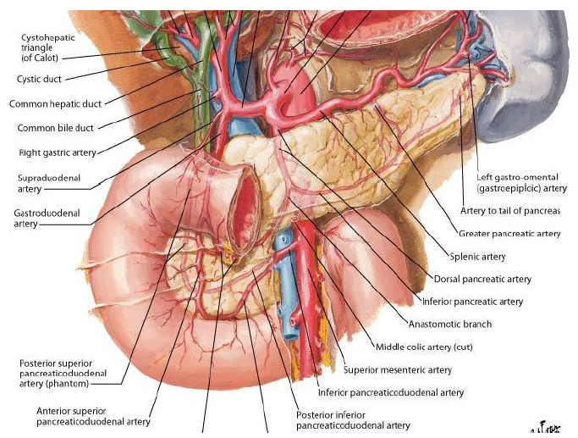
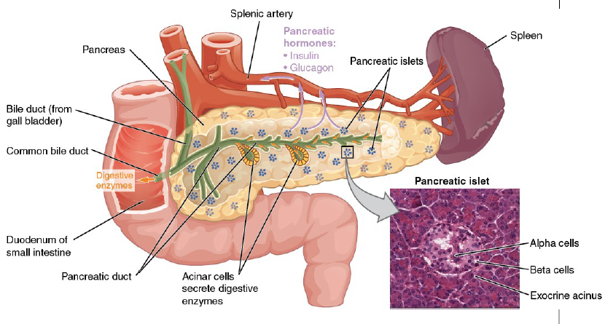

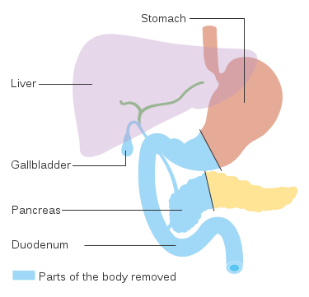
History of pancreatic surgery
…

Pancreatic head resection
(Kausch-Whipple-Procedure)
- surgical removal of the head of the pancreas
- Due to the shared blood supply, also removal of the duodenum, proximal jejunum, gallbladder and occasionally parts of the stomach
- As the bile duct is removed, a new connection for bile to the intestine has to be made

Acute pancreatitis
- Etiology:
  - Gallstones
  - Alcohol
  - Drugs
  - Trauma
  - Iatrogen (resulting from activity of another person)
- Classification:
  - Mild (Interstititial)
  - Severe (Necrotizing)

Acute Pancreatitis – Surgical interventions
- Gallstone pancreatitis: Cholecystectomy
- Pancreatic duct disruption:
  - Image-guided percutaneous placement of a drainage tube into the fluid collection
  - stent or tube placement via ERCP
  - in refractory cases, distal pancreatectomy or a Whipple procedure
- Pseudocysts:
  - None necessary in most cases
  - for large or symptomatic pseudocysts: percutaneous aspiration, endoscopic transpapillary or transmural techniques, or surgical management
- Infected pancreatic necrosis:
  - Image-guided aspiration; necrosectomy
- Pancreatic abscess:
  - Percutaneous catheter drainage and antibiotics;
  - if no response, surgical debridement and drainage

Chronic Pancreatitis
- Etiology:
  - Metabolic
  - Mechanical
  - Hereditary (erblich)
  - Idiopathic (reason unknown)
  - Immunologic
  - Mostly alcohol abuse!
- Symptoms:
  - Pain
  - DM
  - Steatorrhea
  - Icterus
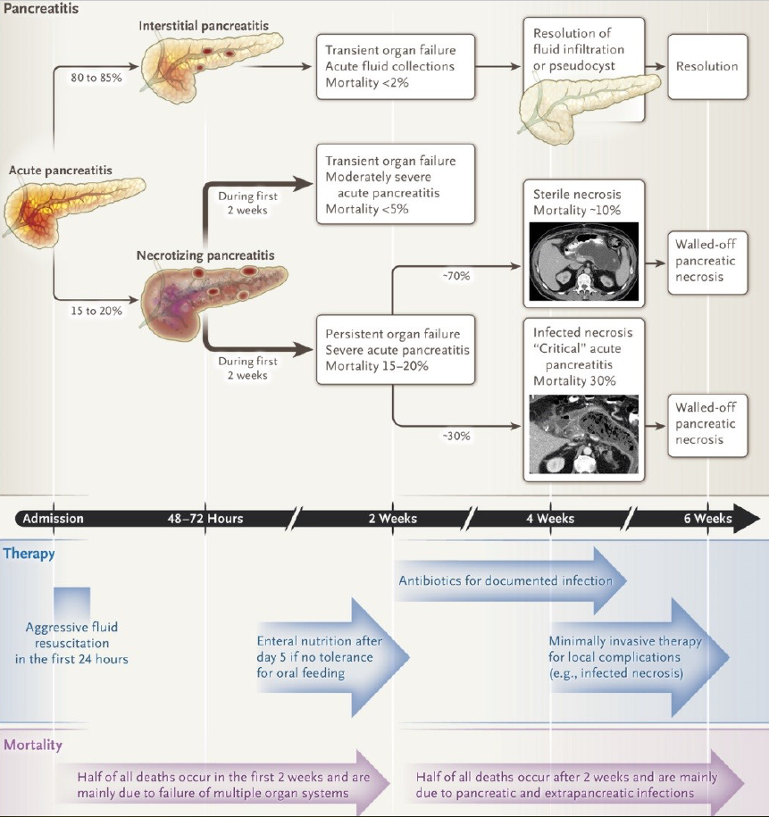

Pancreatic cancer
- Pancreatic cancer is No. 4 of cancer killers of men and women in the US
- Risk factors:
  - Chronic pancreatitis
  - Hereditary cancer syndromes
  - Hereditary pancreatic cancer
  - Hippel-Lindau-Syndrome
- Syndromes:
  - Icterus
  - Back pain
  - Weight loss
  - Loss of appetite
  - Performance dropping

Pancreas transplantation
- Indications:
  - Diabetes mellitus (Typ 1)
  - Avoidance of DM-associated long-term complications
  - Improving quality of life

Diverticulitis (03.07.19)
- Problem of the modern western world, because of low fibers in food and high amount of carbohydrates and fat
- In colon the highest pressure is in the sigmoid colon and lumen is the narrowest
  - Here most of diverticulosis is developed
- Very frequent disease, ca. 60% of older people in the US have diverticulosis, 10-15% develop a diverticulitis

Diagnosis:
- Ask patient for stool (constipation), pain, fever
- Blood test inflammation markers (white blood cells (fast immune response), c-reactive protein (from liver, slower immune response)
- US, CT, MRI
- An acute diverticulitis develops in 36h
- Stages
  - 1: small or confined pericolic or mesenteric abscess
  - 2: Large abscess extending into pelvis
  - 3, 4: perforated need surgery …
  - Don’t need to know the stages

Surgery:
- Removal of the diseased segment with temporal colostomy
  - Ostomy delivers feces trough a bag on the skin
- Reconnection, colon reunited, skin closed
- Vascularization test: inject some fluorescent tracer in the blood, then you can see where the colon is well vascularized and where not this part is resected then

Endoscopic mucosal resection (EMR) (10.07.19)

Flexible endoscopy
- Diagnostic & therapeutic use
- Tip of the endoscope is bendable
- Components: Optic, two light sources, working channel for instruments, cleaning channel (water) & spray head for cleaning the lense
  - Ideally endoscope gets smaller in diameter and working channel gets bigger
- Different wheels on the handle to bend the endoscope tip in many directions

GIT
- Different parts have different thickness
  - Stomach: 5-7mm
  - Esophagus, small intestine, colon: 3-4 mm
  - Caecum (part of colon where appendix is located), right colon: ca 1-2mm
- Layers of GIT:
  - Mucosa (with villi, …)
  - Submucosa
  - Transversal muscles
  - Longitudinal muscles
  - Peritoneum
  - In short: mucosa, submucosa, muscularis
- GIT tumors growth starts in mucosa layer!

Endoscopic resection

Polypectomy
- For polyps (mushroom form)
- (Monopolar) Snare with current placed around the polyp
- Close snare a bit to have all-around contact, but do not squeeze (would be cold cutting)
- Danger of polyp hanging above the snare contact surface too extensive, no cutting possible
- Lift polyp before cutting, but NO CONTACT between intestinal wall and snare or polyp during cutting Danger of perforation
- Permanent activation of HF current during cutting (yellow pedal for CUT)
- Don’t grab the muscle layer with the snare also perforation
- Different size, shape, stiffness, mono-/polyfilament, … of snares
  - Wire diameter influences degree of coagulation
  - Monofile snare has smaller contact surface than polyfile snare with identical total diameter
  - Monofile snare has higher stiffness
  - If risk of perforation > risk of bleeding monofile

EMR: Endoscopic mucosa resection
- Used to remove cancerous or other abnormal lesions
- = mucosectomy
- Ablation of mucosa of organ
- Treatment of early tumors
- Broad base, extensive, flat lesion, up to 2 cm
- Indication for EMR: tumor limited to mucosa or submucosa no lymphogenic or hematogenic metastasis, for Tis, T1 and sometimes T2 stages of tumors
- Techniques:
  - Submucosal injection: inject water (with NaCl) cushion underneath & cut
    - decrease risk of perforation and thermal damage, increase en-bloc rate and graspability
    - “non-lifting sign”: infiltration of muscularis propria layer and you can’t lift it up
  - “Suck & cut”: use a cap to suck the mucosa in and cut then
    - Esophagus, stomach
    - Problems: scars, pre-resection
- EMR complications: 11% bleeding, 3% perforation
- Risk factors: size of lesion, localization, expertise, number of polyps, adjuvant technique: injection +/- vasoconstrictors, more big polyps, HF surgery – standard setting?
- Limitations: Tumors > 2 cm piecemeal technique is necessary (cutting more than once, overlapping resection), R0 resection not ensured

ESD: Endoscopic submucosa dissection
- Flat lesion, but bigger > 2 cm
- Also injection to elevate the mucosa
- Electrosurgical knife (instead of snare) to cut and coagulate circumferential, whole piece is cut out at once
- Advantages:
  - En-bloc (all at once) resection of large lesions
  - R0 resection (complete removal of tumor)
  - Low recurrent rate
  - Mechanical and thermal safety function of water cushion
  - Lower risk of bleeding (compression of vessels by water cushion)
  - Possibility of waterjet injection needleless

Summary
- Snare, cap < 2 cm
- Injection
- …

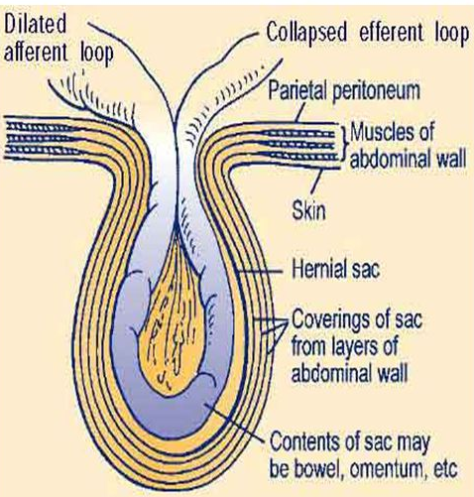
Hernias of the abdominal wall (17.07.)

Definition Hernia
- Bulge or protrusion of an organ through the structure or muscle that usually contains it
- Composed of:
  - Hernial orifice (Öffnung)
  - Hernial content (small or large intestine, can also be urinary bladder etc.)
  - Hernial sac (diverticulum of the peritoneum)

Predisposing factors
- Weakness/defect in the abdominal
  - Congenital
  - Acquired
    - Surgical scar
    - Muscle wasting
    - Fatty infiltration
    - Weak connective tissue
- High intra-abdominal pressure
  - Chronic coughing (Smoker, Asthma)
  - Pregnancy/Childbirth
  - Obesity
  - Ascites
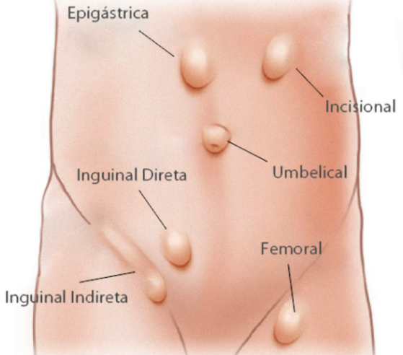
  - Constipation
  - Heavy lifting/strenuous muscular exercises

Types of hernia
- Inguinal hernia (indirect/direct) most common
- Femoral hernia
- Umbilical hernia pregnancy, after laparoscopy
- Incisional hernia
- Epigastric hernia
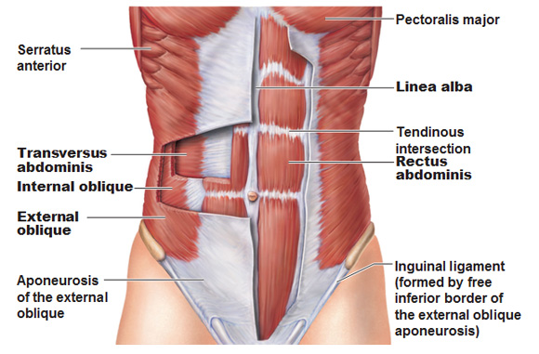

Abdominal wall
4 main muscles:
- Transversus abdominus
- Internal oblique
- External oblique
- Rectus abdominis

Symptoms
- Swelling = visible mass or lump
- Pain/discomfort
- Feeling of pressure /heaviness in the abdomen
- Nausea and vomiting (because of obstructed bowel)
- Increased symptoms when coughing, lifting, bending over, sneezing, exercising

Examination
- Inspection: Location, Size, Predisposing factors
- Auscultation: Bowel sounds?
- Palpation: With a fingertip, attempt of reposition of the hernia
  - If the hernia can be repositioned it is not so urgent, can have a planned surgery
  - Otherwise have to be quick

Classification
- Reducible hernia: can be pushed back into the abdomen by putting manual pressure to it
- Irreducible/Incarcerated hernia: can´t be pushed back into the abdomen
  - Obstructed hernia: the lumen of intestine is obstructed
  - Strangulated hernia: the blood supply of hernial content is cot off ( surgery should be within 6h after obstruction to rescue the tissue)

Surgery
Aims:
- Reducing of the hernial content
- Excising of the sac = herniotomy
- Repair/closure of the hernial orifice (herniorrhapy/ hernioplasty)
- Some kind of bandages can be used as non-surgical therapy, but nor very useful (sometimes used after surgery)

Femoral hernia
- Location: Below the inguinal ligament, in the upper thigh
- Never congenital
- In the older age group
- 2-3 times more common in females
- Frequently irreducible
- Surgical treatment is unavoidable: always open surgery!!!
- hard to distinguish femoral and inguinal

Umbilical hernia
- More frequent in obese and pregnant women and after laparoscopic surgery
- Becomes painful when it gets bigger
- Associated with incarceration and obstruction of the intestines
- Surgery is recommended! (laparoscopic or open)

Open surgery:
- The two muscle layers are sutured together
- Sometimes a synthetic material (mesh) is included if the gap is to big
- Smiling technique: little half circle incision under the navel

Incisional hernia
- Occurs in 2-10% after laparotomy during the first postoperative year
- Predisposing factors: Healing disorders, obesity, big incisions, constipation, high age group
- Kind of operative method depends on incision size
- e.g. laparoscopic and bring a mesh inside

Epigastric hernia
- Weak points on the midline (Linea alba)
- Only palpable on slim patients
- Always open surgery (Mayo technique)
- High risk of recurrence (often have to repeat the surgery)

Inguinal hernia
- Protrusion of abdominal-cavity through the inguinal canal
- 27% of males, 3% of females develop an inguinal hernia at some time in their life
- Most common hernia à 75% (both sides in 10-15%)
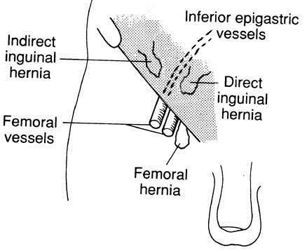
- Two types = direct and indirect
- Direct:
  - Origin medial to vessels
  - Through a weak point in the fascia of the abdominal wall
  - Always acquired
- Indirect:
  - Origin lateral to vessels
  - Protrudes through deep inguinal ring
  - Congenital or acquired
- Femoral is under the inguinal ligament
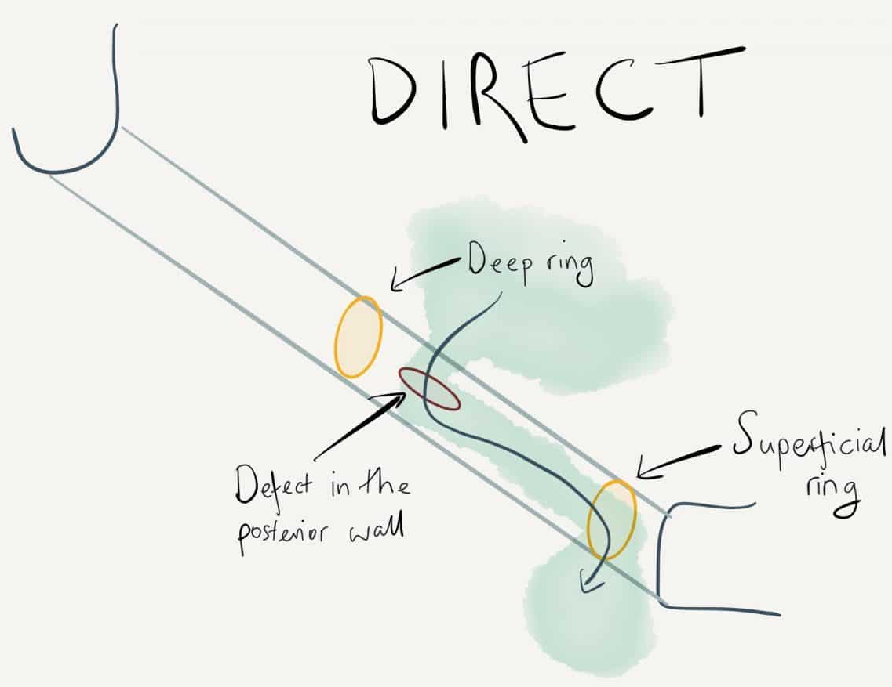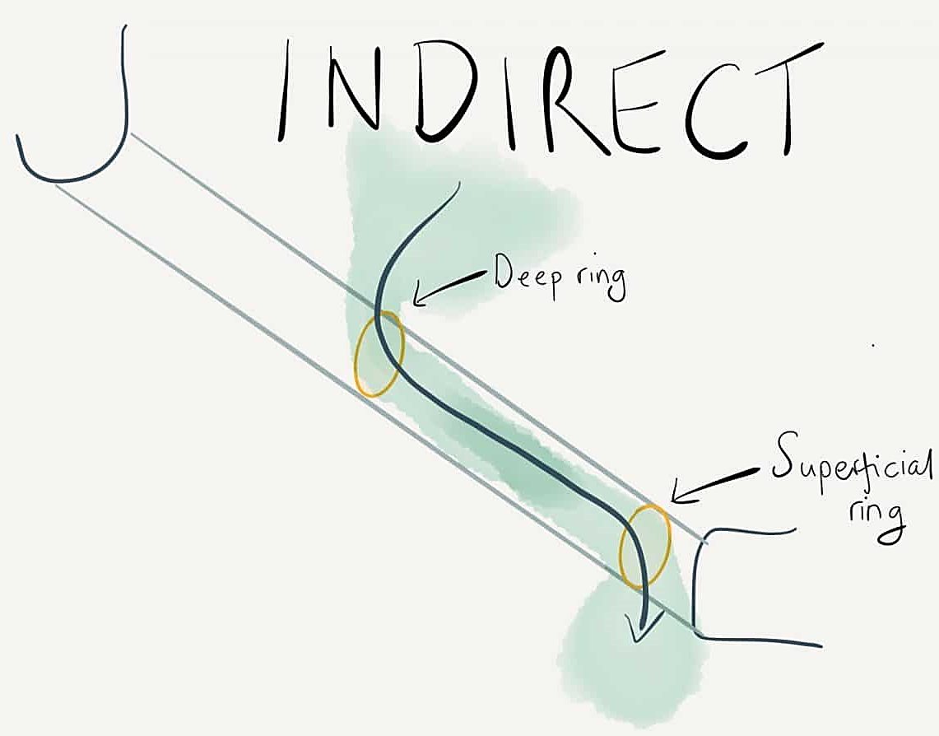

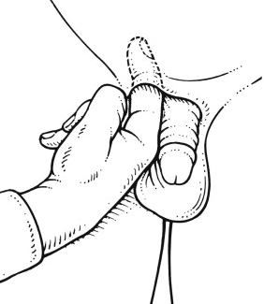
Inguinal hernia - Examination
- (Supine and) Standing position
- Palpation with fingertip
- Try to find the superficial inguinal ring (there are two rings where the hernia go through, you can find it with the finger)
- Move upward the inguinal canal
- Try to reposition the hernia

Inguinal hernia - surgery

Open surgery
- Shouldice: only sutures, no mesh
  - < 40 years, small hernia
- Lichtenstein: big incision, use mesh
  - < 40 years, big hernia, obese patient, weakness in abdominal wall

Laparoscopic
- TEP (totally extraperitoneoal): do not pass the peritoneum ( optic etc. is in between the skin and the peritoneum)
  - Usually not used
- TAPP (trans-abdominal preperitoneal): go through the peritoneum
- Trocar positions:
  - Navel Camera
  - Left and right midclavicular line (left end right of navel) laparoscopic instruments like forceps, scissors, …

TAPP- procedure
- position trocars
- identifying of inguinal region
- Stickle-shaped incision of peritoneum
- Preparation of the hernial sac
- Insertion of the mesh and fixation
- Peritoneal closure

Why use a mesh?
- Tension free repair less postoperative pain
- Higher stability less recurrences

Types of meshes
- small-pored vs. large-pored
- absorbable vs. non-absorbable
- monofilament vs. multifilament
- biological vs. artificial
- optimal:
  - large-pored ( so that cells can migrate inside, more stable afterwards)
  - non-absorbable ( more stability)
  - monofilament ( higher risk of infection for multifilament)

Mesh fixation
- Suture
- Tacks
- Staples
- Fibrin sealant (not common)
- Self-fixating mesh
- No fixation at all

Complications
- Foreign body sensation
- Dislocation
- Mesh infection mesh has to be removed, have to wait long to heal and only then can do another surgery
- Chronic pain syndrome, ca 1% (almost reversible after 6 months)
- After-bleeding probably reoperation
- Recurrences

Conclusion
- Indication for operation is always given (at any age!)
  - Because hernia could become bigger or emergency better do it before
- Laparoscopic prior to open surgery
- TAPP prior to TEP
- Correct placement of mesh determines the clinical outcome

