Clinical cases I WiSe 2018/19
This is just my self-made script. No guarantee for completeness and correctness!

Cholecystectomy (07.11.2018)
- When should a gallbladder be removed?
  - Symptomatic gallstones biliary cholic
  - Acute cholecystitis
  - chronic disease calcified (porcelain) gallbladder
  - gallbladder polyp
  - gallbladder cancer
  - gallbladder trauma
- Cholelithiasis: gallstone disease without localization
  - Cholecystolithiasis = gallstones in gallbladder
  - Choledocholithiasis = gallstones in biliary tract
  - Caused by imbalance in the chemical composition of bile
  - Female:male = 3:1
  - 32% of women over 40 years have gallstones
  - Increased progression
  - 75% of cases without symptoms, 25% symptomatic ( need of operation)
  - First sludge tiny crystals solid stones
  - Risk factors: 5 Fs: female, fat, forty, family, fair
    - Other risk factors = high-dose oestrogen therapy, combined pill, hypercholesterolemia, rapid weight loss, low activity level
  - Types of stones: cholesterol stones (80%), bilirubin stones, mixed
Cholecystitis | Cholangitis
- Inflammation of gallbladder  - 90% caused by gallstones + bacterial infection  - 10 % acute necroinflammatory disease | - Inflammation of the bile ducts  - Biliary tract obstruction (gall stone, stricture, cancer)  - Ascending bacterial infection

Function of the gallbladder
- Reservoir for bile (constantly produced by liver)
- Expulsion on demand to facilitate digestion
- Excretion of bilirubin and cholesterol
- Bactericide action
- Neutralization of gastric acid
- Located in the RUQ (right upper quadrant), sub-costly and sub-hepaticaly
  - Cystic duct connects with Common hepatic duct to form the Common bile duct
  - Pancreatic duct drains in Common bile duct and enters the duodenum at the major papilla

Diagnosis
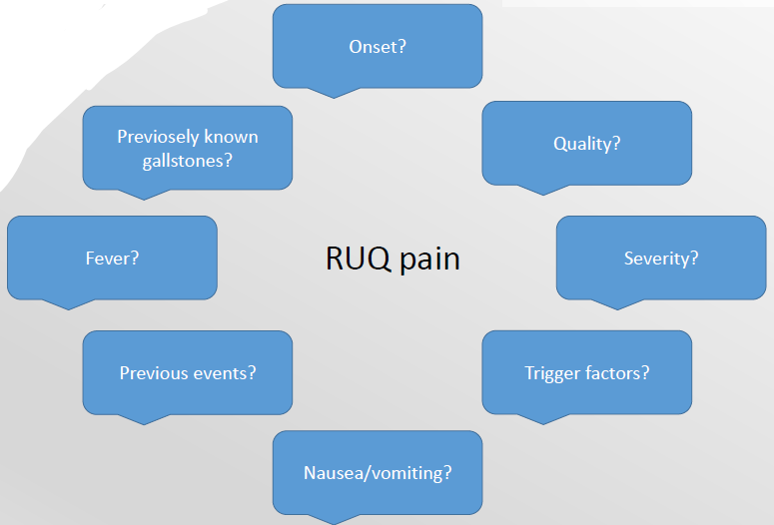
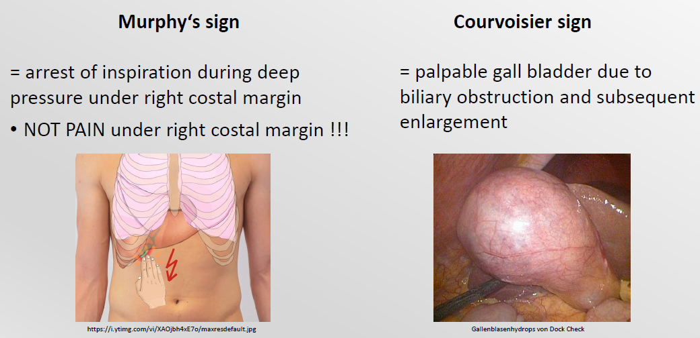
- Lab tests important: Biliary obstruction: increased GGT, AP, Bilirubine
  - Gamma-Glutamyltransferase (GGT): Enzym zur Verarbeitung von Eiweißen, wichtiger Leberwert
  - Alkalische Phosphatase (AP): Gruppe von Enzymen für Dephosphorylierung
- Diagnostic tests:
  - Gold standard = Ultrasound
    - Ultrasound findings:
      - Increased wall thickness on > 3mm (postprandial > 5mm)
      - 3 layerdness
      - Sludge/Stones within the gall bladder
      - Pericholecystic fluid
      - distended gallbladder
      - Common bile duct dilatated > 7mm
  - Additionally = CT
  - Calcified stones = X-ray
  - Exclusion of differential diagnosis = Gastroscopy
Laprascopic surgery:
- Triangle: gallbladder duct, common duct and artery you have to be careful with the artery
- First the peritoneum around the gallbladder is opened, then the cutting is prepared: first isolate the duct, clip it and then cut it, then isolate the artery, clip it and then cut it
Two other methods:
- ERCP (endoscopic retrograde cholangiopancreatography)
  - through stomach with endoscope (oral intake) and with a “needle/…” through pancreas to the gall duct/bladder
- PTC (percutaneous transhepatic cholangiography)
  - Needle from outside through skin, … to gall duct
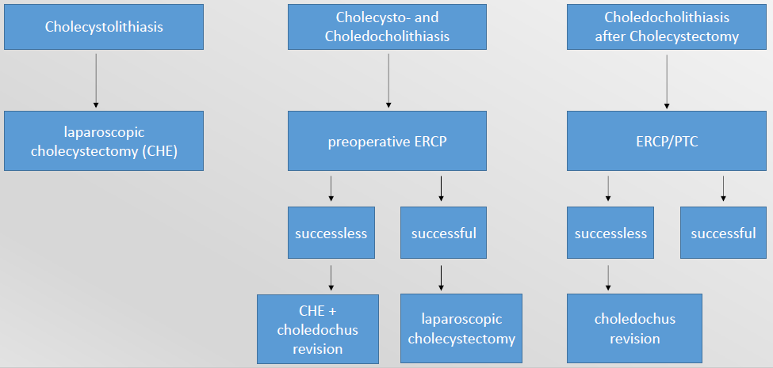

Blood

Erythrocytes: Transport of oxygen
- Diameter: 6.2–8.2 µm, thickness at the thickest point: 2–2.5 µm
- Adult humans have roughly 20–30 trillion red blood cells
- lifetime of about 100–120 days
- Erythropoiesis in the bone marrow, stimulated by erythropoietin (EPO) which is synthesized by the kidney
- Determination of erythrocyte indices
  - MCV: mean corpuscular volume [80-95 fL]
  - MCH: mean corpuscular hemoglobin [28-34 pg]
  - MCHC: mean corpuscular hemoglobin concentration [31-37 g/dL]
- Diseases:
  - Anemia (deficiency of vit. B12 or folic acid, intrinsic defects of cellular membrane or enzymes, hemoglobinopathies)
    - Definition: Reduction of
      - Hemoglobin Hb < 13.0 g/dL [m], < 12.0 g/dL [w]
      - Hematocrit HCT/Packed Cell Volume PCV < 42% [m], < 38% [w]
      - Erythrocytes
  - Hypo- vs. hyperregeneratoric anemia
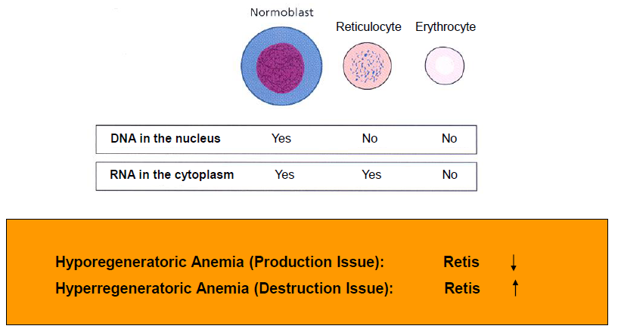
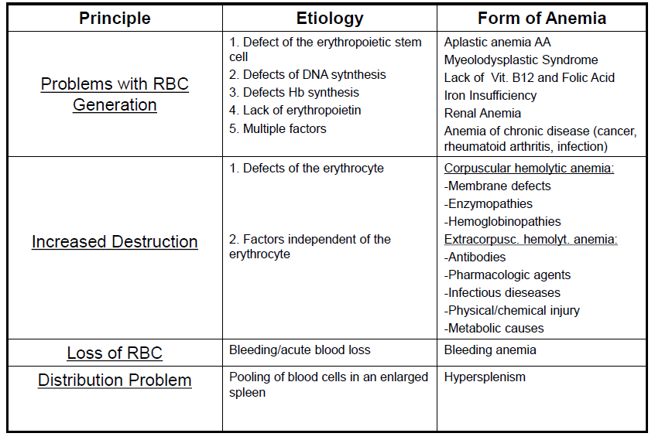
  - Aplastic Anemia: Bone Marrow Insufficiency with Pancytopenia (Stem Cell Disease) All 3 lineages are involved (Leukocytes, Platelets, Erythrocytes)
    - Causes:
    - 1. Ideopatic AA (70%), cause unknown
    - 2. Secondary AA (25%) pharmacologic agents, chemicals, radiation…
    - 3. Congenital AA (<5%)
    - Therapy:
    - 1.Supportive Therapy:
      - Transfusions
      - Antibiotics
    - 2. Causal Treatment:
      - Allogeneic Stem Cell Transplantation
      - Immunosuppressive Therapy (CsA, ALG, ATG)
      - With doc. viral genesis: Therapy with 7S-Immunglobulins
  - Polycythemia (Polyglobulia) (e.g. EPO-dependant formation in polycythemia vera)

Iron Metabolism
- Loss of iron per day: Male 1 mg, Menstruating Female 2 mg, Pregnant Female 3 mg
- Body iron:
  - 70 kg Male: 3.5 g Iron (50 mg/kg body weight)
  - 60 kg Female: 2.1 g Iron (35 mg/kg body weight)
- Distribution of iron in the human organism:
- Heme Iron (70%) Iron in the heme of hemeoglobin
- Storage Iron (18%) Intracellular storage as ferritin and hemosiderin
- Functional Iron (12%) Myoglobin und other iron-containing enzymes
- Transport Iron (0.1%) Iron bound to transferrin

Causes of Iron Insufficiency
- Lack of intake (babies, children, vegetarians)
- Issues with iron resorption (gastrectomy, celiac disease, CIBD)
- Increased demand (growth, pregnancy, breast feeding period)
- Iron loss (> 80 % of cases!!!)
- Genitourinary bleedings in females (menorrhagia)
- Gastrointestinal bleedings
- Other types of blood loss (e.g. ENT)
- HP-positive gastritis, gastric lymphoma
- Münchhausen-Syndrome, borderline personality disorder

Clinical Symptoms of Iron Insufficiency Anemia
- General anemia symtoms: Pallor, fatigue etc.
- Unspecific psychiatric/neurologic Symptoms: Cephalgia, issues with concentrating, irritability, pikacism.
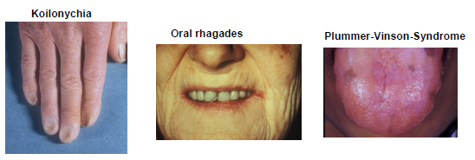
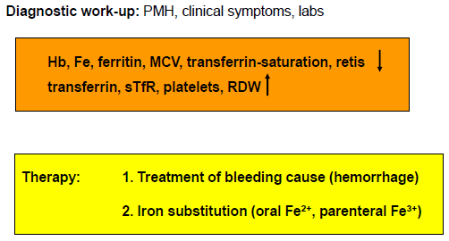

Important differential diagnoses
- Cave: Hypochromic, microcytic anemia with normal or elevated ferritin is not an iron insufficency anemia!!!!
Important differential diagnoses:
- Anemia of chronic disease (Tumor, chron. Infekt etc.)
- Sideroachrestic anemia
- Thalassemia

Sideroachrestic/Sideroblastischic Anemia
- Acquiered, inherited or idiopathic disorder of iron usage.
- Deposition of iron in erythroblasts (sideroblasts), monocytes, macrophages parenchymatous organs (e.g. liver)
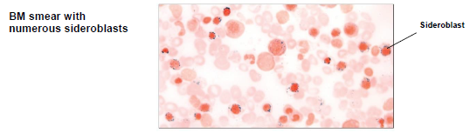

Thalassemia
- Quantitative disorder of Hb synthesis
- Common in the mediterranean area (Thalassa Θάλασσα „Meer“)
- Genetically fixed dysregulation of the synthesis of the globin chains (-thalassemia, -thalassemia)
- Diagnosis by Hb-electrophoresis, HPLC

Megaloblastic Anemia
- Lack of Vitamin B12 (Cobalamin) a/o Folic Acid with consecutive dysregulation of DNA synthesis and nucelar maturation.
- Appearance of megaloblasts
- Leading symptoms: Makrocytic anemia, in the case of Vit. B12-insufficiency additional neurological und gastrointestinal symptoms.
- Folic acid is necessary for DNA methylation and repair/synthesis
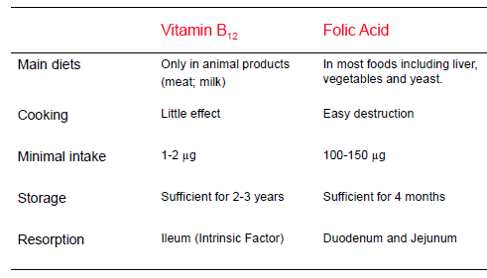

Causes for Vit. B12 or Folic Acid Insufficiency
- Vitamin B12-Insufficiency
  - Vegetarian/vegan diet
  - Lack of intrinsic factor (gastrectomy, pernicous anemia)
  - Gastrointestinal diseases with malabsorption syndrome
  - Increased need (fish tapeworm)
  - Intestinal bacterial overgrowth (e.g. „blind loop syndrome“)
- Folic Acid-Insufficiency
  - Insufficient diet, unbalanced diet (e.g. alkoholics)
  - Increased need (pregnancy, hymolysis)
  - Gastrointestinal diseases with malabsorption syndrome
  - Impairment of dekonjugation by certain medications
  - Treatment with folic acid abtagonists (e.g. methotrexate, trimethoprim)
- Trias in severe Vitamin B12-Insufficiency:
  - Hematologic Syndrome: anemia, jaundice
  - Gastrointestinale Syndrome: Trophic mucosa alterations, atrophic Glossitis Hunter
  - Neurologic-psychiatric Syndrome: Funicular myelosis with ataxia and loss of vibration sensitivity.
- Symptoms in severe Folic Acid Insufficiency:
  - Megaloblastic anemia w/o funicular myelosis
  - Folic Acid Insufficiency in pregnant women increases the risk for neural tube defects (e.g. spina bifida)
- Therapy of Vitamin B12-Insufficiency:
  - Treatment of the underlying disease (e.g. treatment of fish tapeworm infestation).
  - Parenteral substitution of hydroxycobalamin.
  - In chronisc-atrophic TypeA-Gastrtis: regular follow-up gastros-copies (increased risk for gastric cancer).
- Therapy of Folic Acid Insufficiency:
  - Causal therapy (e.g. alcohol abstinence, compensation of unbalanced diet).
  - Substitution of folic acid (5 mg/d oral).
  - Special scenario: Prophylaktic application of folic acid during pregnancy for the prevention of neural tube defects.

Renal Anemia
- Normochromic, normocytic hyporegeneratoric anemia, which develops during the course of a renal insufficiency (creatinine > 3.5 mg/dL, creatinine clearance < 30 mL/min).
- Main Cause: Lack of Erythropoietin
- Other factors: Decreased erythrocyte survival time, iron deficiency, inappropriate dialysis
- Therapeutic options: 1. Substitution of erythropoietin 2.Kidney transplantation

Platelets: Blood clotting
- Diseases:
  - Thrombocytopenia: hemorrhages (z.B. ITP)
  - Thrombocytosis: vessel occlusion, thrombosis (z.B. essential thrombocytosis = ET)

Leukocytes /White blood cells (WBC): Immune defense
- Innate Immunity: phagocytosis of foreign material/pathogens
  - Neutrophils
  - Monocytes /macrophages /dendritic cells
- Adaptive Immunity:
  - B Lymphocytes/plasma cells
    - can produce specific antibodies against pathogens after specific stimulation/activation
  - T Lymphocytes
    - coordinate the immune response, can directly attack bacteria/virus infected cells via cytotoxic mechanisms
  - Leukocytes
    - produce different mediators (cytokines, chemokines) to coordinate the immune response.
- Generation of blood cells in the bone marrow
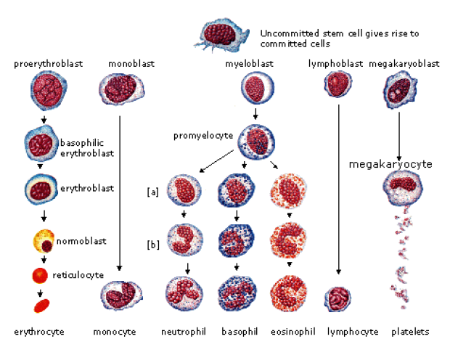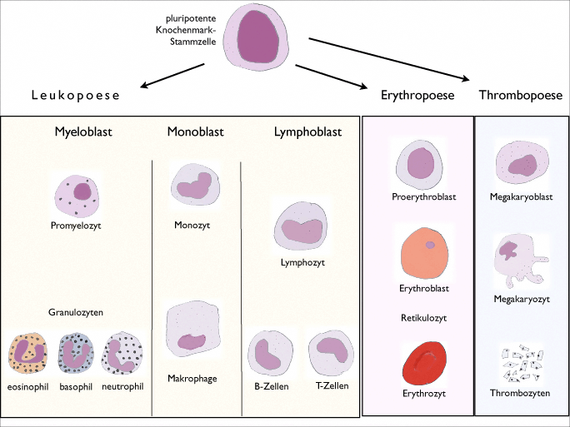
- Flow cytometry of blood: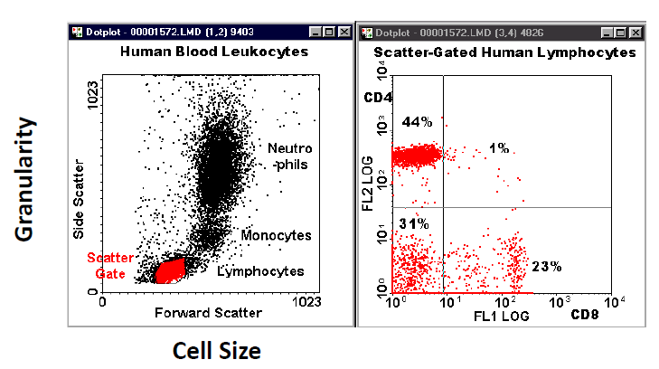
- Diseases:
- Chronic myelogenous leukemia (CML)
  - myeloproliferative disorder characterized by increased proliferation of the granulocytic cell line without the loss of their capacity to differentiate
  - accounts for 20% of all leukemias affecting adults
- Aplastic anaemia
  - rare disease in which the bone marrow and the hematopoietic stem cells that reside there are damaged
  - causes a deficiency of all three blood cell types (pancytopenia): red blood cells (anemia), white blood cells (leukopenia), and platelets (thrombocytopenia)
  - Aplastic refers to the inability of stem cells to generate mature blood cells.

Embryonic developement

Summary
- Naming of different blood cell types
- Main functions of blood cells
- Normal CBC
- Examples for pathological deviations in the CBC
- BM versus peripheral blood

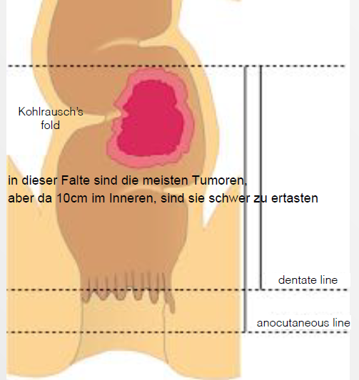
Colorectal cancer

case history
- 71 y/o male patient reports to the OPD with rectal blood loss for 4 days.
- few „blood clots and fresh blood“ after bowel movement
- started 4 days ago; no pain
- earlier episodes of obstipation (Verstopfung) and diarrhea; now mostly thin stool
- in rectal cancer tumor grows and stool can’t move forward obstipation
- then bacteria dissolve the stool very bad smelling diarrhea
- then very thin stool because only small amount can pass

diagnostics
- clinical examination + DRE (digital rectal examination = with finger)
- palpable?
- ability to pass?
- rigidity?
- blood?
- Blood taking:
  - Tumor markers CEA and CA19-9
  - To set a “baseline” before resection and compare it with the values after resection
- rigid rectoscopy to get the distance from tumor to anus
- colonoscopy (flexible endoscope)
- endosonographic lymph node assessment
- staging-CT liver metastasis?
- pelvic MRI very precise image

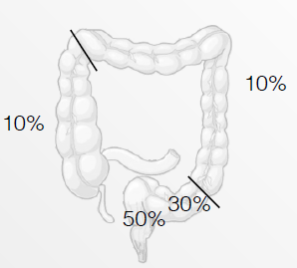
Colorectal cancer
- 2nd most common of all malignomas
- typical age: 70-75
- f/m: 50/50
- 90% follow an adenoma-carcinoma sequence
- 85% adenocarcinoma, 10-15% mucinous carcinoma
- Hereditary (erblich) forms:
  - FAP (familial adenomatous polyposis)
  - HNPCC (hereditary nonpolyposis colorectal cancer)

TNM-staging system
- T: invasion of the primary tumor
  - T1: tumor invades submucosa
  - T2: tumor invades muscularis propria
  - T3: Tumor invades subserosa or beyond
  - T4: tumor invades adjacent organs or perforates visceral peritoneum
- N: involved regional lymph nodes
- M: distant metastasis

Therapy
- primary surgery for stages I, II, III
- neoadjuvant therapy >T3 / N+ (IIIb)
- adjuvant therapy for stages III (II)

Prognosis (5 year survival)
- stage I (T1/T2, N0, M0) approx. 80%
- stage II (T3/T4, N0, M0) approx. 50%
- stage III (all T, N+, M0) approx. 30%
- stage IV (all T, all N, M+) approx. 5%
- andere Zahlen in neuem Dokument…

Total mesorectal resection/excision TME
- mesorectum: fascia, in which the arteries, venes, and lyphs are located (same for mesocolon)
  - resection minimizes risks
- There are lymph nodes in the Waldeyer’s fascia and Denonvillier’s fascia, that’s why they also have to be resected
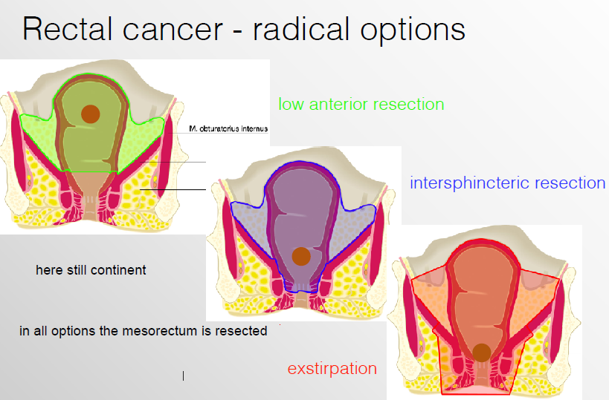

TEM (transanal endoscopic microsurgery)
- local surgical therapy
  - T1 <3cm
  - low-risk histopathology

RF Ablation (23.01.19, Prof. Enderle)
Wikipedia: RFA is a medical procedure in which part of the electrical conduction system of the heart, tumor or other dysfunctional tissue is ablated using the heat generated from medium frequency alternating current (in the range of 350–500 kHz). RFA is generally conducted in the outpatient setting, using either local anesthetics or conscious sedation anesthesia. When it is delivered via catheter, it is called radiofrequency catheter ablation.
- RF-energy is driven into the body to induce a coagulative necrosis ( “cook” a tumor)

Physics
- High frequency current (>100 kHz) flows through the body
- Active electrode tissue ground pads
- Heat is created where the active electrode is placed ionic agitation friction heat tissue heating (“joule heating”)
- Tissue desiccation (Austrockenen) increases impedance which eventually decreases current flow (self-limitating over time)
- The current density falls rapidly with the distance of the electrode (dadurch wird anderes Gewebe nicht erhitzt)
- Generated heat spreads into the surrounding tissue by conduction until steady sate (thermal equilibrium)
- Higher energy amounts are required for larger ablation volumes
- BUT to high current density leads to rapidly desiccation of the tissue surrounding the probe impedance rise not good
- 35-40°C Normothermia
- 42 Hyperthermia (Fieber ab 38,5)
- 60° Rapid coagulation (irreversible denaturation)
- 70-90°C Desiccation
- 100°C cooking, boiling
- Brain cells are very sensitive for heat (deshalb muss man manchmal Fieber senken)

- Immediate cell damage is happening when protein denaturation/coagulation (direct thermal destruction)
- Tissue boiling release of intracellular water vapor mechanical destruction (indirect thermal destruction)
- Maximal extend of destruction after 72 hours in human

Technical components
- RF source (generator)
- 2 electrodes: 1 active and at least 1 grounding (passive, neutral) pad
  - (often 2 grounding pads)
- Imaging system for ablation control
- Simplified bioheat equation (Goldberg):
  - $Tissue cogulation=Energy intake⋅Tissue interactions-heat loss$
  - Real one much more complicated
  - Heat loss due to blood flow (e.g. important in the liver, because there are huge vessels)
    - Heat sink effect
To increase the size of the RFA lesion, you can
- Increase the energy deposition
- Increase tissue interactions
- Decrease energy loss

Increase the energy deposition
  - Increase voltage/power BUT limit is reached very fast e.g. middle of tumor not reached
  - Lower voltage and longer activation time higher volume of lesion e.g. whole tumor ablated
- Increase probe size
  - When only length is increased, only the long axis of the coagulation is increased (oval shape then), not the short axis (diameter of coagulation around the probe)
  - Short axis is always the critical parameter because long axis is controlled easily
  - To increase diameter of coagulation the diameter of the probe has to be increased
  - BUT larger probe diameter larger invasion in the body
Modification of probes
  - Multiprobe arrays multiple small probes
  - Umbrella RF electrodes with multiple probes (“Schirm” mit vielen Elektroden wird im Tumor aufgefaltet, geht ber nur in weichen Tumoren
  - Bipolar arrays
    - 2 probes = elliptical lesions – not spherical
    - Bipolar – two electrodes in one probe
Prevent charring/overcooking
- Internal cooling of probe or tissue by simultaneous saline injection, …
- Temperature regulated ablation
- Pulsed RF ablation -> proper balance between high – and low- energy deposition
Cooling – Joule-Thomson-Effect
- Temperature change of gas or liquid when it is forced through a valve
- Atmospheric gases warm when….
- Internally cooled electrode with CO2 (closed-loop-system)
  - Cryo/RFA is much better then only cryo or RFA
  - Gas cooling is better than water cooling
  - Monopolar is better than bipolar
  - best is monopolar gas cooled

Summary- increase energy deposition
- Increase size of probe
- Multiprobe arrays (several monopolar probes, Umbrella, bipolar arrays, …)
- Simultaneous saline injection
- Temperature regulated ablation
- Pulsed RF ablation
- Internally cooling
  - Water cooling
  - Joule Thomsen effect = gas cooling

Increase tissue interactions
- Improving tissue heat …
- Altering tissue thermal and electrical conductivity
- Reducing heat loss – reducing blood flow
  - Mechanical or pharmacologic occlusion of vessels
    - balloon occlusion of hepatic artery, portal vein (Pringle Maneuver)
    - theoretically possible but still experimental state
clinical indications (location, tumor type,..)
- interstitial FR-Ablation = locally curative treatment
- cure of early stage of HCC tumor
- most of the time palliative treatment
  - liver metasitses
  - renal tumor
  - lung cancer and met.
  - Head and neck cancer
  - Breast cancer
  - …
EUS RF Ablation
- Flexible endoscope to get a biopsy , if it is a tumor, then the biopsy needle can be used for RF ablation

In comparison to surgery, RFA is
- Less invasive
- Can be applied to non-surgical candidates
- Precise, reproducible clinical results
- Less complications
- Provides both surgical and non-surgical candidates with additional treatment options
- Less expensive = cost effective solution

Alternatives
- For more lesions within the liver which cannot
… There are a lot, but none of them can cure the late state tumors

Summary
- Indication
  - Almost all tumors, but not curative
- Procedure
  - Using an insulated probe with tip exposed, FR is administered at a specific site guided by CT or ultrasound
- Physics
  - Ionic agitation to ideal temp. coagulative necrosis
- Limitations
  - Charring, heat sink, tissue conduction, collateral damage
- Current FR Research
  - Cooling, hypertonic fluids

Hepatobiliary surgery / Liver transplantation (30.01.19 Dr.med. Markus Quante)

Topography of the liver
- Blue belongs functionally to the left side (right part of liver)
- 8 segments
  - Resections are made according to this anatomical landmark

History of liver surgery
- Hogarth Pringle invented the “pringle maneuver”
  - Occlude a ligamentum which contains the bile duct, portal vein and proper hepatic artery
- CT was a major step too see bleeding and decide if surgery is necessary (if bleeding stays inside the liver you don’t have to undergo surgery immediately)
- Liver trauma-packing concept: put a towel on the cut and put a bit of pressure
- Pringle maneuver can be compared with total vascular exclusion (additional occlusion of vena cava?)

Benign liver lesions
- case of a 42y woman with hepatic adenoma, segment II and III are resected
- techniques:
  - vascular stapler
  - LigaSure (combination of pressure and energy to seal vessels), endoscopic
  - Cavitron Ultrasonic Surgical Aspirator (CUSA): cutting using ultrasound and simultaneously aspirating
- Adenoma is capsuled not infiltrating the liver, can just be resected

Hepatic adenoma
- benign epithelial liver tumors that develop in an otherwise normal-appearing liver
- predominantly in young women (20 to 44 years old)
- strongly associated with use of oral contraceptives, anabolic androgens, and glycogen storage disease
- associated with malignant transformation, spontaneous hemorrhage, and rupture
- recommendation for resection of all symptomatic hepatic adenomas and adenomas >5 cm

Malignant liver lesions
- 56 y/o male, had rectal cancer, now metastasis in liver
- right liver had to be removed completely

Liver volumetry
The amount of the future liver remnant volume is fundamental for hepato-biliary surgery, representing an important potential risk-factor for the development of postoperative liver failure.
- Volume total liver: 1811 ml +/- 23,4 ml
- Volume segment II, III and IVb: 471 ml +/- 12,6 ml
- Calculated remnant volume: 26% of total volume
- Critical remnant volume is 25-30%, sometimes 20% is sufficient
- Liver volumetry is done with the CT scans and a computer program

Extrahepatic cholangiocarcinoma (Klatskin-Tumor)
- Rare incidence at 1:100000
- Median survival in a palliative setting 6-12 months
- Major hepatic resections often including resection and reconstruction of the hepatic artery or the portal vein are the only curative option
- Often multimodal concepts: pre-operative biliary drainage, portal vein embolization, staging laparoscopy and neo-adjuvant chemotherapy
- Not curable
- The tumor is occluding the bile ducts, sitting very central
- Right party of the liver has to be removed (right part because there are 5 outputs of bile ducts and the left liver has 4, and ale the outputs have to be connected to the intestine via anastomose)

5) Liver transplantation
- first in 1963
- technique: vena cava superior and inferior, portal vain and bile duct have to be anastomosed with the new liver
- extreme shortage of donor organs
- donor pool can be expanded by living donation (only segm. II and III is enough for a baby and will grow with baby)
- for adults half of a liver is possible

Inflammatory Bowel Disease

Clinical presentation
- Diarrhea longer than 4 weeks
- More than 2 Bowel Movements per day
- Fluid or thin Defecation
- Abdominal pain
- Blood or Mucus in stool
- Inflammatory Bowel disease possible

Epidemiology
- Incidence:
  - Crohn‘s Disease 0,5-6,3 : 100000
  - Ulcerative Colitis 1,3-15,1 : 100000
- Prevalence:
  - Crohn‘s Disease 10-70 : 100000
  - Ulcerative Colitis 20-130 : 100000
- Little bit more common in urban areas, but rural is only better in the first years of upbringing

Risk of the Genetics (for inflammatory bowel disease
- Risk of 2-10% relatives 1. Grade
- Up to 50% Increase in Prevalence in Siblings
- Up to 100% Increase in Prevalence in Children of Patients with disease

Pathogenesis

Crohn‘s Disease: Definition
- subacute or chronic inflammation of the gastrointestinal tract (from mouth to anus)
  - most common area affected is the end of the ileum or the colon
  - As well as affecting the lining of the bowel, Crohn’s may also go deeper into the bowel wall
- Abdominal cramps, pain
- Weight loss
- Diarrhea
- Fever
- Localized inflammation with erosions, fissura, Ulcera

Diagnostic procedures

Crohn‘s Disease: Finding the Diagnosis
- Anamnesis and clinical Presentation
- Ileokoloskopie with sample biopsies
- Survey of the complete gastrointestinal tract
- Hydro MRT: Kontrastmittel Trinken + Wasser in Kolon einführen, dann MRT, das sehr schönen Kontrast gibt
- Rö Sellink: Röntgenuntersuchung nach Sellink ist eine radiologische Untersuchung mit der die Schleimhaut des Dünndarms am besten dargestellt werden kann; dient Erfassung von entzündlichen Prozessen, z.B. bei Morbus Crohn oder tumorösen Veränderungen
- capsule endoscopy (tiny wireless camera to take pictures of your digestive tract)
- Ösophagogastroduodenoskopy (endoskopische Untersuchung des Ösophagus, Gaster und Duodenum in einem Untersuchungsgang)
- Ultrasound (intraabdominal mass)
- Labaratory Check: Infection markers, vitamin deficiency, Bacteriology

Case example
- Abdominal Pain
- Resistance palpable in the right lower quadrant
- Impossibility of food or fluid intake
- 11kg weight loss in one Week
- Last Defacation 4 days before
- Know Crohn‘s Disease
  - First Resection of the ileocoecal Region 1985
  - Resection of the Anastomosis in 1992 and 997
  - In 2008 Resection of a Part of the new Ileum and the
  - Colon creation of a new Anastomosis

Therapy
- Parenteral liquid and symptomatic therapy
- Acute Phase: Cortison
- Bacterial contamination: Antibiotic drug (targeted)
- Remission Control Azathioprin
- But:
  - Pulmonary infections
  - Patient refused continous drug treatment due to side effects

Ulcerative Colitis
- Recurrent inflammatory ulcerative Disease of the Colon and Rectum
- Inflammation usually begins in the rectum and lower colon, but it may affect the entire colon
- Symptoms:
  - Diarrhea
  - Bleeding
  - Abdominal cramps
  - Loss of appetite and weight
- Diffuse inflammation with ulcerations, abscesses, Infiltration

Diagnosis
- History Taking
- Clinical presentation
- Ileocolonoscopy with sample probes
- Ultrasound
- Labarotory marker for inflammation and Bacteriology

Problems: extrabowel manifestations
- Primary sclerosing Cholangitis
  - Affects the liver bile ducts
  - 5-10% Development of a Cholangiocarcinoma
  - Transplantation often needed

Case example
- 24 year old girl (student)
- Since 6 weeks recurrent Diarrhea
  - Since one week with blood
  - After questioning: often Mucus like Defacation
- Abdominal pain
  - Regular intake of Pain Killer Paracetamol
- Clinical examination:
  - Diffuse Pain over the complete abdomen
- No Peritonitis signs

Therapy
- Drug therapy
  - Acute Cortison
  - Mesalazin (Acetylsalicate)
  - Biological Therapy with antibodies
- Surgery only when the drug regiment fails
  - Healing of Colitis possible with removal of the colon
  - BUT: You need a pouch or a oostomy

